DRIVER+ Protect PoS
12-03-2019

1) Use Case for Protect tool
The proposed use case can be any incident or hazard.
The proposed LOC (Local Operational Centre ) and NOC (National Operational Centre) are just examples, because it can be entities of any type: local national or international.

- Use case overview:
Note that the use of a intermedium CIS (Common Information Space) is not mandatory.
Protect can support the request for assistance between organizations without any intermedium system.

Figure 1: Sequence diagram describing the message exchange between solutions
(Protect, CIS and Other tools)

- LOC proceeds with a manual Emergency creation (or receive a EMSI message from other organization, from the Test Bed), and Send an update EMSI message using the Test Bed.

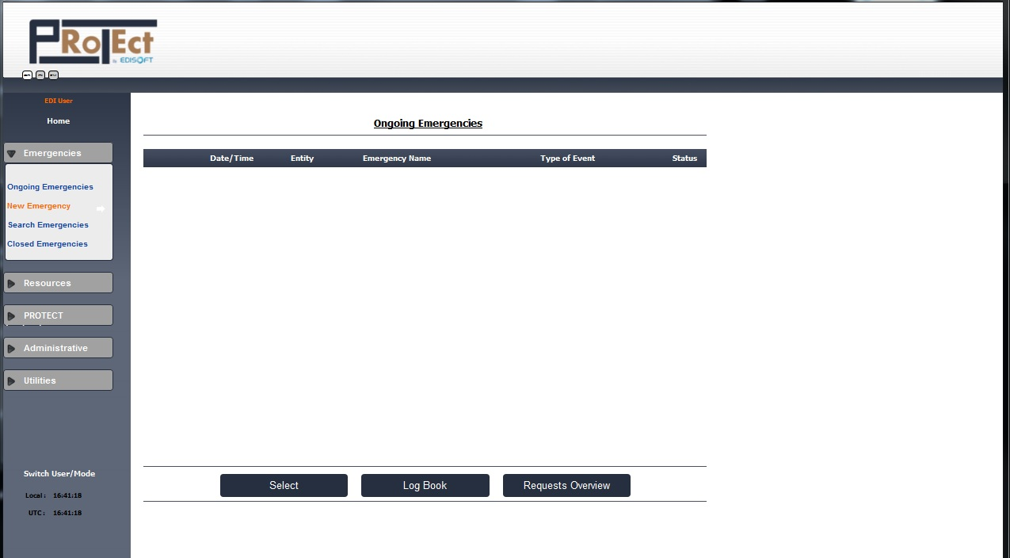

- The emergency characterization uses the received information from a xml (in EMSI Standard form the CIS) file or as alternative by inserting manually the emergency.

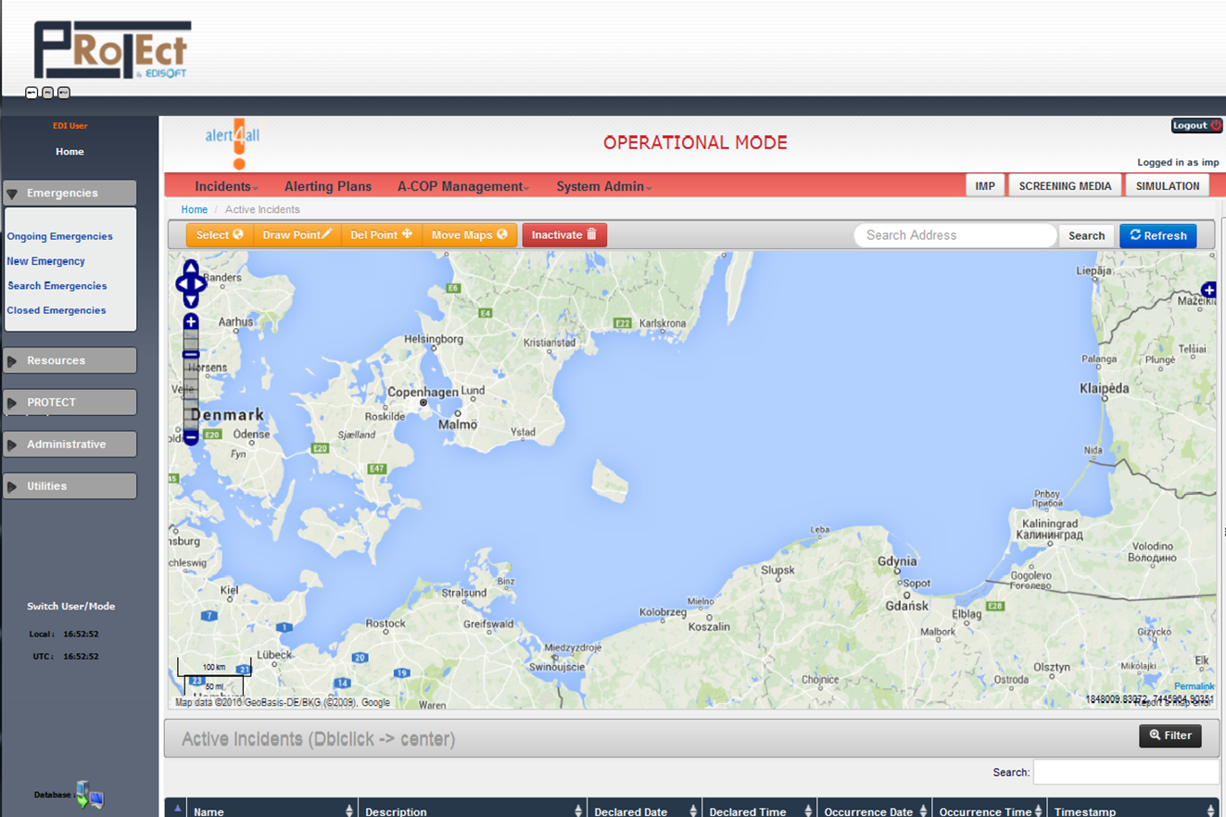

- The user visualizes (or as alternative draw a point to fill) the event position and the incident characterization.
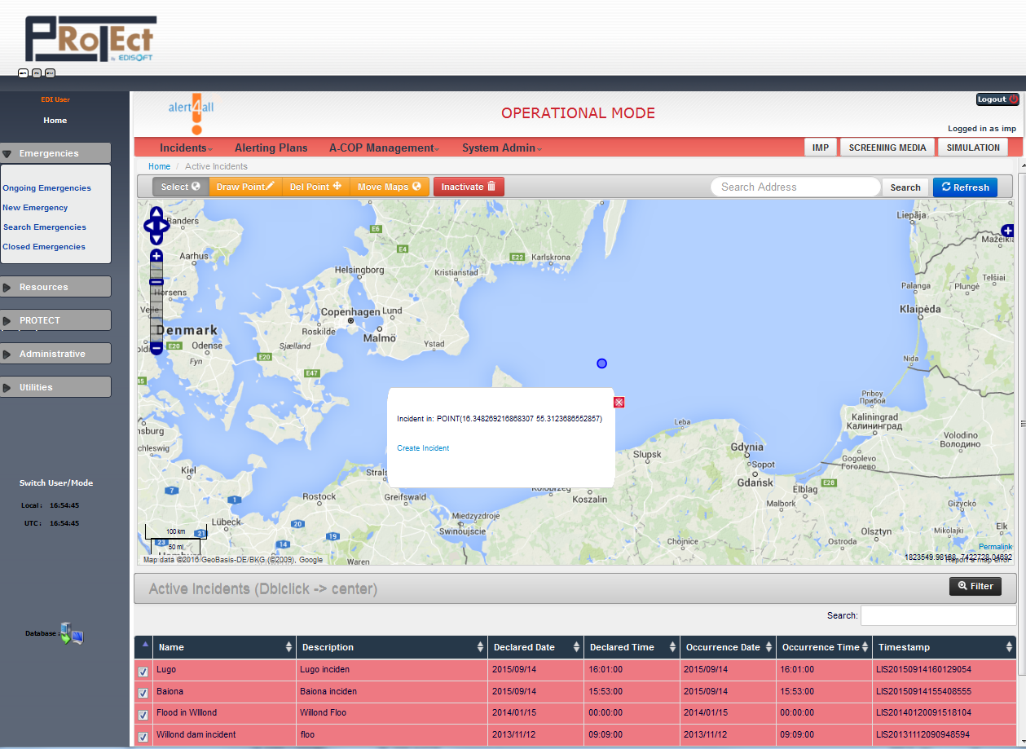

- The emergency status is activated and characterized to be used by other entities.

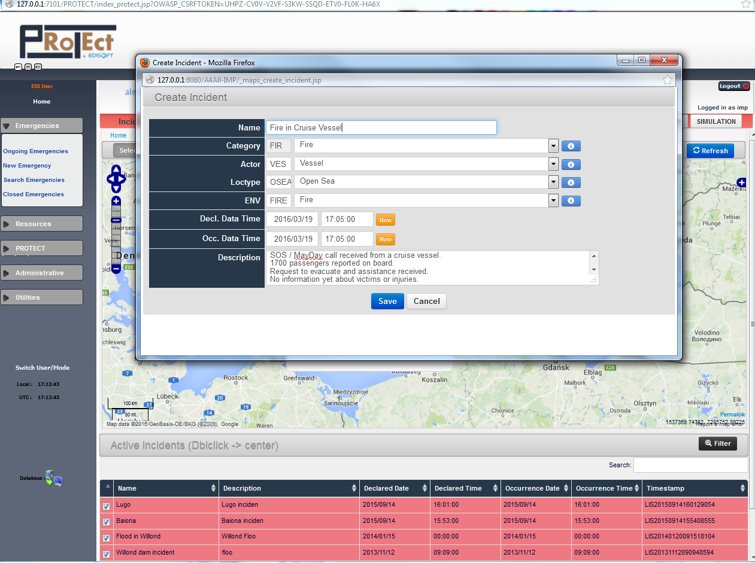

- The Incident is now available and included in the map.

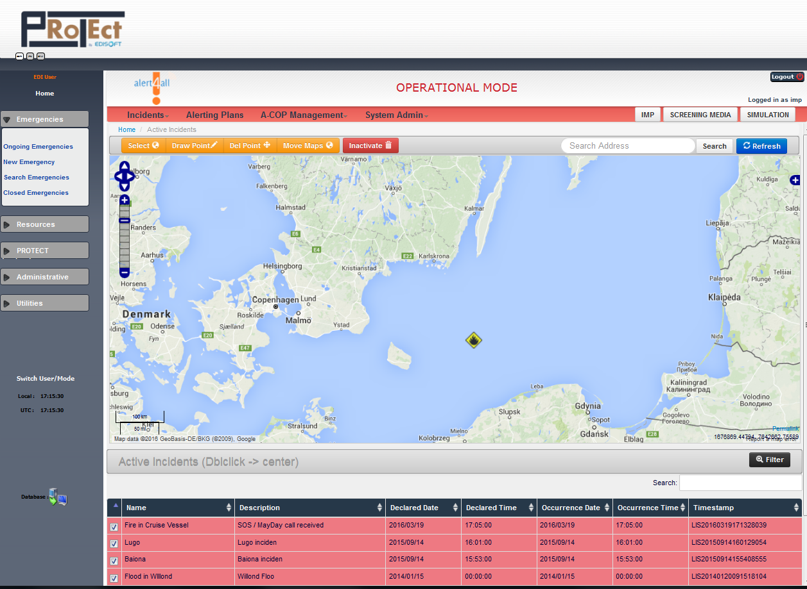

- The incident is now in the system and using Protect, a notification can be sent to the others registered authorities system using the CIS (EMSI messages).

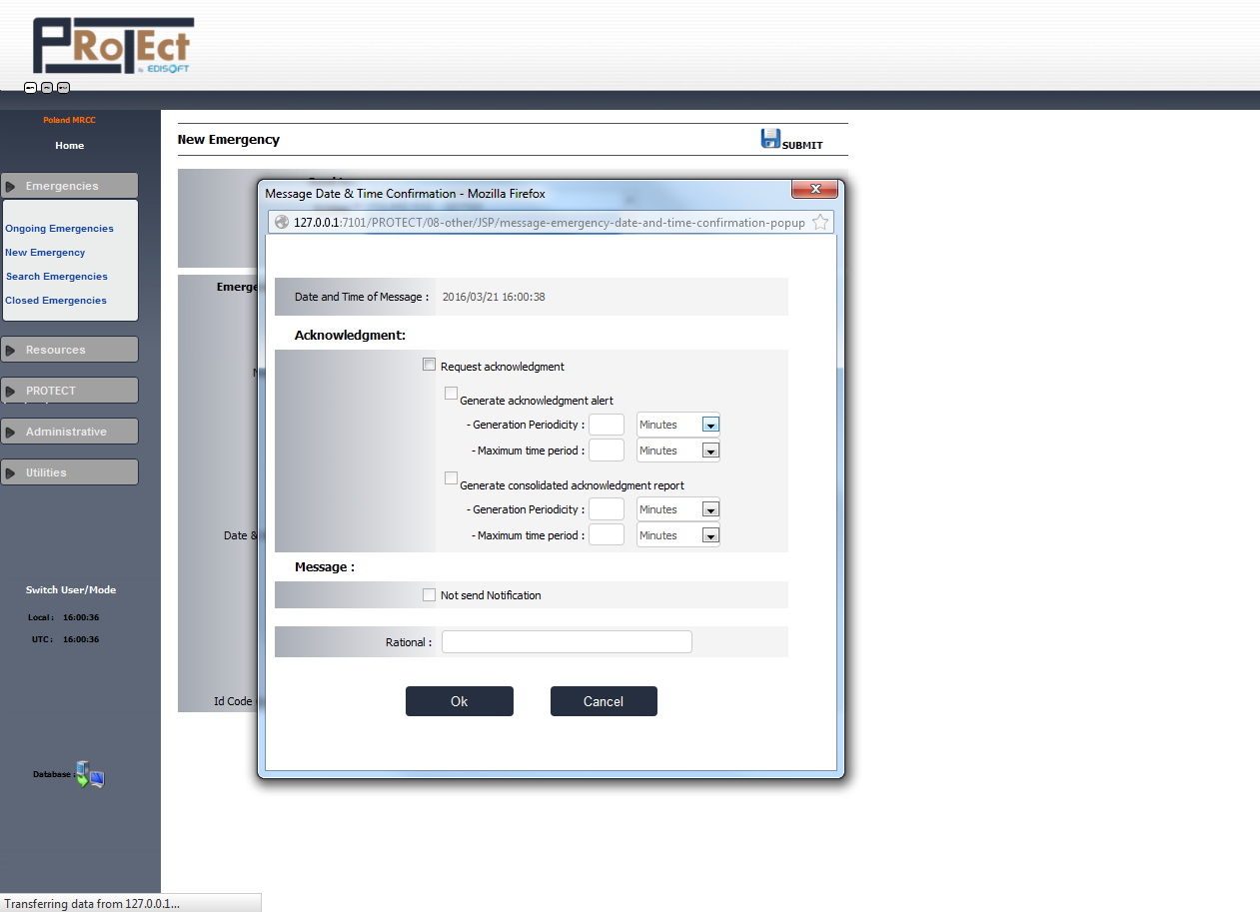

- According to the information gathered from the assets and the amount of own resources that are available, LOC asks NOC for cooperation in the incident response.
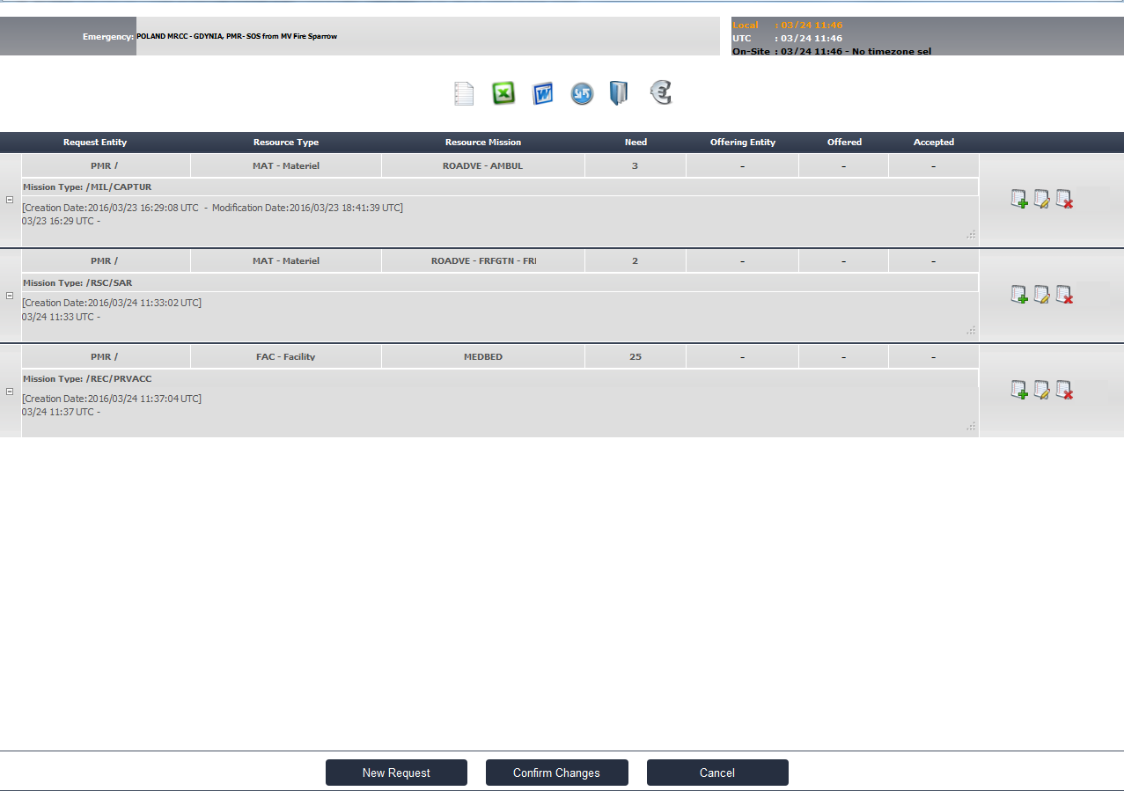

- NOC start to answer for the request for assistance with the amount of resources available.

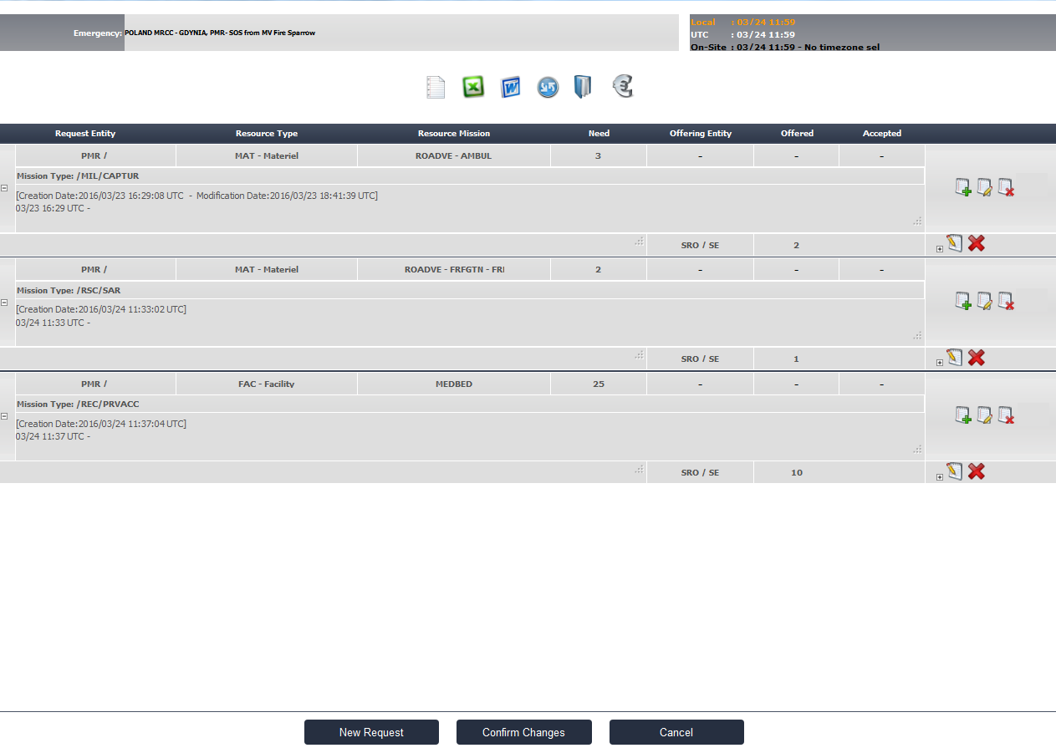

- NOC inform LOC about the costs involved
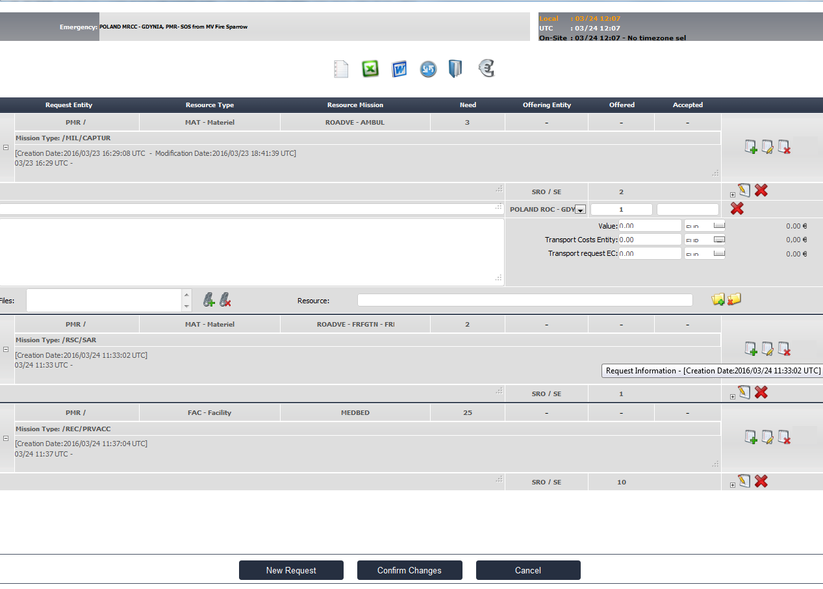

- LOC user selects the authority that is offering the request for assistance

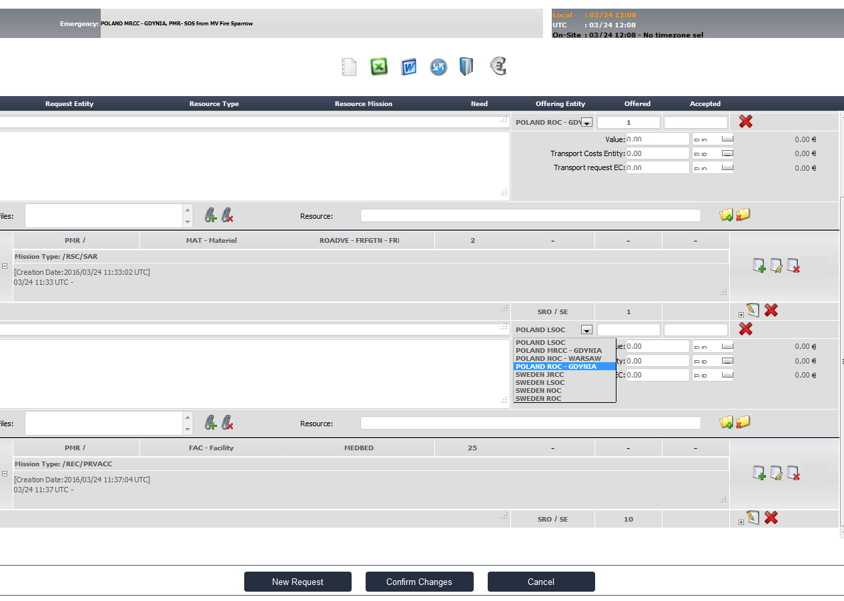

- Taking into account previous information from NOC and other entities, LOC accept or refuses the request for assistance
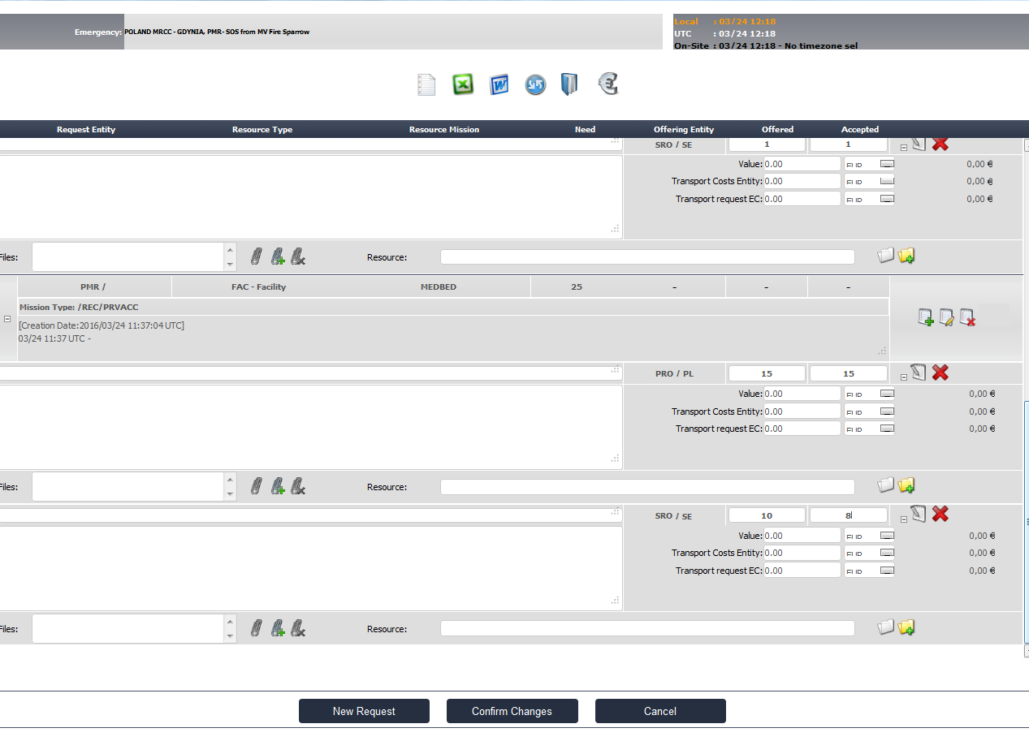

- Example of a request for assistance final resume
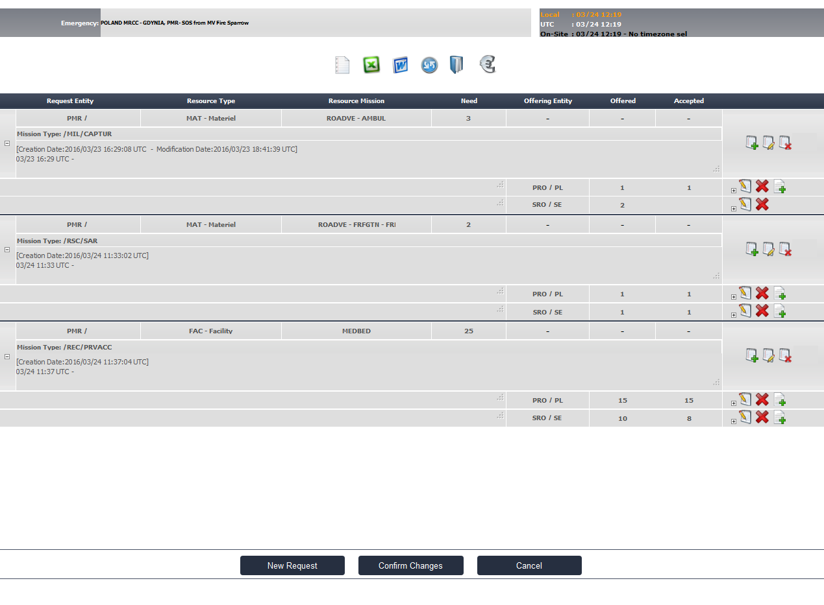
- This information will be available to other entities in the CIS

