Driving Innovation in Crisis Management for European Resilience

CYPRUS
Policy, Legislation, Organisation, Procedures & Capabilities (PLOPC) in crisis management and disaster response
Responsible Partner: ATOS (Nadia Politou, Adem Yaşar Mülayim, Alejandro Afonso Spinola, Dario Ruiz)

  - Scope and limitations
This study serves as supporting information for further work within DRIVER.
Only limited time and budget has been available for this first general survey, which needs to be considered in terms of scope and completeness of the respective studies.
The author/s of this study is/are responsible for its content and quality.
This report was revised at the end of 2015, reviewed internally by AIT and amended according to reviewer's comments and recommendations upon the decision of the author/s.

Overview
The republic of Cyprus consists of six administrative districts: Famagusta, Kyrenia, Larnaca, Limassol, Nicosia and Paphos. A district administration in "exile" exists on the Republic of Cyprus-controlled part of the island. The north-eastern part of the island is a self-declared state controlled by the Turkish Republic of Northern Cyprus (TRNC) and recognised only by Turkey, whereas the international community considers it as part of the Republic of Cyprus.
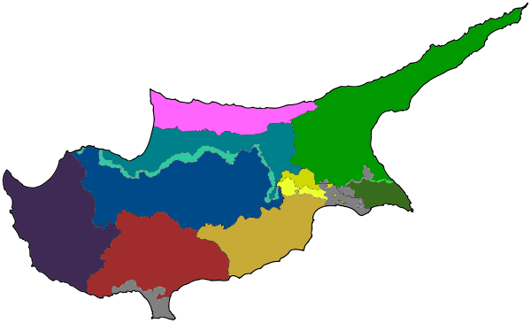
Figure 76: The Republic of Cyprus administrative divisions
In more detail:
- The Famagusta district, with the main town Famagusta which is the island´s most important port.
- The Kyrenia district, with the main town Kyrenia. It is the smallest district of Cyprus and the only one controlled entirely by the TRNC.
- The Nicosia district, with the main town Nicosia (or Lefkosia) which is also the island country´s capital city. The northern part of the district is controlled by the TRNC.
- The Larnaca district, with the main town Larnaca where the island´s primary airport is located. Part of the district is controlled by the TRNC.
- The Limassol district, with the main town Limassol.
- The Paphos district, with the main town Paphos, which is entirely controlled by the internationally recognised government of Cyprus. It is composed by four municipalities; Paphos, Yeroskipou, Peyia and Polis Chrysochous
- The two areas in grey colour, namely Akrotiri and Dhekelia, officially named the Sovereign Base Areas of Akrotiri and Dhekelia, is a British Overseas Territory on the island of Cyprus.

National crisis management & disaster response concept:
In Cyprus, crisis management and all emergency situations are handled by the Civil Defence, a governmental agency under the Ministry of Interior. Its main mission is to carry out various humanitarian actions intended to deal with the consequences of disasters, resulting either from natural actions (earthquake, flooding, hurricanes etc.) or from human actions (industrial accidents, armed conflicts etc.).
The members of the Civil Defence serve either at the General Directorate of Civil Defence (GDCD) or at one of the five regional managements (RMCD): Nicosia, Limassol, Larnaca, Paphos and Famagusta.
The RMCD offices operate five departments;
- Search, Rescue and Fire Fighting,
- First Aid department,
- Welfare department,
- Neighbourhood Watch department and
- Secretarial-Communications department.

Key stakeholders: Minister of Interior, GDCD, RMCDs, civil defence units (e.g. Search and rescue teams), community councils, Cyprus Red Cross, volunteers.

Financing: Other than civil protection purposes allocated to other government agencies 0.0452% of GDP is allocated for Cyprus Civil Defence/Protection organisation.

Furthermore, crisis management for Cypriots around the world is handled by the department of Crisis Management that belongs to the Ministry of Foreign Affairs. Under a crisis situation, this department is responsible for the risk evaluation and to provide recommendations on the best management and most possible actions to the Permanent Secretary of the Ministry of Foreign Affairs, such as repatriation of Cypriot citizens.

Table of Contents
CYPRUS Policy, Legislation, Organisation, Procedures & Capabilities (PLOPC) in crisis management and disaster response 466
Overview 467
Table of Contents 469
List of Figures 471
List of Tables 471
List of Abbreviations 472
1 Policy 473
1.1 Risk Assessment 473
1.2 Policy and Governance 475
1.2.1 Strategy scope and focus 477
1.2.2 Monitoring and analytical support to policy making; R&D 477
1.2.3 Policy for Prevention 479
1.2.4 Policy for Preparedness 479
1.2.5 Policy for Response 479
1.2.6 Policy for Relief and Recovery 479
1.3 Financing 480
1.3.1 Investing in preparedness 480
1.3.2 Investing in consequence management 480
1.4 Policy review, Evaluation & Organisational Learning 480
1.4.1 Post-Disaster Assessment 480
1.4.2 Departmental Lessons Learned systems 481
1.4.3 Centralised (national) Lessons Learned system 481
1.4.4 International exchange for Lessons Learned 481
1.4.5 Regular policy reviews 481
1.5 Resilience 481
1.6 Information sharing and data protection 481
2 Legislation 482
2.1 Crisis (emergency, disaster) management concept 482
2.2 General crisis (emergency, disaster) management law 482
2.3 Emergency rule 482
2.4 Specific, department/agency-level legal arrangements and regulations on emergency and disaster management 482
2.5 Specific to the regional and local authorities legal arrangements and regulations on emergency and disaster management 483
2.6 Legal regulations on the involvement of volunteers and specialised NGOs 483
2.7 Legal regulations for international engagements of first responders and crisis managers 483
3 Organisation 484
3.1 Organisational chart 484
3.2 Organisational cooperation 485
4 Procedures 487
4.1 Standing Operating Procedures (SOPs) and Guidelines 487
4.2 Operations planning 487
4.3 Logistics support in crises 487
4.4 Crisis communication to general public; Alert system; Public Information and Warnings 487
5 Capabilities 489
5.1 Human resources 489
5.2 Materiel (non-financial) resources 489
5.3 Training 490
5.4 Procurement 490
5.4.1 Procurement regulation 490
5.4.2 Procurement procedures 490
5.5 Niche capabilities 490
Resources 491
Legislative acts 491
Other normative acts 491
Official documents (white papers, strategies, etc.) 491
Online resources (e.g. websites of key CM organizations) 491
Publications 492
Expert interviews 492

List of Figures
Figure 1: The Republic of Cyprus administrative divisions 467
Figure 2: Frequency of disasters in Cyprus 1990 - 2014 473
Figure 3: Mortalities as a consequence of disasters in Cyprus 1990 - 2014 474
Figure 4: Economic effect of disasters in Cyprus 1990 - 2014 474
Figure 5: The R&D landscape of Cyprus 478
Figure 6: Organisational chart of the Civil Defence organisations in Cyprus 484
Figure 7: Cyprus civil defence organisational chart 485

List of Tables
Table 1: Major disasters in Cyprus. 475

List of Abbreviations
AMC | Assessment Mission Course
ECHO | EU Humanitarian Aid and Civil Protection
EU | European Union
GDCD | General Directorate of Civil Defence
NRIC | National Research and Innovation Council
RMCD | Regional Management of Civil Defence
SRC | Scientific Research Council
TRNC | Turkish Republic of Northern Cyprus

Policy

Risk Assessment
In Cyprus key risks and areas of concern are natural and man-made hazards, such as earthquakes, large fires, floods and marine pollution.
The Civil Defence department is the responsible authority in Cyprus for the execution of different measures for the prevention and control and management of all concequencies related to natural and manmade disasters.
Cyprus has a major earthquake about every 10 years. During the 20th century there were recorded 30 incidents and 400 injured. The Paphos district is considered as a high risk area for earthquakes, where the last three major earthquakes occurred; in 1953 with 63 dead, in 1995 with 2 dead and in 1996 with no fatalities. Similarly, floods and tornados are quite rare with a very small number of casualties. On the other hand, technological accidents and fires, especially in periods of extreme temperature, are more common with about ten large incidents per year.
Based on the disasters recorded for Cyprus in the OFDA/CRED - International Disaster Database between 1990 and 2014, the following figures demonstrate the frequency, mortality and economic effect of the disasters.
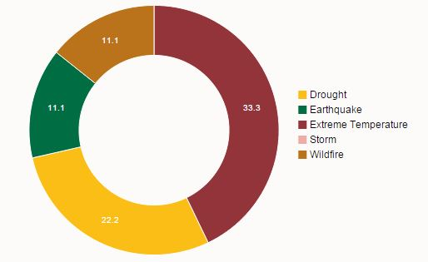
Figure 77: Frequency of disasters in Cyprus 1990 - 2014
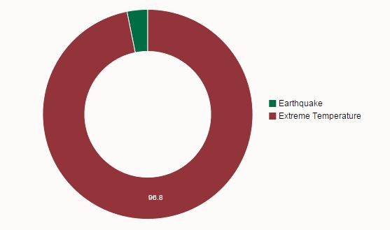
Figure 78: Mortalities as a consequence of disasters in Cyprus 1990 - 2014
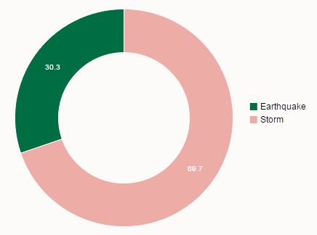
Figure 79: Economic effect of disasters in Cyprus 1990 - 2014
The following table lists the major disasters occurred in Cyprus in the last 25 years.

Table 24: Major disasters in Cyprus.
Year | Disasters
2009 | Tornado
2008 | Forest fire
2007 | Forest fire
2007 | Extreme temperature, Nicosia, 4 dead
2005 | Drought
2005 | Transport accident, 31 dead, 8 people affected
2004 | Storm, Larnaca, 10 people affected
2003 | Tornado, Limassol, Larnaca, 30 people affected, estimated damage USD 10 million
2000 | Wildfire, Larnaca Sud
2000 | Extreme temperature, Nicosia, 5 dead, 400 people affected
2000 | Drought
1998 | Fire at a military base, Episkopi, 692 people affected
1998 | Extreme temperature, 52 dead, 100 people affected
1996 | Viral meningitis epidemic, Limassol, Larnaca, Nicosia, 280 people affected
1995 | Earthquake, seismic activity and ground shaking, Paphos and Nicosia areas, 2 dead, 1865 people affected, estimated damage USD 4.34 million
1991 | Drought
1983 | Storm
1970 | Storm
1970 | Cholera epidemic
1969 | Storm, Limassol, 3 dead, 3100 people affected, estimated damage USD 0.1 million
1953 | Earthquake, seismic activity and ground shaking, south-west, 40 dead, 100 people affected

Policy and Governance
Cyprus has a main national plan for crisis management with the code name “Zenon”. The main objective of this basic plan is to define the framework and to provide clear instructions for the complete organisation and functioning of the state system for crises management in the peacetime, by providing detailed allocation of responsibilities and obligations of ministries and state agencies.
The basic national plan “Zenon” is the institutional framework and guide to the ministries, who use it as a bases for the design and preparation of the individual specific plans, which encode 22 different situations and scenarios, such as the case of major disasters, technological accidents, terrorist attacks, Middle East crisis, large coastal pollution and others which fall in the responsibilities of the corresponding ministries.
The plan considers six main threats and defines the responsibilities of the Ministries of the Government:
- Earthquakes whose primary responsibility for the co-ordination of relief activities rests on the Ministry of Interior - Civil Defence Force.
- Forest Fires where the primary responsibility belongs to the Department of Forest of the Ministry of Agriculture, Natural Resources and Environment.
- Rural Fires whose responsibility lies under the Cyprus Fire Service (which belongs under the jurisdiction of the Ministry of Justice and Public Order through the Police). The Cyprus Fire Service is responsible for fighting rural fires which are up to a distance of 1km from forests boundaries. The Fire Service is also responsible for fighting urban fires and those at airports.
- Marine Pollution where the primary responsibility rests on the Fisheries Department of the Ministry of Agriculture, Natural Resources and Environment. An existing contingency plan establishes the necessary arrangements for the effective and timely response to a marine pollution incident. A Regional Agreement has been signed between Cyprus, Egypt, and Israel to combat major pollution accidents in the Eastern Mediterranean.
- Radiological emergencies where the responsibility lies to the Ministry of Labour, Social Welfare and Social Insurance.
- War whose responsibility lies with the Ministry of Interior - Civil Defence Force.
Some of the specific plans based on the master plan “Zenon” are listed below:
- Enceladus for earthquakes: in the first phase, a detailed analysis of all data and information is carried out so that all necessary services are mobilized. Then it is assessed whether Cyprus will need additional assistance from the EU or the UN. The second phase provides for setting up crisis and coordination centres.
- Electra plan on preparedness and response on extraordinary Radiological or Nuclear Incidents that might affect a large population.
- Estia plan that involves the mass evacuation and repatriation of citizens via Cyprus from the Middle East region, with the participation of thirteen more countries (Australia, Austria, Belgium, France, Germany, Denmark, Spain, Italy, Canada, UK, USA, Norway and The Netherlands).
- SEVESO plan, for the crisis management in the event of a major technological incident, based on the implementation of the European Directive “SEVESO”.
- Ifestos plan, for the crisis management in the event of forest fires.
- National health plan, in order to ensure a health system of the country that is human-centred, emphasizing the prevention and aims at strengthening social contribution through continuous upgrading service with professionalism and respect, equal rights for all citizens.

Strategy scope and focus
The Civil Defence in Cyprus is taking preparedness measures in response to natural or man-made disasters, the size of which can be dangerous for the life and welfare of the civilians or may cause extensive damage to the environment and the natural resources of the Republic. These measures include a series of actions for prevention, preparation, response, design, education and mitigation of disasters. As a Civil Defence force, its mission extends beyond to what is usually encompassed in civil protection priorities, so as to also include the protection and relief of non-combatant populations during military clashes, and the preservation to the maximum possible of morale and order. They cover a wide range of afflictions and continuous efforts are made in order to modernize and harmonize the policy and governance for crisis management in the country along with the developments in the European Union.

Monitoring and analytical support to policy making; R&D
With the aim to bring all Research / Technological Development / Innovation activities under the management of appropriate entities, which will have a co-operational and complementary role in the implementation of the national strategic objectives, there was a restructure in the research policy making system in Cyprus through the National Strategic Plan for Development for the period 2007-2013.
As mentioned in the Monitoring Policy and Research Activities on Science in Society in Europe (MASIS) National Report for Cyprus, the main actors within the Cyprus’ structure for the research policy making system are:
- The National Research and Innovation Council (NRIC). The highest and main responsible body within the new structure for the drawing of the long-term Cyprus policy in the research, technological development and innovation sectors.
- The Scientific Research Council (SRC). Its aim is to provide assistance and support to the NRIC on policy and strategic issues related to the research, technological development and innovation sectors.
- The Planning Bureau. It constitutes the administrative “arm” of the NRIC, playing mainly a coordinating role in the drawing of long-term policies in the Research, Technological Development an Innovation sectors, and the representation of Cyprus in the relevant European Union bodies.
- The Research Promotion Foundation. It constitutes the executive entity of the new system, realizing the long-term policies of Research, Technological Development and Innovation mainly through the implementation of the National Framework Programs.
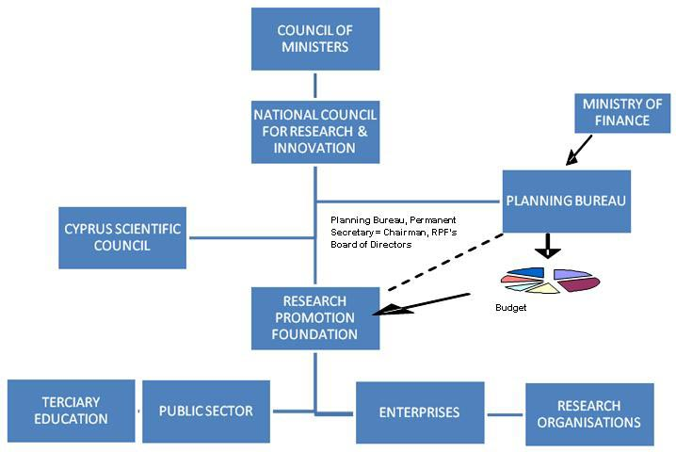
Figure 80: The R&D landscape of Cyprus
Cyprus is also participating in numerous research and other projects in relation to crisis management, contributing to both policy making as well as any disaster risk reduction measures. Some examples of finalised projects:
- EUTAC - European Technical Assistance Cooperation (http://www.juh-ipc.eu/eutac/)
The project´s aim was to develop a Technical Assistance and Support Team for an assistance of EU Civil Protection interventions, through the creation of Assessment Mission Kits and Technical Assistance Support Teams.
- QuestCity (http://www.juh-ipc.eu/questcity/)
QuestCity – a free social game (http://www.questcity.eu/) in which the players are confronted to a variety of emergency situations and asked to avert dangers and harms from themselves or others by providing adequate assistance while awarded with virtual incentives. In the European project consortium of this project participated also the Civil Defence department of the Ministry of Interior of the Republic of Cyprus as an associated beneficiary.
GDCD also participates in ongoing projects, such as the PACES project (http://www.paces-project.eu/index.php/en/) which is a 2-year project and started in 2016. It is co-funded by the EU Humanitarian Aid & Civil Protection, in the area of preparedness in Civil Protection and Marine Pollution under Grant Agreement no ECHO/ SUB/2015/713774/PREP04.

Policy for Prevention
GDCD takes certain prevention and preparedness measures, in co-operation with other involved services, in order to respond in the event of a disaster. Such preventative measures are the following:
- Preparing Action Plans such as the "Enceladus", for earthquakes
- Carrying out various exercises, with different possible scenarios
- Training, equipping and exercising department personnel
- Providing information to the population at regular intervals
- Constructing and designing shelters

Policy for Preparedness
In addition to the prevention efforts, Cyprus’ efforts regarding preparedness are supported by the EU Civil Protection Mechanism training program aiming in improving the level of preparedness of the systems for civil protection systems, their personnel and the rest of the population. These projects tend to be used to develop new concepts or models.
Furthermore, GDCD has installed in Cyprus and monitors a warning system for its population, more specifically an electronic siren system, which allows GDCD to alert the public with alarms, live transmissions and pre-recorded voice messages.

Policy for Response
In the case of disasters, the responsible forces for response depend on the disaster, such as the police or the fire service, according to the specific plans for each disaster. GDCD is not a direct response force, but is prepared to act and provide assistance tot eh other services in case of a major disaster. Moreover, the Civil Defence Rescue department under the GDCD is organised to respond immediately in case of emergencies and if the remaining authorised forces of the state services require assistance. The rescue teams of the Civil Defence Rescue department continually go through training and special exercises in equipped training grounds and also take part in firefighting conditions as well as water plumping during floods.

Policy for Relief and Recovery
The Welfare Department of the Civil defence in Cyprus is in charge of the performance of different types of humanitarian tasks that aim to protect the civilian population from different dangers and to help them recover from the immediate effects of disasters or war hostilities and also provide them with the necessary conditions for their survival, such as shelters, catering and clothing for the homeless, psychological support to the victims and generally provide relief to the population in the event of a disaster.
The mission of the First Aid Department of the Civil defence in Cyprus is to provide First Aid service in the event of a disaster, until medical assistance becomes available. Also the Joint Rescue Coordination Centre organizes the search and rescue system of the Republic in order to be able to find and rescue in the least possible time people whose lives are threatened as a result of an air or naval accident.
For mass emergency catering purposes, there is a special Civil Defence Catering Plan, to be implemented in co-operation with other services. To implement the plan, Civil Defence has a mobile catering unit, the operation of which is undertaken by specially-trained personnel. The unit takes part in exercises to ensure readiness in the event of an emergency.
Civil Defence has implemented a programme for the construction and design of shelters, mainly in the urban areas. For this purpose, civil engineers designed additions and alterations to suitable basements, with the owners’ consent, to render them safe for short periods of stay and protection of the civil population. A large number of shelters have already been completed.
Restoration of damage service, headed by the Director of Civil Defence, was introduced after the earthquake in Paphos in 1995, to house the afflicted and to repair damage. The 1996, 1998 and 1999 earthquakes followed in Limassol and Paphos. The service’s activities continued during the Limassol tornado in 2003 and the flooding in Nicosia in 2004. During these disasters, the service provided grants to restore the damages. In addition to the above, it had an advisory role in the earthquake control programmes and in upgrading refugee housing estates, schools and other public buildings.

Financing
Other than civil protection purposes allocated to other government agencies 0.0452% of GDP is allocated for Cyprus Civil Defence/Protection organisation.
Furthermore, there is an ongoing support from the Participating States to the EU Civil Protection Mechanism in which participating states, like Cyprus, may find funding from 2.800.000 EUR, for both, Prevention and Preparedness projects².

Investing in preparedness
Information on this subject could not be found.

Investing in consequence management
Information on this subject could not be found.

Policy review, Evaluation & Organisational Learning

Post-Disaster Assessment
Information on this subject could not be found.

Departmental Lessons Learned systems
Information on this subject could not be found.

Centralised (national) Lessons Learned system
Information on this subject could not be found.

International exchange for Lessons Learned
Cyprus, as a member of the European Union and ECHO, is participating to the European Experts training and exchange programme. The Civil Protection Mechanism's experts exchange system allows for the secondment of civil protection experts to participating states. This exchange of experts provides participants with knowledge and experience on all aspects of emergency intervention and the different approaches of national systems. In Cyprus, GDCD has the coordinating role of the experts exchange programme.

Regular policy reviews
The detailed plans for Civil Protection, based on the master plan “Zenon” are revised and updated every 6 to 12 months by the responsible bodies.

Resilience
Information on this subject could not be found.

Information sharing and data protection
Information on this subject could not be found.

Legislation

Crisis (emergency, disaster) management concept
The responsibility of the civil defence rests in general with the Ministry of the Interior. The Minister of the Interior, on behalf of the Council of Ministers, is responsible for the implementation of the Civil Defence Act and the relevant regulations as well as the overall supervision and control of the civil defence system. He coordinates services and organisations which are declared as essential for the civil defence purposes.

General crisis (emergency, disaster) management law
The Civil Defence Act was amended and consolidated in 1996, and new regulations were enacted in 1997 in order to reorganise and strengthen the whole civil defence system of the republic. These regulations were then updated as shown below:
- In 2004 and to comply with the EC Act with the Directive 96/82/EK of the council of the 9th of December 1996 for the tackling of major accident hazards involving dangerous substances.
- In 2006 updated in order to comply with the EC Act with title “Directive 2003/105/EK of the European Commission and the council of the 16th of December 2003 for the amendment of the Directive 96/82/EK of the Council for the tackling of major accident hazards involving dangerous substances”.

Emergency rule
In case of war or disaster which requires mass mobilization of human resources or means, the Council of Ministers or the Minister of the Interior on behalf of the Council may declare a "State of Civil Defence" for 48 hours (an extension of this period requires the approval of the House of Representatives).

Specific, department/agency-level legal arrangements and regulations on emergency and disaster management
The Council of Ministers may declare the administration of any Ministry or any Governmental Department/Service or Independent Office or any Public or Private Corporation an "essential service" for civil defence purposes. Any such declaration has a legal effect on the "essential services" concerned in terms of planning, training, preparedness and response, in order to be able to participate effectively in the civil defence system.

Specific to the regional and local authorities legal arrangements and regulations on emergency and disaster management
Members of Civil Defence serve either at the General Directorate of Civil Defence (GDCD) or at one of the five regional managements (RMCD): Nicosia, Limassol, Larnaca, Paphos and Famagusta.
Under every Regional Management, operate Civil Defence Stations and Substations in the towns and within the communities. This is where the volunteers and the citizens serving the Civil Defence attend for training and exercises. Attendance is on fixed days and times of the week. In communities where there are no Civil Defence units, organisation is carried out in co-operation with Community Councils.

Legal regulations on the involvement of volunteers and specialised NGOs
All citizens of the Republic of Cyprus aged over 16 years old have the duty to serve the Civil Defence force for a period that does not extend the two years. Males usually serve the Civil Defence after they have been released from the National Guard duties. Enrolment takes place once a year, following a decision of the Council of Ministers. The notification is issued by the Minister of Interior, and calls male and female citizens to serve and obliges the called citizens to attend a specified unit and enrol either in the town or in the countryside. During their service, members attend training and exercise on fixed days and time in first aid, border guard and communications.
Furthermore, anyone aged over 16 years old has the right to request to join voluntarily the Civil Defence and offer his/her services as a member.

Legal regulations for international engagements of first responders and crisis managers
Cyprus is member of various international organisations in relation to crisis management and response. Some of them are listed below:
- The EU Civil Protection Mechanism
- In 2004 Cyprus Civil Defence Rescue Team got the INSARAG certification and became a member. INSARAG is a global network of more than 80 countries and organisations under the United Nations and deals with urban search and rescue related issues.
- The Organisation for Security and Co-operation in Europe (OSCE).

Organisation

Organisational chart
According to the study made on the Stock-taking of existing critical infrastructure protection activities for the European Commission by Booz & Company,
“The management of emergencies in Cyprus relies on the Civil Defence organisations.
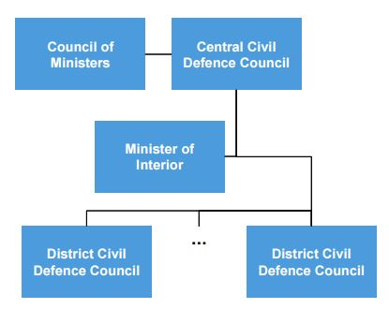
Figure 81: Organisational chart of the Civil Defence organisations in Cyprus
- The Minister of Interior on behalf of the Council of Ministers55 is responsible for the implementation of the Civil Defence Law and the relevant regulations and has the overall supervision and control of the Civil Defence System. Accordingly, Civil Defence in general is under the responsibility of the Ministry of Interior.
- The Council of Ministers may declare the administration of any Minister, any Governmental Department/Service or Independent Office, or any public or private corporation, as an “Essential Service” for Civil Defence purposes. Any such declaration has legal implications for the services concerned. It requires them to undertake planning and training, improving their preparedness and response capabilities in order to participate effectively in the Civil Defence System. The Council of Ministers may appoint a Central Civil Defence Council.
- Civil Defence is a Department of the Ministry of Interior and its primary mission is the execution of measures to prevent natural or manmade disasters and to overcome their consequences.
The Council of Ministers approves the General Civil Defence Plan, which defines the role, duties and responsibilities of all bodies of the civil defence system. According to these roles, duties and responsibilities, each body (mainly the "essential services") has to elaborate civil defence plans in order to deal with contingencies, which may arise either because of war or disaster. The plans are submitted to the Central or District Civil Defence Councils (according to their level) for checking and coordination.
In the event of a crisis, the members of the ministerial team for crisis management consist of the Minister of Foreign Affairs, the Minister of Interior, the Minister of Transport and Public Works, the Minister of Energy, Commerce, Industry and Tourism and the Minister of Labour and Social Security, or their representatives.
The figure below gives an outline of the organisational structure of the Disaster Management structure in Cyprus which is handled by the Civil Defence headquarters or GDCD, under the Ministry of Interior. Within the GDCD operate the five regional Civil Defence administrations, the RMCDs, in Nicosia, Limassol, Larnaca, Paphos and Ammochostos.
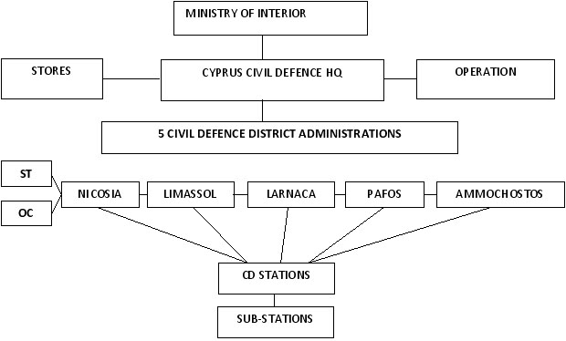
Figure 82: Cyprus civil defence organisational chart

Organisational cooperation
The republic of Cyprus is a member state of the following platforms and organisations:
European and Mediterranean Major Hazards Agreement (EUR-OPA)
Created in 1987, the European and Mediterranean Major Hazards Agreement (EUR-OPA) is a platform for co-operation between European and Southern Mediterranean countries in the field of major natural and technological disasters. Its field of action covers the knowledge of hazards, risk prevention, risk management, post-crisis analysis and rehabilitation.
Website: http://www.coe.int/en/web/europarisks/home

International Civil Defence Organisation (ICDO)
The International Civil Defence Organisation (ICDO) is an intergovernmental organisation with the objective to contribute to the development by States of structures ensuring the protection and assistance of population and safeguarding property and the environment from natural or man-made disasters.
Website: http://www.icdo.org/

Procedures

Standing Operating Procedures (SOPs) and Guidelines
Information on this subject could not be found.

Operations planning
As mentioned in Cyprus Civil Defence: Structure, capabilities, history, manpower,
The Civil Defence Administrative Operations Control Centre operates with a permanent staff on a 24-hour basis, which gives great capabilities to the Republic of Cyprus.
One of these is the link with the EU Emergency Response Coordination Center (ERCC), that uses the Common Emergency Communication and Information System (CECIS system), and includes all member states and countries that have signed a Memorandum of Understanding with the Directorate Humanitarian Aid and Civil Protection. The Operations Control Centre is the National Contact Point for European Community Urgent Radiological Information Exchange (ECURIE) to monitor ionizing radiation in Europe, and transmits the information to the Ministry of Labour and Social Insurance, which is competent for applying the legislation.
The Centre is also the National Contact Point of the European Management Safety Agency (EMSA) in monitoring water pollution in Europe. The information is transmitted to the Fisheries Department, which is responsible for pollution control.
Furthermore, the Centre is responsible for monitoring the electronic sirens system, operating wireless networks, handling information systems, and for the operation of the Centre as a Command Centre in the event of mobilization.
In addition to the above, Civil Defence has at its disposal multifunctional mobile operations control centres.

Logistics support in crises
Information on this subject could not be found.

Crisis communication to general public; Alert system; Public Information and Warnings
The Civil Defence Administrative Operations Control Centre operates with a permanent staff on a 24-hour basis, which gives great capabilities to the Republic of Cyprus.
Some of the main responsibilities of this Centre are monitoring the electronic sirens system, operating wireless networks, handling information systems, and for the operation of the Centre as a Command Centre in the event of mobilization. In addition to the above, Civil Defence has at its disposal multifunctional mobile operations control centres.
Civil Defence has set up an electronic siren network in towns and communities to warn the population in the event of a threat of a natural disaster or hostile air activities. The siren network has the following abilities:
- to sound the alarm
- to transmit a mobilisation signal
- to transmit vocal messages
When the sirens sound, citizens are obliged to follow both Civil Defence instructions and those of other essential services. Additional analytical information on the subject is provided on the special Civil Defence leaflets, entitled "Black-out" and "Alarm".
Cyprus Civil Defence has established a reliable wireless communication system within its units and other state services, municipalities and communities. This modern system has island-wide range and it is very important in case the telephone network breaks down in the event of a major disaster.

Capabilities

Human resources
In order to prepare for, respond and train to disasters, the Civil Defence Force consists of:
- a permanent and well-organised staff of 33 persons
- an interchangeable staff of 45 persons
- around 600 volunteers serving under special terms island-wide
- around 7000 male and female citizens serving Civil Defence island-wide
Other important resources of the civil defence in Cyprus are private and public organisations that have been declared "essential" for civil defence purposes as well as volunteers such as the Cyprus Red Cross and St John Ambulance and other local associations.

Materiel (non-financial) resources
The Welfare Department is responsible for providing shelters, catering and clothing for the homeless, psychological support to the victims and generally provide relief to the population in the event of a disaster.
Civil Defence has implemented a programme for the construction and design of shelters, mainly in the urban areas. For this purpose, civil engineers designed additions and alterations to suitable basements, with the owners’ consent, to render them safe for short periods of stay and protection of the civil population.
For mass emergency catering purposes, there is a special Civil Defence Catering Plan, to be implemented in co-operation with other services. To implement the Plan, Civil Defence has a mobile catering unit, the operation of which is undertaken by specially-trained personnel. The unit takes part in exercises to ensure readiness in the event of an emergency.
In case of war or disaster which requires mass mobilization of human resources or means, the Council of Ministers or the Minister of the Interior on behalf of the Council may declare a "State of Civil Defence" for 48 hours (an extension of this period requires the approval of the House of Representatives).

Training
The personnel of all departments and services of the Civil Defence undergo training both in Cyprus and abroad on a constant basis. The Cyprus Civil Defence members are trained as well as the staff of the essential services and departments.
The volunteers and the citizens serving the Civil Defence attend for training and exercises in the Civil Defence Stations and Substations in the towns and within the communities, under every Regional Management. Attendance is on fixed days and times of the week. In communities where there are no Civil Defence units, organisation is carried out in co-operation with Community Councils.
National, regional and local exercises are run, including the following:
- Earthquake exercises, among these “Egkelados”
- Seveso II exercise
- Search and rescue exercises
- Welfare exercises.
GDCD also takes part in international exercise programmes such as the Assessment Mission Course (AMC), a specialised course for the target group of technical and assessment experts in the field of emergency management and European Commission officials. Further information can be found in http://www.juh-ipc.eu/amc/.
The GDCD is also a partner in the very complex training called “Exercise Unified Response – EUR15” under the EU Civil Protection Mechanism which is scheduled for the 23rd of February to the 3rd of March 2016 in London. Further details on the exercise can be found in http://www.london-fire.gov.uk/exercise-unified-response.asp.

Procurement

Procurement regulation
Civil defence specific information could not be found.

Procurement procedures
Civil defence specific information could not be found.

Niche capabilities
N/A

Resources

Legislative acts
- Act 3111/1996 (Government Gazette 117(I) / 31.12.1996), Civil Defence Law
- Additional Act 3170/1996 (Government Gazette 221 / 25.07.1997) , Modification of Civil Defence Law
- Additional Act 3853/2004 (Government Gazette 509 / 30.04.2004) , Modification of Civil Defence Law
- Additional Act 4084/2006 (Government Gazette 605 / 10.03.2006) , Modification of Civil Defence Law

Other normative acts
N/A

Official documents (white papers, strategies, etc.)
- Zenon plan
- EGGELADOS plan – for earthquakes
- ESTIA – major middle east crisis
- Fire Service Union Officers. Implementation of the European Directive “SEVESO” in Cyprus. Definition of measures and conditions to address risks of major accidents in establishments or plants due to the existence of hazardous substances. April 2015.
- IFESTOS – evacuation from forest fires
- Ministry of Health: Strategic Plan 2016-2018, July 2015.
- Ministry of Labour, Social Welfare and Social Insurance, Special National plan “Electra” for preparedness and response in extraordinary radiological and nuclear incidents. 2015.
- Civil Defence, Annual Report 2011, Ministry of Interior, Republic of Cyprus, February 2012
- Civil Defence, Structure, Capabilities, History, Manpower, Cyprus Civil defence, Republic of Cyprus, 2014
- Sustainable Development Strategy, 2007. Cyprus

Online resources (e.g. websites of key CM organizations)
- Civil Defence - www.moi.gov.cy/cd
- Cyprus Red Cross Society - http://www.redcross.org.cy/
- Cyprus Joint Rescue Coordination Center - http://www.mod.gov.cy/
- Ministry of foreign affairs of the Republic of Cyprus, Crisis Management Centre - http://www.mfa.gov.cy/mfa/mfa2006.nsf/consular06_en/consular06_en?OpenDocument
- E-PS Public Procurement Portal of the Republic of Cyprus - https://www.eprocurement.gov.cy/ceproc/
- EU Humanitarian Aid and Civil Protection department - http://ec.europa.eu/echo/
- Cypriot National Guard - http://www.army.gov.cy/
- Cyprus Fire Service - www.fs.gov.cy
- Cyprus Police - www.police.gov.cy
- Department of Forests - http://www.moa.gov.cy/moa/fd/fd.nsf/
- International Search and Rescue Advisory Group (INSARAG - http://www.insarag.org/
- World Trade Organization - https://www.wto.org/
- Organisation for Security and Co-operation in Europe (OSCE) - http://www.osce.org/
- eProcurement - https://www.eprocurement.gov.cy/ceproc

Publications
- Single European emergency Call Number 112 – 112 leaflet
- Chrisostomou Kristis, Seismic Protection of Cyprus, October 2009
- Dimopoulos, Christos, Monitoring Policy and Research Activities on Science in Society in Europe. National Report, Cyprus. October 2011
- BeSafeNet Booklet, Cyprus Civil Defence and Europa
- Republic of Cyprus, Cyprus Civil Defence: Structure, capabilities, history, manpower. 2014
- Booz & Company, Stock-taking of existing critical infrastructure protection activities, European Commission, October 2009

Expert interviews
N/A

Cyprus, last modified on 2 February 2016, https://en.wikipedia.org/wiki/Cyprus
Government in exile, last modified on 2 February 2016, https://en.wikipedia.org/wiki/Government_in_exile
Cyprus, last modified on 2 February 2016, https://en.wikipedia.org/wiki/Cyprus
Akrotiri and Dhekelia, last modified on 27 January2016, https://en.wikipedia.org/wiki/Akrotiri_and_Dhekelia
Cyprus Civil Defense and Disaster Management Arrangements, Accessed February 11, 2016. http://www.cyprus-storms.net/cypruscivildefense.htm
EM-DAT (Feb. 2015) - The OFDA/CRED - International Disaster Database http://www.emdat.be - Université catholique de Louvain Brussels - Belgium
Cyprus: Disaster & Risk Profile, Basic Country Statistics and Indicators (2014), Accessed February 11, 2016. http://www.preventionweb.net/countries/cyp/data/
Cyprus: Disaster & Risk Profile, Basic Country Statistics and Indicators (2014), Accessed February 11, 2016. http://www.preventionweb.net/countries/cyp/data/
Cyprus: Disaster & Risk Profile, Basic Country Statistics and Indicators (2014), Accessed February 11, 2016. http://www.preventionweb.net/countries/cyp/data/
Minister of Defense: Cyprus a country standard for crisis management, Accessed February 11, 2016. http://www.sigmalive.com/news/politics/72963/yp-amynas-i-kypros-xoraprotypo-gia-diaxeirisi-kriseon#.dpuf
Booz & Company, Stock-taking of existing critical infrastructure protection activities, European Commission, October 2009
Chrisostomou K., Seismic Protection of Cyprus, October 2009.
Ministry of Labour, Social Welfare and Social Insurance, Special National plan “Electra” for preparedness and response in extraordinary radiological and nuclear incidents. 2015.
Fire Service Union Officers. Implementation of the European Directive “SEVESO” in Cyprus. Definition of measures and conditions to address risks of major accidents in establishments or plants due to the existence of hazardous substances. April 2015.
Chrysiliou C., Emergency Plans of Action in case of a disaster in Cyprus: Evacuating the old, disabled and younger people, Civil Defence.
Ministry of Health: Strategic Plan 2016-2018, July 2015.
Papazoglou P. and Paris N., (CyCDF). Cyprus Safety Platform 2nd Symposium on Man-Made Catastrophes - January 2013
Sustainable Development Strategy, 2007. Cyprus
Dimopoulos, Christos, Monitoring Policy and Research Activities on Science in Society in Europe. National Report, Cyprus. October 2011
The R&D Landscape in Cyprus, Accessed February 11, 2016. http://www.euraxess.org.cy/services_incoming_practical_info_1.shtm
QuestCity Partners, accessed February 8, 2016. http://www.juh-ipc.eu/questcity/questcity-partners/
CCD – Cyprus Civil Defence, Cyprus Civil Defense and Disaster Management Arrangements, Accessed February 11, 2016. http://www.cyprus-storms.net/cypruscivildefense.htm
Cyprus Joint Rescue Coordination Center, Mission, accessed February 11, 2016. http://www.mod.gov.cy/mod/CJRCC.nsf/cjrcc01_en/cjrcc01_en?OpenDocument
Republic of Cyprus, Cyprus Civil Defence: Structure, capabilities, history, manpower. 2009
Humanitarian Aid and Civil Protection. Civil Protection Excercises. 2015. http://ec.europa.eu/echo/funding-evaluations/financing-civil-protection/civil-protection-exercises_en
Cyprus fully prepared for natural disasters, Famagusta Gazette, Accessed February 12, 2016. http://famagusta-gazette.com/cyprus-fully-prepared-for-natural-disasters-p24959-69.htm
Cyprus Civil Defense and Disaster Management Arrangements, Accessed February 11, 2016. http://www.cyprus-storms.net/cypruscivildefense.htm
Cyprus Civil Defense and Disaster Management Arrangements, Accessed February 11, 2016. http://www.cyprus-storms.net/cypruscivildefense.htm
Vademecum - Civil Protection, Cyprus - Disaster management structure, Accessed February 11, 2016. http://ec.europa.eu/echo/files/civil_protection/vademecum/cy/2-cy-1.html
National Report – Cyprus. Study on Volunteering in the European Union. 2011
Republic of Cyprus, Cyprus Civil Defence: Structure, capabilities, history, manpower. 2009
Ministry of Defence, Civil Defence, Accessed February 11, 2016. http://www.moi.gov.cy/moi/cd/cd.nsf
International Search and Rescue Advisory Group (INSARAG), Accessed February 12, 2016. http://www.insarag.org/
Prodromou M., Cyprus Civil Defence - Prometheus presentation, April 2013
Organisation for Security and Co-operation in Europe (OSCE), Accessed February 12, 2016. http://www.osce.org/
Booz & Company, Stock-taking of existing critical infrastructure protection activities, European Commission, October 2009
Booz & Company, Stock-taking of existing critical infrastructure protection activities, European Commission, October 2009
Minister of Defense: Cyprus a country standard for crisis management, Accessed February 11, 2016. http://www.sigmalive.com/news/politics/72963/yp-amynas-i-kypros-xoraprotypo-gia-diaxeirisi-kriseon#.dpuf
Vademecum - Civil Protection, Cyprus - Disaster management structure, Accessed February 11, 2016. http://ec.europa.eu/echo/files/civil_protection/vademecum/cy/2-cy-1.html
Republic of Cyprus, Cyprus Civil Defence: Structure, capabilities, history, manpower. 2014
Republic of Cyprus, Cyprus Civil Defence: Structure, capabilities, history, manpower. 2014
Civil Defence, Structure, Capabilities, History, Manpower, Cyprus Civil defence, Republic of Cyprus, 2014
Vademecum - Civil Protection, Cyprus - Disaster management structure, Accessed February 11, 2016. http://ec.europa.eu/echo/files/civil_protection/vademecum/cy/2-cy-1.html
Booz & Company, Stock-taking of existing critical infrastructure protection activities, European Commission, October 2009
Civil Defence, Structure, Capabilities, History, Manpower, Cyprus Civil defence, Republic of Cyprus, 2014
Civil Defence, Structure, Capabilities, History, Manpower, Cyprus Civil defence, Republic of Cyprus, 2014
Vademecum - Civil Protection, Cyprus - Disaster management structure, Accessed February 11, 2016. http://ec.europa.eu/echo/files/civil_protection/vademecum/cy/2-cy-1.html
Cyprus fully prepared for natural disasters, Famagusta Gazette, Accessed February 12, 2016. http://famagusta-gazette.com/cyprus-fully-prepared-for-natural-disasters-p24959-69.htm
Republic of Cyprus, Cyprus Civil Defence: Structure, capabilities, history, manpower. 2009

