Driving Innovation in Crisis Management for European Resilience

AUSTRIA
Policy, Legislation, Organisation, Procedures & Capabilities (PLOPC) in crisis management and disaster response
Responsible Partner: AIT (Bettina Jager, Georg Neubauer)
  - Scope and limitations
This study serves as supporting information for further work within DRIVER.
Only limited time and budget has been available for this first general survey, which needs to be considered in terms of scope and completeness of the respective studies.
The author/s of this study is/are responsible for its content and quality.
This report was revised at the end of 2015, reviewed internally by CSDM and amended according to reviewer's comments and recommendations upon the decision of the author/s.

Overview
In 2003, the Ministry of the Interior became the main responsible federal organisation for the coordination of disaster protection management, crisis management and international disaster relief. In this context, the Federal Crisis and Disaster Protection Management was established and became a major pillar of civil defence in Austria. It defines the measures and responsibilities in crisis and disaster case on the basis of two fundamental principles: the principle of subsidiarity and the principle of solidarity. The first principle is a political maxim specifying that intervention measures have to be implemented in the sense of self-help acting on the lowest possible level, e.g. the local level. This implies a bottom-up principle ensuring that measures necessary to manage crisis and disasters, are as long as possible performed by local organizations. The second principle ensures that in a case of an event, which exceeds the capacities at the local level, the community mechanism to overcome the crisis and disasters will be activated, ensuring that challenges are tackled with the help from the next higher organisational level. While the departments at the federal state are mainly responsible for prevention and financial recovery measures, the authorities of the provinces operate as the core institutions in response to natural as well as other types of crisis and disasters. Therefore the provinces have been featured with special rights for governing this issue. In crisis and disaster cases the Federal Alarm Centre of the state acts as a central hub for the crisis staffs of the authorities. There the responsibility to alert and warn the general public in crisis and disaster situations has been located (Jachs 2011a). At its regional counterparts – the Alarm Centres of the Federal Provinces, the incoming emergency calls will be taken by authorized call takers, who have an overview about the available resources and can alert the competent operational organization. According to the magnitude of the disaster, proper authorities are assigned to manage the events. The governmental authorities of the provinces are authorized to assign accredited emergency service organisations with disaster relief duties.
Several accredited emergency services exist in Austria, such as the Red Cross, Arbeitersamariterbund (“Workers' Samaritan Association”) or the emergency helicopter C16. Moreover, the fire brigades, the water rescue, the rescue dogs brigade and the crisis intervention services need to be mentioned. In addition, the Austrian Armed Forces play an important role in the response to disasters. Apart from the duty of the national military defence, the protection of residuals and public facilities as well as the assistance in emergency cases are core tasks of the Austrian Armed Forces (Ministry of Defence and Sports 2014). After an official request, special units will be engaged independent from the fact, that the mission is taking place in Austria or abroad.
Austria benefits from initiatives of a well-established civil society. Voluntary organisations contribute to a network of civil defence at all spatial levels in Austria. Well-trained professionals and volunteers fulfil several duties in the area of civil protection. A longstanding expertise in risk assessment and a ramified network of cooperation with other countries and international organisations build a basis for comprehensive risk management capabilities in Austria. The knowledge-based approach will be continued in multiple projects within the context of cooperation between the science, industry and governmental stakeholders.
Although, there are no official statistics, the annual expenditures for preparedness measures of disaster management can be estimated at about 0.1 percent of GDP (status of 2013).

Table of Contents
AUSTRIA Policy, Legislation, Organisation, Procedures & Capabilities (PLOPC) in crisis management and disaster response 209
Overview 210
Table of Contents 211
List of Tables 213
List of Abbreviations 214
1 Policy 216
1.1 Risk Assessment 217
1.1.1 Natural hazards 220
1.1.1.1 Avalanche 220
1.1.1.2 Flood 222
1.1.1.3 Further hazards 224
1.1.2 Technological hazards 226
1.2 Policy and Governance 227
1.2.1 Strategy scope and focus 229
1.2.2 Monitoring and analytical support to policy making; R&D 230
1.2.3 Policy for Prevention 231
1.2.4 Policy for Preparedness 232
1.2.5 Policy for Response 233
1.2.6 Policy for Relief and Recovery 234
1.3 Financing 234
1.3.1 Investing in preparedness 234
1.3.2 Investing in consequence management 236
1.4 Policy review, Evaluation &Organisational Learning 236
1.4.1 Post-Disaster Assessment 236
1.4.2 Departmental Lessons Learned systems 237
1.4.3 Centralised (national) Lessons Learned system 237
1.4.4 International exchange for Lessons Learned 238
1.4.5 Regular policy reviews 238
1.5 Resilience 238
1.6 Information sharing and data protection 238
2 Legislation 241
2.1 Crisis (emergency, disaster) management concept 241
2.2 General crisis (emergency, disaster) management law 243
2.3 Emergency rule 244
2.4 Specific, department/agency-level legal arrangements and regulations on emergency and disaster management 245
2.5 Specific to the regional and local authorities legal arrangements and regulations on emergency and disaster management 246
2.6 Legal regulations on the involvement of volunteers and specialised NGOs 247
2.7 Legal regulations for international engagements of first responders and crisis managers 247
3 Organisation 248
3.1 Organisational chart 248
3.2 Organisational cooperation 250
4 Procedures 254
4.1 Standing Operating Procedures (SOPs) and Guidelines 254
4.2 Operations planning 254
4.3 Logistics support in crises 255
4.4 Crisis communication to general public; Alert system; Public Information and Warnings 256
5 Capabilities 258
5.1 Human resources 258
5.2 Materiel (non-financial) resources 259
5.3 Training 260
5.4 Procurement 261
5.4.1 Procurement regulation 261
5.4.2 Procurement procedures 262
5.5 Niche capabilities 263
Resources 264
Legislative acts 264
Other normative acts 264
Official documents (white papers, strategies, etc.) 265
Online resources (e.g. websites of key CM organizations) 266
Publications 267
Expert interviews 270
List of Figures
Figure 1: Climatic map of Austria 217
Figure 2: Pie chart over the occurrence of natural and technological disasters in Austria between 1994 and 2014 219
Figure 3: Spatial distribution of avalanche events in Austria 220
Figure 4: Forest Development Plan (FDP) of Austria 221
Figure 5: Spatial dispersion of torrential events 223
Figure 6: Epicentre map of Austria 224
Figure 7: Nuclear power stations in Austria's neighbouring states 226
Figure 8: Three-pillar-model of the Crisis and Disaster Management in Austria 227
Figure 9: Pie chart about the strategic focus on the phases of the Disaster Life-Cycle 230
Figure 10: Distribution of financial resources of the disaster fund 235
Figure 11: Distribution of funds for measures to protect against some natural hazards 236
Figure 12: Automatic online data exchange between Austria and neighbouring countries as well as link to the European platform EURDEP 239
Figure 13: Organizational Chart of the disaster management in Austria 248
Figure 14: Structure of the Coordination Committee in Disaster Management 249
Figure 15: Information flow in disaster situations between the EU and emergency response authorities in Austria 256
Figure 16: Structure of the Austrian Public Procurement System 262

List of Tables
Table 1: Overview on disasters in Austria from 1994 to 2014 (EDA 2014, PreventionWeb 2014), 218
Table 2: Overview on some relevant standards in the area of disaster management operations 254
Table 3: Overview on relief personnel for emergencies in Austria 259

List of Abbreviations
AMA | Agrarmarkt Austria
APCIP | Austrian Program for Critical Infrastructure Protection
ARC | Austrian Red Cross
ASBÖ | Arbeiter-Samariter-Bund Österreich
BFW | Federal Research and Training Centre for Forests, Natural Hazards and Landscape Austria
BKA | Federal Chancellery
BMASK | Federal Ministry of Labour, Social Affairs and Consumer Protection
BMeiA | Federal Ministry for Europe, Integration and Foreign Affairs
BMF | Federal Ministry of Finance
BMLFUW | Federal Ministry of Agriculture, Forestry, Environment and Water Management
BMVIT | Federal Ministry for Transport, Innovation and Technology
BVT | Federal Agency for State Protection and Counter Terrorism
BWZ | Federal Alarm Centre
CBRN | Chemical-biological-radiological-nuclear
CECIS | Common Emergency Communication and Information System
CIWIN | Critical Infrastructure Warning Information Network
EADRCC | Euro Atlantic Disaster Relief Coordination Centre
ECURIE | European Community Urgent Radiological Information Exchange System
EKC | Action and Crisis Coordination Centre
EKC | Emergency Operation and Coordination Centre
EPCIP | European Programme for Critical Infrastructure Protection
ERCC | Emergency Response Coordination Centre
ESA/ESOC | European Space Agency/Operation Centre
FDP | Forest Development Plan
FFG | Austrian Research Promotion Agency
GDP | Gross Domestic Product
IAEA | International Atomic Energy Agency
IAN | Institute for alpine natural hazards at the University of Natural Resources and Applied Life Sciences (BOKU) in Vienna
INSARAG | International Search and Rescue Advisory Group
LWZ | Landeswarnzentrale (German term) – Alarm Centres of the Federal Provinces
MoI | Federal Ministry of the Interior
NROU | National Rescue Operations Unit
ÖBFV | Austrian Federal Fire Brigade Association
ÖBRD | Austrian Mountain Rescue Service
OECD | Organisation for Economic Co-operation and Development
PHAGO | Austrian Association of Full-Line Pharmaceutical Wholesalers
SKKM | National Crisis and Disaster Protection Management
UNOCHA | United Nations Office for the Coordination of Humanitarian Affairs
WHO | World Health Organisation
WLV | Austrian Forest Engineering Service for Torrent and Avalanche Control
ZAMG | Central Institute for Meteorology and Geodynamics

Policy
Austria is constituted as a federal, parliamentary, and democratic Republic. The Austrian government consists of the Federal Chancellor and the ministers and the Federal President assumes the role of the head of the state, which was considered more as a representative function. The administration structure is divided into the nine provinces Vorarlberg, Tyrol, Salzburg, Carinthia, Upper Austria, Styria, Lower Austria, Vienna and Burgenland (from the West to the East), 80 districts and 2,354 municipalities. The federal Republic of Austria is located in the heart of Central Europe and incorporates an area of 83,855 square kilometres. In relation to the total population of 8,504,850 people, 66 percent lives in urban areas (United Nations, Department of Economic and Social Affairs, Population Division 2014). Austria is bordered in the West by Switzerland and Liechtenstein, by the Czech Republic and Germany in the North, by Hungary and Slovakia in the East and at the southern border to Italy and Slovenia. Austria is a highly-developed industrialised nation and has an important service sector. As main industrial sectors, food and luxury commodities, mechanical engineering and steel construction, chemicals and vehicle manufacturing have been considered. Due to Austria’s impressive landscape, tourism is a core sector of the economy. Widely known as a well-watered country, an innovative market sector for hydroelectric power emerged in the last decade. Furthermore, it has its own resources of petroleum and natural gas.
The Crisis and Disaster Protection Management of Austria is continuously decentralized and organized on a federal basis. This approach considers that the different political levels hold various competences and know-how, which are suitable to manage issues more efficiently. Interrelationships between levels and actors with vague divisions of responsibilities present a challenge for analysing roles and the actors’ spheres of influence (Benz and Zimmer 2010). As in other legal materials in Austria, also in disaster management there is a three-way division of competence. The state is assuming the key part in defining prevention measures and establishing a framework for the implementation and the financing of mitigation measures (Jachs 2011b). The response to disasters mainly falls within the remit of the provinces. While the federal provinces are engaged in establishing a preparedness structure and planning of the response to disasters, as executive units local authorities (municipalities) are mainly responsible for carrying out these response missions.
On the base of a federal law, each province is authorized to create rules and laws on their own (Bußjäger 2003). Civil defence laws regulate how processes must be organized in contrast to normal life to minimize the impact of various kinds of disasters. The extend of validity of the civil defence - laws usually encompasses both the affected communities as well as the aid workers and support staff members, and finally the authority itself, depending on the country and the possible disaster scenarios. The different coordination procedures in the provinces are due to different national regulations governing for instance unequal definitions of crisis and disaster and regionally specific coordination structures. On behalf of crisis and disaster protection authorities, various emergency organizations are accredited to fulfil emergency missions in crisis and disaster situations (Jachs 2011b). Frequently they also use different systems and tools to carry out their tasks. Particularly, the applied systems of several cooperating units are connected and ensure interoperability between organizations and authorities.

Risk Assessment
As shown in Figure 25, four climate zones are influencing Austria. The Alpine Climate dominates the Austria because the Alps extend over 62.8 percent of the surface area and stretch across the West to the East of Austria. According to that, an Alpine Climate heavily influences regions from the West to the East while there are some Atlantic influences in the West and the North-West. The Eastern areas are belonging to the Continental climate zone and are characterised by a Pannonian climate, which causes, on the one hand, summer with hot weather and low precipitation, and on the other hand, cool-temperate winter. The northern area is characterised by a moderate Central European transition climate with (sub-)polar flows. Further South, there is the Illyrian climate with a sub-Mediterranean climate is prevailing. Considering these different starting positions of the climatic region, each of them has another risk profile. As stated by the Environment Agency Austria (2014), “63 percent of the national territory is under permanent risk of natural hazards like floods, debris flows and avalanches. Only 37 percent of the national territory is suitable for permanent settlement and that is under high pressure from competing for land uses.”
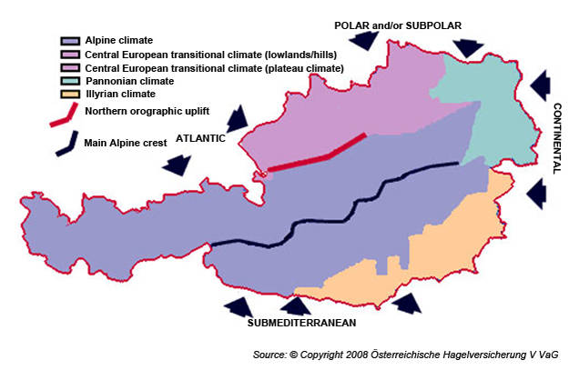
Figure 25: Climatic map of Austria
(Copyright 2008 Austrian Hail Insurance VVaG, modified). Available at: http://www.umweltbundesamt.at/en/soer/soer2010_partc/soer2010_intro/; accessed: 11th October, 2014)
As can be seen in Table 7, a total of 32 events have been observed in the period from 1994 to 2014, which have caused about 30 casualties and a total damage of approximately EUR 6.7 billion. With 72.4 percent of the total floods constitute the largest part of the economic damage, which has been reaffirmed by PreventionWeb (2014). Austria ranks on the 133th place indexed with 3.58 percent in the World Risk Report (2014). As identified in the World Development Report (2013), in the period from 2003-2012, Austria was affected by eight major natural incidents but had been spared from epidemics as well as pandemics. According to Es ist eine ungültige Quelle angegeben. infectious diseases have lost importance in recent decades in Austria, nevertheless, probably due the mobility of people the importance of some infectious diseases is increasing again. About 560 people corresponding to 0.8 % of the population deceased due to infectious diseases in 2007 in Austria. In the same year most often reported infectious diseases were bacterial food poisoning (about 10,200 cases), scarlet fever (about 2,050 cases) and infectious hepatitis (1,830 cases). 64 individuals were infected with AIDS that year. Influenza is one of the most common infectious diseases in Austria, every year up to 400,000 persons are infected by influenza and up to 6,000 of them die due to medical complications arising from this disease Es ist eine ungültige Quelle angegeben..
Table 7: Overview on disasters in Austria from 1994 to 2014 (EDA 2014, PreventionWeb 2014),
Date | Event | Type of Event | Affected/Killed | Est. damage (€)
1994 January | Storm | Natural Disaster | not known | 2,000000
1995 June | Flood | Natural Disaster | not known/2 | 2,00000
1995 August | Transport accident – Braz, Vorarlberg | Technological Disaster | 100/4 | not known
1996 June | Flood | Natural Disaster | not known | 5,000000
1997 July | Flood | Natural Disaster | not known/3 | 175,000000
1998 April | Earthquake – Arnoldstein, Carinthia | Natural Disaster | not known | not known
1998 July | Mine Accident – Lassing, Styria | Technological Disaster | not known/11 | not known
1999 January | Transport accident – Deutschlandsberg | Technological Disaster | 32/18 | not known
1999 February | Avalanche – Galtür, Tyrol | Natural Disaster | 10,000/50 | 41,570000
1999 May | Flood | Natural Disaster | not known/3 | 320000
1999 May | Tunnel Fire – Tauern tunnel, Salzburg | Technological Disaster | 50/12 | not known
2000 March | Avalanche – Kitzsteinhorn | Natural Disaster | not known/13 | not known
2000 May | Storm – Styria | Natural Disaster | not known | 20,000000
2000 October | Fire-Disaster – Kaprun, Salzburg | Technological Disaster | 162/155 | not known
2002 August | Danube Flood | Natural Disaster | 60,000/9 | 2,900000000
2002 October | Storm | Natural Disaster | not known/2 | 5,000000
2002 November | Storm – Salzburg | Natural Disaster | 300/1 | not known
2003 July/August | Extreme temperature – Heat wave | Natural Disaster | not known/345 | 280,000000
2005 July | Flood | Natural Disaster | 900/not known | not known
2005 August | Alps Flood | Natural Disaster | not known/4 | 700,000000
2005 December | Extreme temperature – Extreme Winter Conditions | Natural Disaster | not known | not known
2006 March | Flood | Natural Disaster | 516/not known | not known
2007 January | Extra-tropical Storms | Natural Disaster | not known | 400,000000
2007 July | Extreme Temperature – Heat wave | Natural Disaster | not known/5 | not known
2008 February | Fire accident – Egg | Technological Disaster | 5/12 | not known
2008 February | Storm | Natural Disaster | not known/4 | 500,000000
2009 June | Flood | Natural Disaster | not known/1 | 200,000000
2009 July | Storm | Natural Disaster | not known | 500,000000
2009 July | Flood | Natural Disaster | not known | not known
2009 December | Extreme Temperature – Cold Wave | Natural Disaster | not known/2 | not known
2012 February | Extreme Temperature – Cold Wave | Natural Disaster | not known/5 | not known
2013 June | Flood | Natural Disaster | 200/4 | 1,000000000
Regarding the frequency of the occurrence, as displayed in Figure 26, with eleven events, flood ranks on the first position, followed by storms with seven events and four transport accidents.
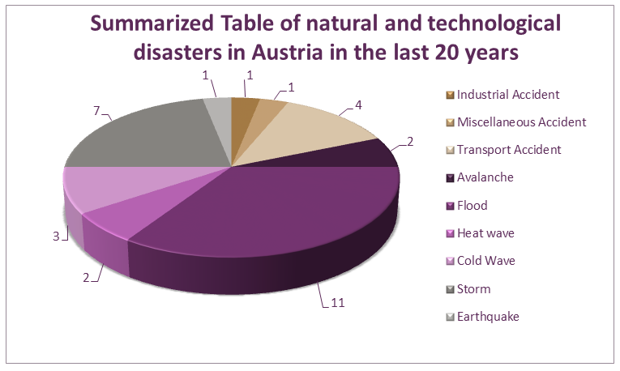
Figure 26: Pie chart over the occurrence of natural and technological disasters in Austria between 1994 and 2014
Available at: http://www.emdat.be/disaster_list/index.html; accessed: 11th August, 2014

Natural hazards
Potyka (2012a) highlighted that among others Austria is mainly affected by floods and landslides during the summer period and avalanches in the winter season. Referring to the Disaster statistic of Austria, presented by PreventionWeb (2014) during the period from 1980 to 2010 most people had been affected by floods, wet as well as dry mass movements and storms. While storms have occurred more frequently than floods, they have a higher impact of the economic loss. The case of extreme temperature in the “record-summer” in July/August 2003 caused the highest death toll at a stroke. In the frame of a common exposure to several natural hazards, the most relevant events listed in Table 7 will be discussed separately in the following paragraphs.

Avalanche
Due to the fact, that Austria has a big share of alpine area, from what significantly more than half has been defined as torrent as well as snow avalanche catchment areas, only 37 percent of the state territory can be used for permanent settlement (Environment Agency Austria 2014).
The past has shown that, despite avalanches have not recognised as the most commonly appearing events, they have caused a lot of human losses and about 35,000 damages to buildings (BMLFUW 2014a). Regarding the spatial distribution of avalanches in Austria, the BMLFUW (2012) stated, that a particularly high density of hazardous events has been registered in western parts of Austria and in eastern foothills of the Alps (see Figure 27).
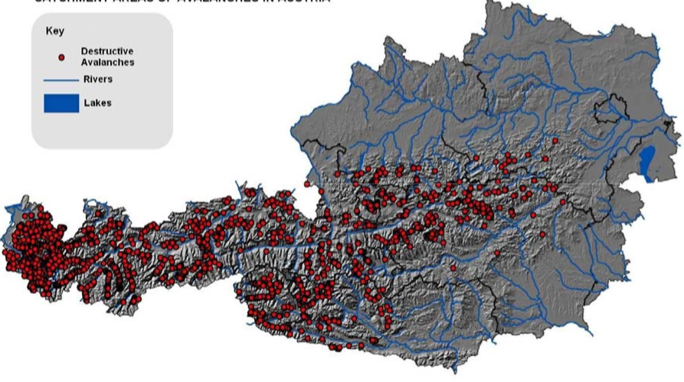
Figure 27: Spatial distribution of avalanche events in Austria
Available at: http://www.fao.org/forestry/21310-09fd2cebf0189b5f2651d6182ff08a6aa.pdf; accessed: 3rd October, 2014
Recent catastrophic events contributed to a higher public awareness for this hazard type. In general, a distinction between material and personnel damage has been made. According to the loss data base of the BFW, the highest percentage of material damage has been recorded in Salzburg and Styria (BMLFUW 2012). Based on an observation of a reference period over 25 years, avalanche disasters claimed an annual average of 30.3 personnel injuries. The BFW explained that the death rate results mainly from serious accidents in high alpine regions and is often caused by entering an unsecured piste. In order to manage alpine risks, several risk-monitoring initiatives have been established in Austria. Different institutions operate avalanche databases with varying emphases – in sum, the avalanche documentation of the BFW and the IAN amounts to 12,000 data sets. Furthermore, Austria participates at some international research programs in the field of forecasting and protecting from Alpine hazards – to name some examples: MANFRED – Management strategies to adapt Alpine Space forests to climate change risks; ALP-Water-Scarce-Management – Water management strategies against water scarcity in the Alps; SicALP – Site protection in limestone Alps by means of forest regeneration measures.
Regarding the financial issue, it has been declared by the BMLFUW (2014a):
Torrent, avalanche and erosion control measures are financed from the Disaster Relief Fund of the Federal State (Disaster Relief Fund Act). Subsidies are granted subject to the provisions of the Hydraulic Engineering Assistance Act, which defines the terms and conditions under which subsidisation is provided as well as the principles of the planning and implementation of control measures. However, comprehensive protection against alpine natural hazards includes also organisational measures (emergency alert, alarm, evacuation) and civil disaster control, tasks, which are mostly implemented by the Federal Provinces.
Aiming at a sustainable mitigation strategy, Austria reverts to gentle protection measures. Due to the fact, that Austria is around 50 percent covered by forest, around 20 percent of this will be utilised as protection forest (BMLFUW 2007). As illustrated in Figure 28, within the Forest Development Plan, a protection function of 30.73 percent is determined for Austrian Forests (BMLFUW 2009). Within the Forest Act, the term protection forest has been specified by differing between site-protecting forests and object-protecting forests. The public will finance costs of the treatment for an object-protecting forest because it is dedicated to protecting human lives and culture. In contrast, expenses for the site protecting forest are mainly for the forest owner’s account.
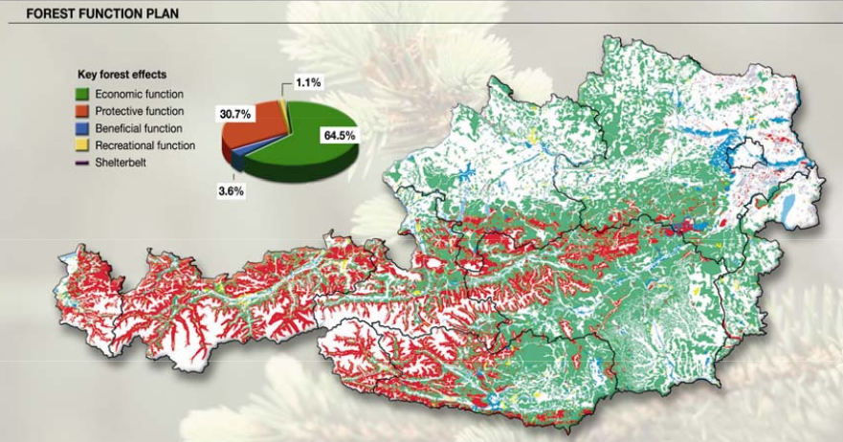
Figure 28: Forest Development Plan (FDP) of Austria
Available at: http://www.fao.org/forestry/21310-09fd2cebf0189b5f2651d6182ff08a6aa.pdf; accessed: 22nd September, 2014
As it is laid down by the Austrian Forest Act (Federal Law Gazette 2002), the governor of the provinces and the district administrative authorities, in that function especially the municipalities are practically responsible for the implementation of the law. On this base, the Forest Development Plan, the guidelines for Hazard Zone Plans and Forestry Plan have been defined. Furthermore, the Torrent Control Act and the Austrian Protection Forest Strategy regulate the avalanche protection measures in Austria.

Flood
Until now, the most damages of flood have been caused by the Central Europe floods in June 2013, which have also affected the Czech Republic, Germany, Hungary, Serbia, Slovakia and Switzerland (Reliefweb 2014). In the frame of the event, 6 fatalities have been recorded and an economic loss of approximately EUR 0.87 billion in the four most affected regions Lower Austria, Upper Austria, Salzburg and Tyrol. With a total loss of EUR 2.9 billion, the previous flood of August 2002 was labelled as “flood of the century” (Profil 2013). Beginning with heavy rainfalls in August, the Danube water levels raised and the overburdening of feeder rivers caused material damages and even personnel injuries (Bossong and Hegemann 2013). With an average annual precipitation of around 1,100 mm Austria is perceived as one of Europe’s most water-wealthy countries (BMLFUW 2014b). In mountain areas, heavy rainfalls occur frequently (Zwittkovits 1983). For the Austrian exposure to flood risk, mainly the two categories river flooding and flash floods will be relevant (Blöschl 2013). While flash floods are characterised by short, small-scale but intensive precipitation, the soil moisture of an affected area plays an additional crucial role for the cause of river flooding. If a certain proportion of the precipitation cannot be drained, the likelihood of a flood will increase. As stated by Gutknecht et al. (2002), a high humidity was observed in the affected regions during the flood in 2002. This factor was reaffirmed in 2006, in which a coincidence of a relatively moderate rainfall in March and high soil moisture caused the March-Flood in March.
In contrast, flash floods are more likely to cause spatial limited mudslides and landslides in mountain areas, but also represent a significant risk for wide asphalt areas in cities (Blöschl 2013). From a risk monitoring perspective, Figure 29 provides an overview of the spatial dispersion of flood and mudflows in Austria. It demonstrates clearly, a concentration of mudflows especially in the western part of Austria, which is due to its mountainous topography and an accumulation of prone-flood in the North and the South of Austria as well at the border regions in the east and the west. Within these areas, Vorarlberg, Tyrol, Salzburg and Carinthia account for around 62 percent of the total recorded torrential events with material damages or personnel injuries.

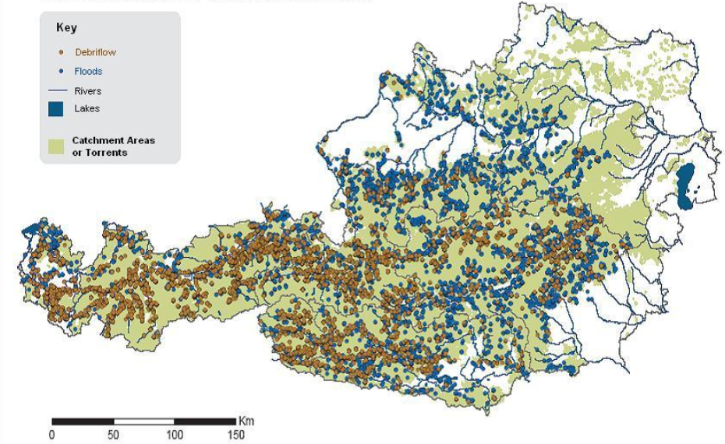
Figure 29: Spatial dispersion of torrential events
(blue bullet = prone-flood areas, brown bullet = risk of mud flows). Available at: http://www.fao.org/forestry/21310-09fd2cebf0189b5f2651d6182ff08a6aa.pdf; accessed: 11th September, 2014
The strategic direction of Torrent and Avalanche Control is located at the department III/5 of the Federal Ministry for Agriculture, Forestry, Environment and Water Management. Additionally, the strategic actor is responsible for the planning and the construction of technical and biological measures to protect against natural hazards (BMLFUW 2014c). Within the management of flood risk, various responsibilities result due to a federalist constitution of Austria. By identifying flood-discharge areas and danger zones, the Federal Water Engineering Administration provides expert opinion for the local regional planning and is also engaged in communicating the threat of flooding to the citizens. Departmental cooperation has been established with the Federal Ministry for Agriculture, Forestry, Environment and Water Management (department IV/6) and the offices of the Provincial government. The Austrian Ministry for Transport, Innovation and Technology/”via donau,” together with competent offices of the provincial government, is responsible for flooding issues concerning the Danube, March and Thaya,. The “via donau” is a limited liability company, founded by the Austrian Ministry for Transport, Innovation and Technology, entrusted with the administration and preservation of Federal waterways. In addition, the “via donau” is operating the shipping information system DoRIS (Donau River Information Services) (BMLFUW 2014d).
Austria maintains an integrated geo-database, where flood risks and their adverse consequences can be assessed by a “total risk per river stretch” on the basis of a combination of past and future floods. As indicated by ICPDR (ICPDR 2012), as a result a total of about 1,840 square kilometres relating to 5.2 percent of the total river length that has been assessed - are classified as having high or very high flood risk in the Austrian part of the Danube River Basin.

Further hazards
Although Austria is not a typical earthquake area, due to the Alpine tectonics several seismic activity has been identified in Austria. To a yearly average, about 600 earthquakes occur in Austria, from which humans will perceive only 10 percent. Embleton-Hamann (2007) stated, that every 46.3 years an earthquake of epicentral intensity I₀>7° can be expected, which would cause heavy damages on buildings. Approximately all 15 to 30 years, earthquakes reached an intensity to cause medium damage on buildings. Certain Austrian regions exhibit a more frequent tendency of earthquakes than others. In particular, the Vienna Basin, the Mur-Mürz Valley, the Inn River Valley and the Lavant Valley region of Carinthia are the most prominent earthquake regions of Austria. Figure 30 provides an overview on the seismic activity perceived by the Austrian population since 1900, while only technically registered earthquakes have been suppressed. Within the article of Embleton-Hamann (2007), Villach (a city in Carinthia), Murau (a region of Styria) and Neulengbach (a city in Lower Austria) have been identified as the three regions with the most hazard potential. Furthermore, there it has been indicated, that the biggest spatial earthquake zone is stretched from the Mur-Mürz Valley to the Vienna basin. Approximately all 15 to 30 years, earthquakes reached an intensity to cause medium damage on buildings and only in an interval of 75 to 100 years they cause heavy damages on buildings.
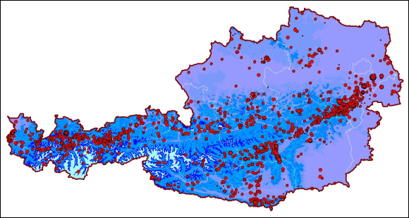
Figure 30: Epicentre map of Austria
provided by ZAMG. Available at: https://www.zamg.ac.at/cms/de/geophysik/erdbeben/erdbeben-in-oesterreich/erdbebengefaehrdungzonen-in-oesterreich; accessed: 11th June, 2014.
Since 1992, ZAMG (2014a) has never registered a higher value than I₀=6° on the European Macro seismic Scale. The total of eight registered earthquakes, which have reached intensity higher than I₀=6° and have caused damages to buildings in the last 20 years have distributed as followed: Styria 4, Lower Austria 2 and Carinthia and Tyrol in each case one event.
According to ZAMG (2014b), the analysis of historically relevant areas provides cyclical repetition rates of these events, which build the basis for an estimation of the average of intensity and the occurrence of an event. On this knowledge basis, risk reduction strategies have been implemented for vulnerable regions, i.e. by zoning of the previously affected areas within an earthquake catalogue. Prevention measures play an important role in avoiding or limiting the potential impact of an earthquake, economically as well as life-saving. Furthermore, the provision of knowledge from an applied research, i.e. in the area of risk mapping, risk monitoring etc. will improve the basis of decision-making ability of responsible bodies. Thereby, appropriate deployment plans for the case of an event can be created and specific training programmes can be prepared for the rescue workers. In addition, the most relevant relief organisations for the emergency – fire brigades, emergency services, the Austrian Armed Forces and the police can be adjusted to known hazard scenarios (ZAMG 2014b). Especially, with earthquake-proof construction of historical buildings and critical objects mitigation will be achieved.
The Austrian Institute for Standards has contributed to the mitigation strategy by launching the standard “ÖNORM B 4015” concerning the establishment of a building code for an earthquake-proof design (2002). Hausmann et al. (2010) emphasised the importance of seismic risk mapping for the areas with a high residential density and for those, where critical infrastructures are located.
As illustrated in Table 7, the heat wave in August 2003 caused 345 deaths. It has been found out, that the so-called tropical days are the main driver for healthy risks. Especially, the number of days with a temperature higher than 30°C and not lower than 25°C constitutes a decisive factor. In the frame of the StartClim project (2005), it has been found out, that since the middle of the last century the number of hot days has increased significantly. As a consequence, the mortality rate has increased in Austria by 12.6 percent in the course of only six days in August. In combination with a lack of precipitation, drought caused high financial damages (about EUR 197 million) and the agricultural sector probably suffered the most, i.e. 30 percent of fodder deficit has been registered in Austria (Strosser et al. 2012). Frequently, heat wave phenomena have been discussed in the context of climate change. Based on the findings of the Centre for Climate Adaption (2014), “a widespread warming trend in both daily minimum and maximum temperatures was confirmed for homogenized time series of temperature data covering the period 1948-2009”. Looking at the extreme temperature in August 2003, which has reached 38.5° in Styria – 2013 a new record with 40.5°C has been registered in Lower Austria (ZAMG 2013). Extremely cold temperatures might cause material damages, but will not lead directly dangerous effects. An increased likelihood of avalanches, as a result from more frequent heavy precipitation events in winter has been assumed for central and northern Europe (Centre for Climate Adaption 2014). From an economic perspective, (thunder)storms and hail have also been taking into account for the risk profile of Austria. Especially in the summer periods between June and July, thunderstorms have been frequently accompanied by hail, which can cause damages to private property, i.e. cars, building facades, etc. as well as to the agricultural sector. Austria’s position has been identified as located in the middle of the European hail epicentre. Due to this fact, particular big hailstones with a diameter of more than 2 cm can be observed several times a year. As an example, in 2004 hail caused damages beyond EUR 20 million (SKYWARN Austria 2014). Considering the frequency of the occurrence, storms are belonging to the more frequent phenomena. Influenced by an Atlantic depression, the average wind speeds reach about 103 km per hour.
Additionally, hurricane-like winds might be triggered by warm winds, resulting from an extensive foehn situation. SKYWARN Austria indicated (2014), that a common occurrence of downbursts and winds with hurricane strengths can be registered in Austria. High wind strengths have been recorded in peripheral areas of Austria, in particular for the South-East of Styria and the Western part of Upper Austria.

Technological hazards
In the context of this chapter technological disaster means a man-made, but not intentionally triggered event. In the reference period of the last twenty years, six major technological disasters have been recorded in Austria. As illustrated in Table 7, especially the accidents in Kaprun and Deutschlandsberg caused heavy damages of and caused a lot of fatalities with a total of about 180 persons. Since the nuclear disaster of Chernobyl in 1986, Austria became aware of the potential nuclear hazard. Although, Austria does not operate a nuclear reactor by its own, only in distances of about 30 km and more from Austrian borders, several nuclear power stations are in operation (see Figure 31).
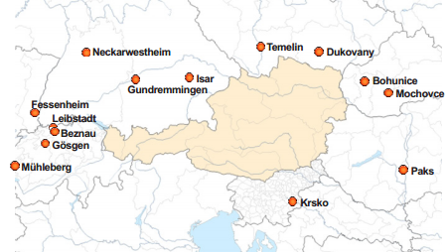
Figure 31: Nuclear power stations in Austria's neighbouring states
Acquired from (BMLFUW - V/7 Radiation Protection 2013).
It has been indicated by experts of the BMLFUW (2013), that hazards of radiological emergencies might also result from transport accidents with radioactive material or might be caused by a terroristic attack. In order to be promptly informed, Austria has established a close cooperation with neighbouring states to exchange data obtained from radiological monitoring stations in each state (International Atomic Energy Agency 1986). Furthermore, the Department of Radiation Protection at the BMLFUW operates an automatically radiation early warning system, which detects data of the measuring network and sounds the alarm, if values exceed the limit. In the case of an emergency, an alerting path must be maintained. The Federal Alarm Centre, located at the EKC serves then as an information hub of the Federal Ministry of the Interior (Jachs 2011b). Since a bilateral or international notification has been receipt, a 24-hour stand-by service will be informed. Simultaneously the emergency will be communicated to the general public and the responsible authorities at the federal and the provincial level, as well as appropriate emergency personnel will be notified. In sum, stakeholders at the community, the provincial, the federal as well as the international level will participate in a radiological emergency case (BMLFUW - V/7 Radiation Protection 2013). This strong involvement of several stakeholder types can be also recognised based on the curriculum of training programs. Special ABC-training courses for emergency personnel, i.e. the Austrian Armed Forces are organised by the Austrian Research Centre GmbH (Seibersdorf/Austria) and the International Atomic Energy Agency (IAEA).

Policy and Governance
Based upon the “SKKM Strategy 2020” of the Federal Ministry of the Interior (2009), traditionally the Crisis and Disaster Management in Austria is built upon the principle of three pillars. As shown in Figure 32, these pillars comprise measures of the authorities, of the emergency organizations and self-protection measures of the citizens. This model can be complemented by the involvement of selected economic stakeholders as well as by the contribution from the scientific community.
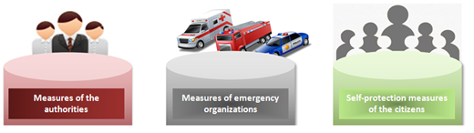
Figure 32: Three-pillar-model of the Crisis and Disaster Management in Austria
Measures of the authorities
Authorities are obliged to operate a preventive protection and a responsive protection in the case of an incident by prescribing provisional measures, coordinating protection activities and organizing the administrative process. Regarding the response phase of the crisis management cycle, authorities have to define strategic goals, instruct emergency forces and assistance staff by official jurisdiction and the usage of coercive measures. The tasks of the authorities are perceived as obligatory tasks and include the establishment of a framework and providing financial resources. According to the various phase of crisis and disaster management, civil defence and disaster protection require the support of hierarchically ascending administrative entities in emergency procedures because the competences are shared between the state, the provinces and the municipalities (Jachs 2011b).
Measures of the disaster relief units (emergency organization)
One characteristic of the Austrian Crisis and Disaster Protection Management is the strong involvement of voluntary organizations, which enable an easy access to a huge amount of human resources. Due to the fact that there is no single organisation in Austria, which will be mainly responsible for the response to disasters, related duties will be organized by voluntary organisations. The Austrian Fire Brigades as well as the rescue services have gained the most attention in this area. Regarding the possibility to request assistance from the Austrian Armed Forces, if the capacities are insufficient, their deployment is regulated by the Law concerning the military service § 2 (1)c), where it has been defined, that in the case of major emergencies, the provincial governor, the head of the district or the Major of a municipality are authorized to request for assistance (Jachs 2011a).
The security headquarters or warning centres of the Federal Provinces are the central control points for request and organize emergency services in Austria. On behalf of crisis and disaster protection authorities, various emergency organizations are accredited to fulfil emergency missions in crisis and disaster situations, some are mentioned below. “The Austrian Red Cross (ARC) is a private organization based on the ideal of selfless charity and motivated by non-profit thinking. Operating independently, it performs humanitarian tasks with the help of volunteers and employees in order to assist all people in need, at home and abroad.”
The Austrian Fire Brigade consists of umbrella organizations at the district, provincial and federal level and is together with the ambulance services and the Austrian Red Cross the most important stakeholder in protection against natural hazards. Furthermore, the Arbeitersamariterbund (workers' Samaritan association), the service of the Emergency helicopter C16, the Water rescue, the Rescue dogs brigade and the Crisis intervention team is strongly involved in emergency operations. Security agencies and its bodies, e.g. the federal police, support disaster protection authorities in the response phase by providing data to authorities and field support. For preparedness, the federal fire brigades, the ARC as well as disaster relief authorities have developed civil defence plans, mainly consisting of plans for alerting and operations as well as procedures (Jachs 2011b).
Measures of citizens (individuals and companies)
As an important part of mechanism of civil defence and disaster protection, individuals are encouraged to local self-protection measures and neighbouring help (Federal Ministry of the Interior 2009). Also companies have specific obligations in the case of an event. Everyone has the obligation to notify appropriate institutions and organizations in the case of a hazardous notice. Responsible authorities are authorized to force individuals and companies to cooperate and collaborate with authorities, to follow their instructions and to tolerate the utilization of private equipment.
Support from economic stakeholders
With stakeholders from the economy a close cooperation regarding the implementation of protection measures, fostering industrial resilience and risk mapping has been envisaged.
According to Jachs (2011b), operator of critical infrastructures in Austria will be regularly involved in committees addressing the preparation of protection strategies and risk profiles. Within the ANVIL report (2013), it has been noted that operators of critical infrastructures can be required to provide special equipment, e.g. emergency operation trains.
Contribution of the scientific community
Especially in the frame of risk mapping and monitoring, a comprehensive collaboration between research institutes, the academia and governmental departments of the state and the provinces has been established. Several state departments have introduced their own research departments.

Strategy scope and focus
A question that arises beforehand is what “all necessary activities” includes in this context since so far there is neither a general nor a European disaster management model, which would define the scope of all activities (Expert Interview 2014). Thus, the answer must be subjective to a certain extent. The expert at the MoI indicated that the current national disaster management strategy, which has a time frame until 2020, basically aims at the whole disaster management cycle but, nevertheless, there is a noticeable focus on preparedness issues like education and training of key response personnel, the promotion of new response technologies like decision support systems, simulation tools and also on an improved organizational framework for cooperation and coordination in the response phase. It is noteworthy that like in other legal matters in Austria, and thereby also in disaster management, there is a three-way division of competence. The state is not assuming overall responsibility but the key part in defining prevention measures and establishing a framework for the implementation and the financing of mitigation projects while the federal provinces are primarily engaged in establishing a preparedness structure and planning the response to disasters. The local authorities (municipalities) as executive units are mainly responsible for carrying out these response missions on the first intervention level and for that purpose they also provide the majority of response resources.
In general, strategic decision-makers in Austria are pursuing an all-hazard approach, but the priority-setting derived on the basis of the hazard experience in the last twenty years (Expert Interview 2014). Realistic scenarios, depending on the probability of occurrence of the event, their potential impacts and appropriate coping capabilities have shaped the awareness at the strategic level. Due to the fact that there is no primarily responsible for risks, separate foci on natural hazards have been defined by Austrian provinces, depending on the particular affectedness of the province. Although technological disasters had devastating effects in the past, e.g. the heavy fire disaster in Kaprun (in the Austrian province of Salzburg) on 11 November 2000, or the mine accident in Lassing (province of Styria) in July 1998, there is an emphasis on natural hazards.
Since high-risk plants are not very strong represented in Austria and SEVESO facilities are well regulated, Austria is not highly exposed by technological disasters. Floods have offered a big challenge for Austria, while avalanches deemed probable, but remain locally. In the most of the cases, personal injury could be prevented and natural hazards are limited to material damage – especially storms and floods generate the most significant economic losses. The higher feasibility to protect against more frequent risks like the impact of flooding but – as explained by the expert at the MoI – not against more rare events like a plane crash is reflected in policies and the legislation (2014). Because a big earthquake occurs once every four hundred years, mainly structural protection measures have been implemented in that area, i.e. historic buildings have been made earthquake-proof.
Like in many countries, there is still a noticeable tendency to pay highest attention to the response and the prevention phase, while there is a lower priority for the recovery phase. Nevertheless, recovery from disasters has always been achieved quickly due to the availability of public funding, a large number of volunteers and additional spontaneous volunteers and private donations. In the recovery phase after bigger events usually a higher number of diversified actors come into play, which is not permanently engaged with disaster management structures, which makes planning for this phase even more difficult. The preparedness phase and the response phase rather constitute priorities for the state’s level. Finally, the individual phases can be weighted as illustrated in the pie chart in Figure 33.

Figure 33: Pie chart about the strategic focus on the phases of the Disaster Life-Cycle
Although the national security strategy pursues an all-hazard approach, due to the national experience of the last twenty years, there is an emphasis on natural hazards. Based on the interconnectedness, also non-natural disasters have to be considered in Austria, especially pandemic hazards like the Swine Influenza in April 2009 (Reliefweb 2014).
The identification, presentation and the assessment of relevant natural hazards, e.g. by the mean of hazard zone plans, constitutes a relevant element of the integrated risk management.
As pointed out by the department of the Facility-related Water Management at the BMLFUW (2012):
Findings of the hazard assessment will be considered within the phases of the risk cycle including the management of disasters, the regeneration in the aftermath of a disaster as well as preventive measures. By providing a comprehensive presentation of natural hazards, the response phase is supported by preventive measures before a disaster occurs. As a part of the prevention, the activation of emergency services, i.e. fire brigades, etc., the provision of human and material operating resources, as well as warning and alerting mechanisms have been implemented.

Monitoring and analytical support to policy making; R&D
The academic sector is well integrated into governmental activities. Several research programmes are in place, which provide opportunities for the academic sector to engage with governmental bodies in research activities. Programs like the Climate Fund and the KIRAS security research program line have contributed considerable strides to disaster management to enumerate some academic important initiatives. Cooperation has been established for instance in cooperation with the University of Natural Resources and Life Sciences, Vienna, the University of Vienna or other universities. International attention has for example been gained by the findings of projects like FloodRisk I and II, which have promoted a fully integrated and comprehensive approach to flood risk management.
The Federal state has launched multiple programmes to promote the protection capacities of various hazards. Research programmes are often focusing on an interdisciplinary or even a trans-disciplinary work in the area of hazard protection. In particular, the Ministry of Science and Research, the Ministry for Transport, Innovation and Technology and the Ministry of Economy, Family and Youth are strongly involved in research and technology. Associated to these ministries, there have been three agencies set up to manage the funding of research and science as well as development and innovation in Austria. These are the Austrian Science Fund, the Austrian Research Promotion Agency and the “Austria Wirtschaftsservice” (“Austrian Business Service”). For example, the Austrian Research Promotion Agency (FFG) – hosted by the Austrian Ministry for Transport, Innovation and Technology and the Federal Ministry of Science, Research and Economics concentrates on diverse security issues, inter alia at the Protection of Critical Infrastructure and the development of systems to manage or prevent various threats. Institutions as the Austrian National Bank, the Federal provinces as well as ministerial departments provide an incentive to promote research in the area of protection against hazards. As example, The Department of Natural Hazards and Alpine Timberline – located at the Federal Research and Training Centre for Forests, Natural Hazards and Landscape Austria, is a research institution dedicated to the development of practice-oriented methods for the sustainable protection of human settlements and infrastructure. As main tasks the department is concerned with the monitoring of several natural hazards, their analysis and the development of countermeasures. The BFW is an Austrian federal, multidisciplinary research and education centre which holds the legal status of an institution under public law. Planning and protection measures will be funded by national and provincial programs, as well as by the EFRE fund of the European Union. Furthermore, the risk prevention of the natural hazards insurance completes the adjustment of losses by the Federal State. Austria does not confine oneself to one overall initiative, but generates benefit from many small programs. As mentioned by MoI (2014), important initiatives have been established in cooperation with the University of Agricultural Sciences and Natural Resources, the University of Vienna and the University of Innsbruck. Furthermore, projects of the AlpS, the Climate Fund and the KIRAS program line have contributed considerable strides to disaster management.

Policy for Prevention
At first of all, within the Austrian National Crisis and Disaster Protection Management emphasis is placed on mitigation concepts, including the avoidance of natural hazards by the construction of hazard zone plans and spatial planning. Furthermore, flood protection initiatives and torrent and avalanche control as well as avoidance strategies for technical disasters fall into mitigation measures. The establishment and the maintenance of disaster relief organisations and the promoting of disaster protection planning by encouraging mines rescue services, pandemic planning and radiation protection planning are important prevention measures. Furthermore, the crisis education and the training of professional and volunteered staff have a long tradition in Austria.
As a particular type of preventive measures, the policy papers European Programme for Critical Infrastructure Protection (EPCIP) and its national counterpart, the Austrian Programme for Critical Infrastructure Protection (APCIP) are concerned with the protection of critical infrastructures. “Europe's critical infrastructures are highly connected and highly interdependent. … Interconnectedness and interdependence make these infrastructures more vulnerable to disruption or destruction” . The purpose of EPCIP (COMMISSION OF THE EUROPEAN COMMUNITIES 2004) is to ensure that there are adequate and equal levels of protective security on critical infrastructure, minimal single points of failure and rapid, tested recovery arrangements throughout the Union. EPCIP would be an ongoing process and regular review will be required to keep abreast of the issues and concerns within the community. Success shall be measured by (i) The Member States governments’ identification and establishment of inventories of critical infrastructures in their jurisdictions according to the EPCIP drawn up priorities; (ii) Businesses collaborating within sectors and with government to share information, and reduce the likelihood of incidents causing widespread or lengthy disruption to critical infrastructures; (iii) The European Community resolves to establish a common approach to tackling the security of critical infrastructures through cooperation of all public and private actors.
A shared responsibility can be also observed within the prevention phase of the disaster life-cycle. According to specific hazard types, regional authorities are coordinated with the responsible federal authorities. Based on the state’s legislative power in the area of shipping, aviation and railway, the state plays an important role in the protection against human induced and technological hazards. In contrast, the provinces are exercising sovereign rights in the area of natural hazards – apart from the flood protection mandate of the Federal Ministry of Agriculture, Forestry, Environment and Water Management. As an example, the risk zoning initiative of the Federal Ministry of Agriculture, Forestry, Environment and Water Management has been prioritized in consultation with the corresponding authorities of the Austrian provinces (Expert Interview 2014). At the strategic level, prevention measures are primarily concentrated on risk analysis and hazard monitoring. The risk assessment approach complies with the European standards, which have to be implemented since 2013. In Austria, the prevention strategy has been geared towards the knowledge about probable hazards, related risks and a nation-specific vulnerability assessment. This strategic approach has been also reflected in academic programmes, which are aiming at a trans-disciplinary research of risks by encouraging the participation of stakeholders from politics, administration and multiple scientific disciplines. The MoI indicated, that a common consensus about prevention priorities amongst the various stakeholders have been achieved by the knowledge based approach to policy making (2014). In case of a need, also economic stakeholders will be involved. As defined in the APCIP, the protection strategy for critical infrastructures is to be made under cooperation of the responsible ministries, public bodies and relevant infrastructure managers. Furthermore, special education and training programs are tailored for economic partners, especially for energy providers, because provincial governments are holding parts of their companies.

Policy for Preparedness
As mentioned above, preparedness is initiated at the level of the federal provinces. Stipulated by the arrangement Art 15a B-VG about the establishment and operation of an alerting and alarm system, the Federal provinces are induced to contribute to the preparedness by establishing warning centre, construct control and command centres as well as to manage operating centres (Jachs 2011a). They have the competence to establish emergency and relief organizations, provide an appropriate infrastructure and organise training events. Within the SKKM Strategy 2020 (2009), the core issues of preparedness have been supplemented with the recommendation to promote special technical skills and education programs and optimize coordination and cooperation structures. Despite the recent economic crisis, a slight increase of membership could be registered in voluntary organisations in Austria. Thereby, issues regarding the material equipment of these organizations or the creation of a national framework for a continued payment of remuneration will be raised. Due to the fact, that the source of financing volunteering is not very transparent – also municipalities do not pay the entire costs, financial adjustments or compensations from the Disaster Relief Fund seem to be possible operative requirements for the strategic level (Expert Interview 2014).

Policy for Response
The expert at the MoI (2014) indicated , that the response to disasters is based on the principle of subsidiarity encompassing a high degree of delegation of competence to the local and regional level. As emphasised by the BMLFUW (2012), public safety authorities and organisations – namely the fire brigades, the emergency services, the police, the armed forces and aid organisations are the key players within the response phase. Jachs (2011b) points out, that the response strategy comprises the danger removal by the government agencies, the mobilisation of disaster relief organisations, the command and control of disaster response operations, a cross border mutual aid system, the legal arrangement of the contributing rescue workers as well as media work and crisis communication. The response to disasters is based on the principles of competence (at local level) and delegation (subsidiary intervention to higher layers of administration, in case of necessity) and involves several departments at the municipal, district and provincial level. In the light of the sovereignty principle, the provinces instead of the federal state are the central control body of governing response activities. Competences to response to a concrete event are highly developed at the local level of communities, which are not steered centrally.
Although, the efficiency of the recent organisation principle is not clear at the first glance, the MoI emphasised that distributed responsibilities, in particular the decisive competences at the local level, become apparent in the case of an event during the relief and response phase (2014).
The capacity of local communities to response rapidly to known threats is owed to the circumstances that municipalities dispose of their own locally available utilities. The high level of self-initiative of the communities in is an advantage of the distributed administrative systems and accordingly high is the local commitment. The Federal Ministry of the Interior assumes the role of a strategic coordinator and raises cross-cutting issues, which exceed the spatial dimension of the individual provinces, e.g. cross-border missions and the establishment of early warning systems (2014). On the basis of several arrangements, the Federal Ministry of the Interior acts as a focal point by providing an interface for the systematic exchange of information between the regional level and the international level (Jachs 2011b).

Policy for Relief and Recovery
The BMLFUW (2012) has specified that the regeneration after a disaster means the rehabilitation of damaged buildings, infrastructure and transport routes as well as the financial settlement of the damage. As is evident from the national legislation, the approach and the means used in the preparedness and the response phases are covered by appropriate paragraphs in the legislation on disaster management. There is no rule, which defines recovery activities, because – from a legal perspective – the disaster management is ending with the response phase. The same pattern pertains at the policy level – there are programs concerning the prevention/mitigation of hazards and the protection against threats, but there is no recovery plan. Based on the hierarchical structure of the federal state, there is a clear division of subject-matter jurisdiction – while the state is responsible for the rehabilitation of essential infrastructures, the provinces attend to restore roads and the municipalities establish the community infrastructure. However, voluntary emergency/relief organisations have developed approaches for recovery. From a strategic viewpoint, the MoI argued that Austria has sufficient capacities for recovery and therefore, recovery is mainly considered as a financial issue (2014), while relief organisations are concerned with the reconstruction of buildings and infrastructure as well as the reimbursement. Two important instruments are the disaster relief fund and the solidarity fund of the European Union (Jachs 2011b). The disaster relief fund as an important financing instrument becomes also effective in the recovery phase. Financial provision has been made to individuals, including the payment of compensation to flood victims and to administrative units by granting financial alleviation, e.g. tax deferment or charge exemption. The civil society and the local economy express its solidarity and offers support, e.g. private donations to the victims of natural disasters or the offer of favourable loans for affected persons by banks or the “Austria Wirtschaftsservice” (Expert Interview 2014).

Financing

Investing in preparedness
As indicated by BMLFUW IV/5 (2013), the federal state provides as a central financing instrument for the natural hazard prevention the disaster relief fund, which will be financed at a rate of 1.1 percent of the annual revenue from some taxes, e.g. income, gain or cooperation taxes. The Federal Ministry of Finances administrates the funds and recorded a distribution of subsidies in the amount of EUR 1,873.71 million for the period 2002 to 2006. In sum, based on the financial resources from the Disaster Relief Fund, federal funding and financial contribution of the provinces, a total amount of EUR 4 billion will be provided from 2007 until 2016 for protecting against natural hazards. Due to the fact, that disaster relief falls within the competences of the provinces, their expenditures will be replaced by the federal state. As illustrated in Figure 34, three quarters of the committed funding was reserved for prevention (73.3 percent), followed by costs to remedy the damage with about 17.8 percent and reimbursements for means used in missions with 8.9 percent. The Law on a Fund for Catastrophes provides a budget for the establishment of disaster risk reduction on the national level by ordering the raising of financial means and regulating in detail their expenditure within Austria. Dedicated to finance prevention measures, a further substantial reinforce of the fund in the amount of € 47.5 million from Federal funds has been decided in 2013 (Federal Ministry of Finance 2014).
A clear focus on natural hazards – about ¾ of the fund, can be identified in Austria (Jachs 2011b). In accordance to the principle of subsidiarity, the provinces have their own budgets for DRR issues as well as the municipalities.
Although, there are no official statistics, the annual expenditures for preparedness measures of disaster management are estimated to be about 0.1 percent of the GDP (status of 2013).

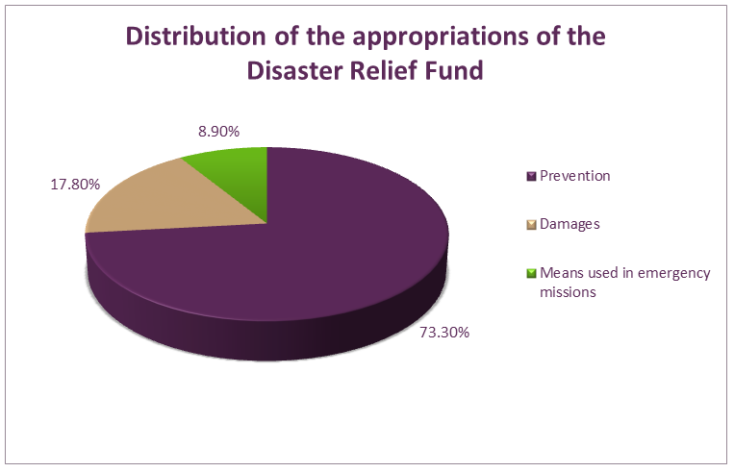
Figure 34: Distribution of financial resources of the disaster fund
Source: Federal Ministry of Finance (2014)
In the light of the Tsunami disaster in 2004, the Austrian government decided to establish a fund for response to disasters abroad. The budget of this fund is dedicated to financial aid in the aftermath of disasters as well as for the prevention against hazards. The Federal Ministry for Europe, Integration and Foreign Affairs (BMeiA) is administering the fund while the Austrian Development Agency (ADA) assumes the supervision of the fund. The Foreign Disaster Relief Fund regulated by the law on a Fund for disasters abroad, Art. 1-3 and provides for the establishment of a budget on national level to make contributions to combat disasters abroad (Federal Ministry for European and International Affairs and Austrian Development Agency 2009)
As illustrated in the Figure 35, the federal state, the provinces and municipalities of Austria allocate an annual amount of EUR 120 million for torrent, avalanche and erosion control. The largest share of 54 percent is used for torrent control, followed by 14 percent for avalanche control and 11 percent for protection forest and management of catchment areas. Only 4 percent of the sum is dedicated to implementing measures against rocks fall and slides (BMLFUW 2009).

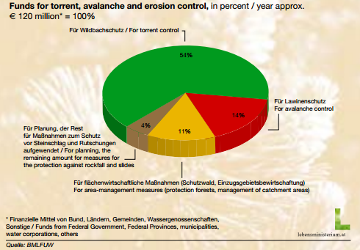
Figure 35: Distribution of funds for measures to protect against some natural hazards
Source: BMLFUW 2009.

Investing in consequence management
Annually, the federal government spent more than EUR 200 million on natural disaster management. The bulk of this funding is channelled through the Federal Disaster Fund, which receives 1.1 percent of federal tax revenue. One quarter of the Federal Disaster Relief Fund is used to compensate households and businesses for losses from natural disasters. At present, neither individuals nor businesses bear the full cost of their exposure to climate risk, which effectively acts as a subsidy for development in high-risk areas (OECD 2013).
After an event, the reconstruction and stabilisation has top priority. There are some possibilities to fund certain recovery measures by the disaster relief fund or the solidarity fund of the European Union. The disaster relief fund is dedicated to finance prevention measures as well as recovery measures. The settlement is processed by an official request of the provinces, which take 40 percent of the total amount. Damages to private property as well as to public infrastructure will be covered by the fund. The BMLFUW IV/5 (2013) stated, that the disaster relief fund satisfies about 20 percent or 30 percent of the loss from disaster of private households and companies. By application for permit at the municipalities, subsidies will be paid out to aggrieved persons. This fund co-finances the operating equipment for fire brigades as well as warning and alerting systems.

Policy review, Evaluation &Organisational Learning

Post-Disaster Assessment
It was indicated by the expert that organisational learning in Austria is mostly based on the experience from real events, which might become disasters in Austria or in neighbouring countries (Expert Interview 2014). Several developments and projects have been put in place in the last decades as results of lessons learned from disasters. A mining disaster in 1988 for instance led to a fundamental adaptation and reorganisation of emergency service for mines. A major avalanche in 1989 was the starting point for improvements in avalanche warning and protection. Although, there was not a general governmental evaluation of the floods in 2002, individual insights caused several adjustments. As a result of the disaster assessment of the tunnel blaze in Kaprun in 2000, the analysis concluded a lack of preparedness and information (CRiSMART 2014). On the one hand, the personnel of the mountain railway had not been trained for this kind of situation; they had received training for other types of accidents, but not for a tunnel fire. On the other hand, there was no awareness of the threat of a fire, because the train and the tunnel were considered to be fireproof. Apart from the shortfalls, the crisis response was smooth because there was an existing crisis management plan in Kaprun. “This plan had been designed for a possible accident at the local power station, but it was quite useful for structuring the rescue work in Kaprun.”
Frequently, results from research project have set the starting point for learning processes. The evaluation of the floods in 2002 in the frame of the projects Flood Risk I and II caused an institutionalisation of flood protection, legislative amendments of the Water Act, etc. A follow-up project FloodRisk II was launched after the recent floods in 2013 in order to evaluate the achievement of these two projects. Also, the case of the Icelandic Ash has revealed a demand for optimization and awareness of rare dangers to mention another concrete example (Expert Interview 2014). A number of other projects could be mentioned as well. According to the BMLFUW (2012) lessons learnt have been considered within the prevention phase and will further direct the realisation of protection measures.

Departmental Lessons Learned systems
The expert at the MoI (2014) explained, that events will be reviewed either in the course of regular coordination meetings, initiated by the ministry concerned or by the competent authority on the basis of the departmental principle or in specific working groups if necessary. In that frame inter-ministerial working groups can be established to discuss hazard potentials and take appropriate actions.

Centralised (national) Lessons Learned system
Once a year, a meeting will be held to coordinate the state and the provinces, as well as individual departments and relief organisations. In the case of a cross-border event, a shared situational awareness will be reached by information exchange systems, located at the Federal Ministry of the Interior. The Federal Ministry of the Interior participates at the INSARAG and is also the main contact point for providing humanitarian aid. Within the last conference of Forum Alpach, the Ministry of the Interior organised a workshop about that issue together with UNOCHA. If there is no event, the bi- and multilateral information exchange is organised in the frame of experts’ meeting (mostly in Brussels). At the time, a close cooperation has been established with representatives from Switzerland and Germany.
It was critically noted by Bossong and Hegemann (2013) that the most investigations deal with technical aspects of a disaster, e.g. torrent control and hazard zoning.

International exchange for Lessons Learned
Exchange of knowledge in Austria is organised on a geo-strategical level in the aftermath of real events. As stated by the expert at the MoI (2014), additionally, insights gained from the supranational level or international organisations like the WHO have stimulated the examination of global threats, e.g. pandemics or epidemics. If a case of a global threat becomes apparent, the competent ministry conveys a conference to discuss the potential threat for the nation with all number of ministries. The MOI usually takes part in lessons learned meeting under the EU civil defence mechanism and shares the results with other national stakeholders (Expert Interview 2014).

Regular policy reviews
As indicated by Bossong and Hegemann (2013), apart from some attention-getting events, there was only less interest on crisis events in Parliament. Mostly, financial aspects, e.g. compensation were raised within debates, but also further protection strategies. Bossong and Hegemann (2013) counted 23 important reforms as a result of disaster experience, which changed the shape of the Austrian Civil Defence System (the Austrian Civil Defence System is based on five pillars: authorities, first responders, the population, science and economy. The Federal Crisis and Disaster Protection Management is a central element of the Civil Defence System) . Finally, a nation-wide capacity of disaster management was established based on the initiative of the Federal government.

Resilience
Within the Austrian Security Strategy (2013), the security policy referred to the concept of resilience as “restoring the proper functioning of the state and society in the aftermath of crises”. Resilience has not become a conventional term in the Austrian linguistic usage.
With regard to the Hyogo Framework for Action, where an emphasis is on the strengthening of the local resilience, Austria is fully on schedule. The well-established principle of sovereignty and subsidiarity is fostering the self-capacities on the community level. The community-based approach is supported by a strong civil society and effects a comprehensive protection against the impacts of natural disasters. A big part of the initiatives at the local level are concerning preparedness activities, and therefore, the national resilience concept is strongly related to that phase.

Information sharing and data protection
Data exchange with third states is done in specific areas on the basis of bilateral agreements. The Austrian Federal Ministry of Agriculture, Forestry, Environment and Water Management, for instance, has already established programmes to exchange information about relevant threats and monitoring systems from neighbouring countries on the basis of special agreements related to nuclear incidents. Other data like meteorological data are also shared with corresponding institutions (Expert Interview 2014).
On the basis of intergovernmental agreements, experts have access to measurement data of the systems of neighbouring countries. In the case of releases of radioactivity in a connected country, effects bear on Austria can be estimated at an early stage. As can be seen in Figure 36, an access to exposure levels of nearly all European member states will be achieved via the link to the European platform EURDEP.
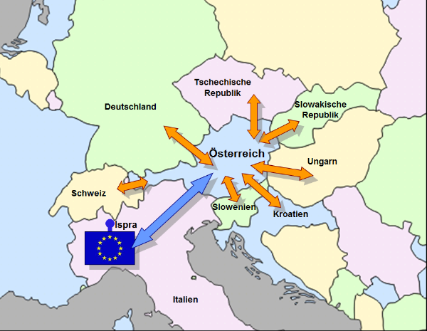
Figure 36: Automatic online data exchange between Austria and neighbouring countries as well as link to the European platform EURDEP
Available at: http://www.bmlfuw.gv.at/umwelt/strahlen-atom/strahlenschutz/strahlen-warn-system/sfws.html.
In cooperation with the Austrian radio channel Ö3, which is a programme of the Austrian Broadcasting Corporation (ORF) and the Austrian Cross, Team Austria was founded in 2007. The initiative is purposing the recruitment, mobilising and coordination of spontaneous volunteers in advance. Thus will be lead to a more efficient assistance of volunteers in the case of a disaster. Via a volunteer’s platform, crisis committees and authorities are enabled to get access of about 35,000 pre-registered volunteers. At the moment, a crowd-tasking feature for fostering resilience by improving the management of volunteers is being developed within the research project RE-ACTA. This approach is further pursued in the frame of DRIVER. According to the Data Protection Act, the protection of the personal integrity has priority. Albeit, if the forwarding of personal data is in the interest of the affected person, i.e. in the frame of the search for missing persons by relatives, the reasons will be balanced. However, only involved organisations exchange personal data among each other, e.g. the emergency service forward information about missing persons to the police, because the search for missing persons is the duty of the police. Also, between the provinces and hospitals data will be exchanged. With regard to data about terrorist activities, data will be available for the Federal Agency for State Protection and Counter Terrorism (BVT) and operative units, but there is no central data management because there is no central unit for data retention (Expert Interview 2014). The Provincial Laws, e.g. the Vienna Data Protection Law envisages an own phrase for dealing with the registration of individuals. The Austrian Federal Ministry of Agriculture, Forestry, Environment and Water Management has already established programmes to exchange information about relevant threats from neighbouring countries on the basis of agreements, e.g. about nuclear incidents and more general – meteorological data (Expert Interview 2014). According to the Data Protection Act, the protection of the personal integrity has priority. Albeit, if the forwarding of personal data falls within the predominant interest of the affected person, e.g. in the frame of the search for missing persons by relatives, the reasons will be balanced. However, only involved organisations exchange personal data among each other, e.g. the emergency service forward information about missing persons to the police, because the search for missing persons is the duty of the police (Expert Interview 2014). Some provincial laws envisage an own phrase for dealing with the registration of individuals.

Legislation

Crisis (emergency, disaster) management concept
In general, there are three documents, which can be considered as the basis for shaping the Austrian approach of civil defence.
SKKM 2020 Strategy
As the main strategic document at the national level, the Ministry of the Interior developed the “SKKM 2020 Strategy”, which defines some basis elements of the Austrian civil defence. The strategy is in compliance with the security and defence doctrine (adopted in 2001) and in addition, it provides amendments concerning the internal security. Therein, the pillars of the National Crisis and Disaster Protection Management were defined (Federal Ministry of the Interior 2009). In July 2009, the Federal Government took notice of the report and approved it. Within the SKKM 2020 Strategy, several commitments to European strategies, such as the prevention strategy, were made and the need for harmonisation between the Federal State, the Federal Provinces and response organisations in disaster cases was addressed. As explained by Potyka (2012), the coordination activity of the SKKM, is a service by the Federal Ministry of the Interior to the provinces.
The main principles, mentioned within the SKKM 2020 Strategy are:
- Considering the principle of self-sufficiency and subsidiarity.
- Ensuring a comprehensive network of danger avert and disaster relief on the basis of volunteers and professionals.
- Easy access to military assistance.
- Promoting self-protection capability of the general public by civil protection initiatives.
- Increasing the level of intervention by concluding cross-border cooperation.
- Respecting the principles of non-discrimination, independency, need-orientation and efficiency in international disaster aid.
In order to achieve the aims of an optimal risk and hazard mitigation, early detection, ensuring a high level of preparedness, efficient and rapid response as well as a quick return to normality after disasters, several tools and measures were specified. Basic elements include technical innovations, stimulation of trainings and education across organisations, improvement of the coordination structure. As an example, recommendations to establish curricula for strategic, tactical and operative staff were addressed. Amongst others, a focus lies on a research-driven and science-based approach to strengthen the disaster management capacity in Austria. In addition, an emphasis was given to the disaster relief fund as the core financial instrument, which provides ¾ of the budget for flood protection and avalanche control and 8.9 percent for operative respond and surge arrangements. Within the document, the traditional three-pillar-model of civil defence (measures of authorities, respond organisations and self-provision of the population) was extended to include the citizens extra as well as the economy. With regard to the Directive 2008/114/EC, the strategy indicated the involvement of operators of Critical Infrastructures in prevention, mitigation, response and relief measures.
Austrian Security Strategy
The Austrian Security Strategy, adopted in 2013, provides a framework for shaping the security policy (Federal Chancellery of the Republic of Austria 2013). Regarding Austria’s relationship with EU, UN, NATO, PfP (Partnership for Peace), EAPC (Euro-Atlantic Partnership Council) and OSCE (Organisation for Security and Cooperation in Europe), a clear statement was made to efforts establishing a common space of security. Therein, the cooperation of the international stakeholders in accordance with the principle of a division of labour for comparative advantage was emphasised. Within the strategy, main sources of threats were defined (Federal Chancellery of the Republic of Austria 2013):
- international terrorism
- the proliferation of weapons of mass destruction
- domestic and regional conflicts or turmoil that affect Europe or have global repercussions
- “state failure”
- natural or technological (man-made, non intentional) disasters
- attacks against the security of IT systems
- threats to the strategic infrastructure
- transnational organised crime
- drug trafficking, crime, corruption
- illegal migration; unsuccessful integration
- the scarcity of resources (energy, food, water)
- climate change, environmental damage and pandemics
- piracy and threats to the transport routes
- the repercussions of the international financial and economic crisis on security
In order to overcome threats in an adequate way, it was defined to continue contributions to PfP (Partnership for Peace) in the security area. Particularly, military interoperability, participation in operations, and the utilisation of cooperation opportunities offered will be ensured by an intense cooperation with other PfP-States.
Within the strategy, special mention was made to the role of the Austrian Armed Forces in internal security. Their participation in national and international crisis management operations recorded remarkable success. In the cases of a natural disaster, threat to a Critical Infrastructure or policing operations, civil authorities can request the Austrian Armed Forces for assistance. Based on multiple areas of the deployment of Austrian Armed Forces, the strategy determines the availability of at least 12,500 soldiers to be deployed in the event of domestic disaster relief operations.
Austrian Programme for Critical Infrastructure Protection (APCIP)
As already indicated in chapter 1.2.3, the Austrian Programme for Critical Infrastructure Protection (APCIP) addresses the protection of critical infrastructures as an approach for specific threats. Therein, the measures to implement EPCIP on the national level of Austria were reflected (Federal Chancellor of Austria 2013). In order to achieve the objectives, defined by EPCIP (European Programme for Critical Infrastructure Protection), an individual investigation of country specific threats and critical infrastructure was conducted. As a part of the vulnerability analysis, the following domains have been examined: the Constitutional Institutions, the Energy Sector, Information and Communication Technologies, Water Supply, Food, Health and Social Affairs, Finance, Transport and Distribution Systems, Chemical Industry, research organizations and emergency and rescue workers. The Action plan proposes the drawing up of a list with strategically important infrastructures in Austria and their prioritization, the definition of standards of protection and security, the implementation of protection measures, the development and the establishment of cooperation regarding the information management and the evaluation of the implemented measures. An orientation on the Critical Infrastructure Warning Information Network (CIWIN), which is part of the European Programme for Critical Infrastructure Protection (EPCIP) have been considered.

General crisis (emergency, disaster) management law
The Austrian Federal constitution does not indicate an own matter of powers and responsibilities for disaster protection or disaster relief. Therefore crisis and disaster management in Austria refers to a fragmented horizontal competence with different legislative responsibilities and laws depending on the specific case of an event (Jachs 2011b). The disaster response system in Austria includes mechanisms to prevent and to ward off disasters. As in other fields of public administration in Austria, legislative and executive responsibilities concerning disaster management are divided between the Federal Government and the Federal Provinces. Exceptions exist, where cases are inseparable matters of the federation, e.g. the radiation protection falls within the competence of the federation. The civil defence laws address the affected communities and the aid workers, support staff members and the authority itself. The different coordination procedures of the provinces are due to the nine different national regulations resulting from unequal definitions of crisis and disaster and regionally specific coordination structures. In Austria, the shaping of the internal security follows the principle of optimizing the warning systems, ensuring cooperation between all bodies with regional civil defence authorities and emergency services based on the legal requirements of the National Crisis and Disaster Protection Management (SKKM).
The National Law Desk Survey conducted by Potyka (2012) concluded:
In substance, there is no national disaster management law, but only national disaster management coordination by the Ministry of the Interior. However, particular legal regulations (e.g. in the fields of customs, traffic etc.) also take account of the needs in case of disaster, which facilitates national activities in the field of disaster management.
In 2009, the directive to mitigate the risks of flooding for health, environment, heritage and economic affairs was implemented in national law (European Parliament and the Council 2007). Thus, competences of the federal state and the provinces were affected in the area of disaster protection, environmental protection as well as flood and avalanche protection (Hornich 2013). Furthermore, the legislation about the Union Civil Protection Mechanism which contributes to the implementation of Article 222 TFEU stipulating the obligation to provide aid in the spirit of solidarity in case of a terrorist attack or disaster came into force in 2014 (European Union 2013).
There is no primary act of disaster management on the state level, but the provinces have established laws on disaster relief or disaster protection on their own. Provinces have enacted regulations regarding the disaster response and the disaster preparedness. Within the report of Potyka, an overview on relevant disaster related laws have been provided (2012). Disaster mitigation, prevention and disaster risk reduction have been covered by the Austria Forest Act (2002). The Water Act defines water-specific mitigation and prevention strategies (Federal Law Gazette 1959). As already mentioned in previous chapters, also the Law on Defence (2001) is a disaster related regulation at the national level.
At the level of municipalities, districts and provinces the following plans are available (Jachs (2011a), Jachs (2011b):
- Disaster Protection Plan
- Special Alarm Plan for certain disasters, like tunnel accidents
- Emergency Plans for SEVESO establishments
- National Intervention Plan for radiological emergencies
- Pandemic Plan
- Plan on the Early Warning System: Radiation Early Warning System, Weather Warning, Communicable Diseases
- Plans on the flood prediction model

Emergency rule
In Austria, no emergency rule exists in the ordinary sense of the word, but what is involved is an extended transfer of legislative power if the Parliament is unable to meet and to perform its functions (EUROPEAN COMMISSION FOR DEMOCRACY THROUGH LAW 1995).
Bossong and Hegemann (2013) reaffirmed this finding and explained:
There are no rules for a general state of emergency including derogations from civil liberties and democratic oversight. Emergency laws are to be differentiated from a local or regional state of disaster that allows for the upscaling of competences. As determined by Art. 18-II B-VG, the federal president can put in place provisional legal acts at the suggestion of the federal government for the prevention of an “obvious, irreparable damage for the society” if the national parliament is not able to convene.
As indicated by Khake (2009), the power to take measures in times of crisis or emergency in order to provide necessary supplies was transferred to the executive body of Austria. In detail, the Constitution of the Republic of Austria entitles the federal authorities to take special measures to ensure basic supplies in times of war, threats to the constitutional order and public security, natural disasters or other calamities are provided for.
On the recommendation of the Federal Government, the President of the Republic of Austria is authorised to take necessary measures by way of provisional law - amending ordinances, if the Parliament is not assembled, or if it cannot meet in time, or is impeded from action by circumstances beyond its control, to prevent obvious and irreparable damage to the community (EUROPEAN COMMISSION FOR DEMOCRACY THROUGH LAW 1995). It was further pointed out, that such an “ordinance requires the countersignature of the Federal Government. Such ordinances must be submitted by the Federal Government to the National Council (comment: a chamber of the parliament) without delay. Within four weeks of submission, the National Council must either vote a corresponding Federal Law in place of the ordinance or pass a resolution demanding that the ordinance immediately be invalidated.”
Within the Constitution, the Austrian Armed Forces are foreseen to “protect the constitutional order and public security by assisting in cases of natural disaster or other serious calamities. This implicates the right of the Armed Forces to intervene on their own initiative in certain cases when civilian authorities are incapacitated” (Khakee 2009).
The web page of the Parliament of the Republic of Austria provides the following information (2014):
The Austrian Federal constitution determines for the state of emergency special emergency provisions, namely the deployment of armed forces, an emergency decree of the Federal President, an emergency decree of the Federal of the Federal provinces as well as a direct Federal land management by the governor of the province. Emergencies in the face of wars, natural disasters and comparable events pertain as exceptional circumstances. In the course of a state of emergency, the Federal President can modify laws and order certain measures to be taken by emergency decree, can decide to move the seat of the chief organs of the state and the National Council to a different location. The Standing Sub-Committee has a particularly important role to play in exceptional situations – natural disasters or the outbreak of a war: if the National Council cannot meet, the Federal President can issue emergency decrees, but only when proposed by the Federal Government, which in turn requires the approval of the Standing Sub-Committee of the Main Committee.
The constitutional law limits the emergency decree by prohibiting:
- the amendment of Federal constitutional provisions
- a permanent financial burden on the Federal State, the Federal provinces, the municipalities or financial obligation of citizens
- the sale of state property
- measures concerning labour law, social security and insurance act system, Chamber of Workers and Employees, right of association.
Since the Second Republic has been proclaimed, the emergency decree has never been applied (Austrian Parliament (2014)).

Specific, department/agency-level legal arrangements and regulations on emergency and disaster management
Due to the fact, that crisis and disasters might cross the borders of the federal provinces or the federal state, which require an overall coordination, the national government has the power to coordinate disaster relief (Potyka 2010). On Federal level, the Law on Federal Ministries defines that the Ministry of the Interior is responsible for the coordination of the federal crisis management, governmental Crisis and Disaster Protection and the International Disaster Response (Bossong and Hegemann 2013).
According to the principle of a divided administration, relevant legislation for risk and disaster management can be identified at the three administrative levels (Leitgeb and Rudolf-Miklau 2004). In particular, nine legal acts by the state constitute the disaster management framework in Austria.
- Water Act
- Forest Act
- Torrent Control Act
- Water Construction Financing Act
- Disaster Relief Fund Act
- Ordinance on Hazard Mapping
- Guidelines on Hazard Mapping
- Technical Directive for Torrent and Avalanche Control
- Directive for Cost- Benefit- Analysis on Torrent and Avalanche Control Measures

Specific to the regional and local authorities legal arrangements and regulations on emergency and disaster management
According to the general clause of Article 15 (1) of the Federal Constitutional Law, the response to crisis and disasters is primarily a matter of the provinces. Each province is authorized to create appropriate rules and laws on their own (Bußjäger 2003). This means that the Federal provinces are mandated to organize disaster relief services and resources for emergency assistance and disaster relief operations. “In case of local emergencies, regional laws generally foresee official responsibility for relief measures and their management to rest with district administrations or mayors, while major disasters fall under the competences of regional administrations.” (European Commission 2014)
In Austria, nine different laws exist, which take influence of the structure of the Land centres. Civil defence laws regulate how processes, in contrast to normal life, must be organized to minimize the impact of disasters of various kinds. The civil protection laws are on one hand relevant for the affected communities and on the other hand, aid workers, support staff members, finally the authorities themselves. Depending on the country and the possible disaster scenarios, the laws are adopted at various levels. Potyka (2010) indicated that the provinces use different terminologies of disaster, which caused a plurality of the legal scope.
At the level of federal provinces, mainly three laws influence the Austrian disaster management.
- Civil defence Acts
- Areal Planning Regulations
- Building Trade Acts
Due to the executive nature of municipalities, the sphere of disaster management has been shaped by ordinances of the community. Furthermore, at the local level of municipalities and communities the following regulations play an important role (Leitgeb and Rudolf-Miklau 2004):
- Hazard Maps on Torrent and Avalanche Control
- Area planning scheme
- Local development concepts
- Development scheme
- Planning and building permissions
- Alarm and action plans for disasters

Legal regulations on the involvement of volunteers and specialised NGOs
The involvement of voluntary organisations in disaster relief is regulated on the basis of nine provincial laws, which may differ in some kind. However, there is no unified law on that issue. In the case of any damage, caused by a volunteer, the cost must be covered by the Disaster Relief Fund Law on Official Responsibility (Amtshaftungsgesetz), BGBI. Nr. 20/1949 as amended by BGBI. Nr.537/1984) (Austria, 1984).

Legal regulations for international engagements of first responders and crisis managers
As stated by Potyka (2010), the Federal Ministry of the Interior is the competent authority to coordinate disaster relief in Austria. The legislation does not specify extra procedures for international assistance and Austrian relief. However, bilateral agreements are in place between Germany, Croatia, Liechtenstein, Jordan, Slovakia, Switzerland, Slovenia, Czech Republic and Hungary.
Regarding the regulation for the international deployment of rescue workers, it has been stated by Potyka (2010):
Foreign state aid providers requested by Austria would possibly have to be regarded as employed by the competent Austrian authorities. Furthermore, the Austrian authorities or their legal entities (federation, federal state and community) would generally be responsible and accountable for the actions of these foreign aid providers.
According to the Law Implementing the Aliens Act (No. 188/2005), ”nationals of non-EU states are exempted from visa obligations for the length of the transit if they are part of the flight crew or attendants of an emergency or rescue flight or are otherwise active as rescuers in the event of disasters or accidents.” Travel Visas will also be granted for relief workers for the duration of three months. Regarding the liability, “foreign state aid providers requested by Austria would possibly have to be regarded as employed by the competent Austrian authorities. Furthermore, the Austrian authorities or their legal entities (federation, federal state and community) would generally be responsible and accountable for the actions of these foreign aid providers.” At the moment, law does not specify certain qualifications of the relief workers. The security services are responsible for the safety of relief workers, premises, transport, equipment and goods. It was stated, that some rescue services have “fleet insurance policies” because of the number of vehicles they have.
Potyka indicated that provisions were made for the exemption of import duties for relief supplies and relief items of disaster relief teams. The Federal Ministry of Economics, Family and Youth has to ensure a rapid supply of relief items, simplifying the bureaucratic hindrance. Exceptions of the import and export of medical products are covered by the Narcotic Drugs Act.

Organisation

Organisational chart
The Disaster Management in Austria is organized decentralised with different responsibilities on the various spatial levels. As illustrated in Figure 37, the management of crisis and disasters calls different actors and responsibilities on stage.
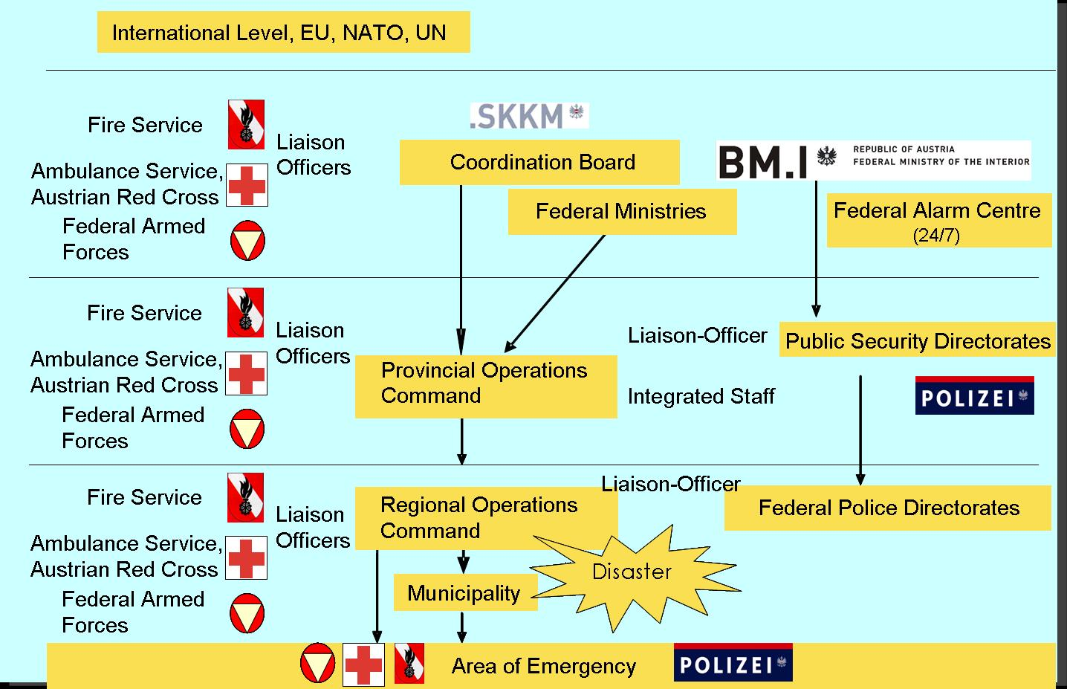
Figure 37: Organizational Chart of the disaster management in Austria
Available at: http://ec.europa.eu/echo/files/civil_protection/vademecum/at/2-at-1.html; accessed: 14th June, 2014.
The Federal Crisis and Disaster Protection Management (SKKM) is located at the Federal Ministry of the Interior (FMI) and acts as a centre for coordinating measurements of authorities and relief organizations in the case of particular hazards, hazardous events and disasters. Chaired by the Executive Vice President of public safety, the council of ministers, where Federal Ministries, provinces and relief organizations are represented, decided to establish an administrative organization for the coordination of public safety - the Federal Crisis and Disaster Protection Management (called SKKM). The responsibility area of the department II/4 of the Federal Ministry of the Interior is divided into National Crisis and Disaster Protection Management (SKKM) and Civil Protection (Federal Ministry of the Interior 2014).
As explained by Jachs (2005), in the frame of the preparation for the World Conference on Disaster Reduction:
At the federal level, a co-ordinating committee was set up for crisis and disaster management. This committee consists of representatives of all ministries, offices of provincial governments, the major rescue organisations and representatives of media. Similar co-ordinating committees are established at the level of provinces and districts. According to the magnitude of a disaster co-ordination is done by district administrative units, provincial governments or the federal government.
An overview of the composition of the Coordination Committee, chaired by the Federal Ministry of the Interior is provided by Figure 38.
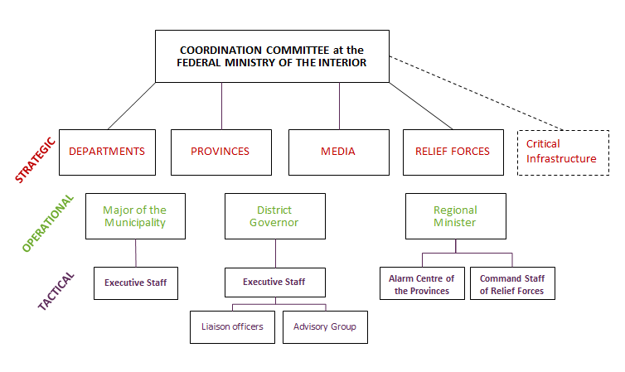
Figure 38: Structure of the Coordination Committee in Disaster Management
Within the Coordination Committee, strategic, operational as well as tactical actors are represented.
The BWZ serves as the central point for the combined warning and alarm system of the Federal Government and the Federal Provinces and is the permanent observatory for the radiation early warning system. It is connected with the information system of the Warning Centres of the Federal Provinces (LWZ), all competent centres on a federal and regional level, the relief and rescue organisations, such as Fire Brigade, Red Cross, Alpine Rescue Organisation, as well as the contact points on a bilateral (neighbouring states), supranational (EU–ERCC), multinational (NATO partnership for peace), and international (UN) level (Federal Ministry of the Interior 2014).
As another step to implement the National Crisis and Disaster Protection Management (SKKM), the provinces assume a strategic part in disaster protection. Measures are managed partly in cooperation with the federation. Each Federal Province has a duty to ensure an efficient disaster protection at the level of district and Federal Province by entrusting appropriate authorities (Jachs 2011a). The disaster relief service of the provinces includes the country’s fire brigade association, its institutions and equipment, as well as relief (forces) organizations and personnel resources. The authorities of the provinces operate as the core institutions to manage events; therefore they are featured with special rights for governing the crisis and disaster management. In consequence, every country has established alerting and warning systems. “Their task is to warn and alert the public in case of imminent danger and to coordinate rescue and relief forces during major disasters.” .
As soon as an incident exceeds the capabilities of the local authority, the responsibilities are transferred to the next high level. If an event extends the territory beyond the competence of a municipality, the district authority assumes the role of leading disaster protection authority. The government of the Federal State is called into action if an event cannot be managed with the capabilities of the district level and/or exceeds the political area of the district.
Within reasonable limits, the municipalities have the responsibility to ensure an effective disaster protection. In the case of an event, municipalities are obligated to provide mutual help. Fire brigades have to carry out supporting measures if a certain alert level is reached. Furthermore, the governments of the provinces are authorized to request the assistance of the municipalities for prevention and response activities on district level. Following the principle of subsidiarity, the Mayor of a municipality, the district authority or the government of the provinces are acting as the major authorities for managing the local disaster response.
Based on the coordination approach, the media, especially the ORF as the state broadcasting station, participate at coordination meetings. Mandated with a public service mission, ORF is recognised as a trustworthy source of information about current events. In emergencies, a permanent communication will be established between the EKC and the ORF (also with the APA – the Austrian Press Agency), which will disseminate serious information to the public (Jachs 2011c).
Furthermore, private business is covered within the civil security strategy based on specific regulations. They address certain economic sectors in particular. Especially, for risky or high-vulnerable industries appropriate standards and instructions exist. Each province disaster management law addresses certain regulations. As indicated by Bossong and Hegemann (2013), especially those companies, which are operating hospitals or mines or dealing with dangerous goods, require emergency plans. The strong focus on specific industrial partners has been reflected in the Austrian Programme for Critical Infrastructure Protection. Bossong and Hegemann have illustrated the relationship on the basis of some examples, which will be summarised below. Due to the fact, that the ASFINAG is responsible for tunnel safety and transport issues, a close cooperation with the state-owned infrastructure corporation exists to prevent transport accidents. Also, the ÖBB, as the Federal Railway Company, is integrated in issues regarding the transportation security. The security of the supply chain is amongst others addressed to the power providing company “Verbund AG”, which is a relevant stakeholder in the field of energy security. Last but not least, the ELG – as the Austrian Central Stockholding Entity is considered as a critical infrastructure because it is responsible for the holding of emergency stocks. As illustrated in Figure 38, these four companies – labelled as Critical Infrastructures, will be optionally consulted, if a relevant issue has been raised.

Organisational cooperation
Within the “National Crisis and Disaster Protection Management Strategy 2020”, it has been defined that the Federal Ministry of the Interior acts as the head of the coordinating body. Chaired by the Director-General for Public Security, the strategic level of the coordination body will comprises of the representatives of the federal ministries, the offices of the Provincial governments and accredited emergency services, i.e. ARC, ASBÖ, ÖBFV and ÖBRD. Core issues at that level cover an overall information exchange, the definition of strategic action points and fundamental aspects of an emergency. If a cross-border event will require coordination, the MoI is authorized to establish specialist groups by requesting the Austrian Press Agency, the media as well as experts. Legally, cross-border missions are directed by bi- and multilateral agreements of regions, provinces and the state, which define the request and the provision of assistance. Apart from regional agreements between a province of Austria and a neighbouring region or a neighbouring country, the Federal Ministry of the Interior is processing the assistance, i.e. the organisation of the deployment of domestic forces in a third country and vice versa (Expert Interview 2014).
Tactically, the commander of emergency services, i.e. the commander of the fire brigade or the commander of the National Rescue Operations Unit of the Austrian Red Cross, will be able to expand their staff on its own. As it has been stated within the “SKKM Strategy 2020”, the federal structure benefits from an easy access to military forces of the authorities at all spatial levels (2009). Due to the fact, that the disaster management at the national level is based on an interdepartmental cooperation by the superordinate Coordination Committee, several federal ministries are strongly involved in National Crisis and Disaster Protection Management. The Federal Ministry of the Interior is concerned with the strategically processing of assistance interventions, its preparation and execution. The processing of logistic flows, e.g. transport, crossing of boarders in the frame of foreign aid and customs matters also lies in its competence area. Furthermore, a permanent communication to other contact points like the NATO, UN and the media is ensured. The preparation of final reports for submission to the Federal Government and the securing of the financing of response activities are required (Jachs 2011b). According to the legislation (listed in 2.4.), the Federal Ministry for Agriculture, Forestry, Environment and Water Management (BMLFUW) is the main strategic responsible prevention measures in Austria. As an authority of the BMLFUW, the Federal Forest Engineering Service for Torrent and Avalanche Control together with the technically specialised district authorities at the provincial level fulfil their duties on the community level (Leitgeb and Rudolf-Miklau 2004). The strategic direction of Torrent and Avalanche Control is located at the department III/5 of the Federal Ministry for Agriculture, Forestry, Environment and Water Management. Additionally, the strategic actor is responsible for the planning and the construction of technical and biological measures to protect against natural hazards (Stiefelmeyer and Sattler 2012). Within the management of flood risk, various responsibilities result due to federalist constitution of Austria. By identifying flood-discharge areas and risk zones, the Federal Water Engineering Administration provides expert opinion for the local regional planning and is also engaged in communicating the threat of flooding to the citizens. Departmental cooperation has been established with the Federal Ministry for Agriculture, Forestry, Environment and Water Management (department IV/6) and the offices of the Provincial government. The department IV/5 - Torrent and Avalanches Control, takes the strategically regulation of the protection against natural hazards, e.g. torrents, avalanches, rock falls, mudslides and floods. According to the Austrian Radiological Protection Act and the EURATOM Treaty (Art. 35), Austria is obliged to operate an Environmental Monitoring Network. In the case of exceeding thresholds, the Federal Ministry of Agriculture, Forestry, Environment and Water Management are responsible for the alerting procedure. Therefore, it uses the real-time forecasting system TAMOS, which is also applied at the ZAMG. In Austria, 335 automatically ODL-measurement devices for the measure of the gamma radiation are installed. These systems send status messages to the data centre of the radiation early warning system (BMLFUW, V/7 2009). A part of the disaster relief fund is dedicated for immediate measures of the Federal Ministry of Agriculture, Forestry, Environment and Water Management. This department is also assigned with the development of appropriate approaches and strategies for preparedness, prevention and mitigation, as well as the coordination of the expert analyses. The supervision of analysis on natural area and the geographical information system NIAS-Forts are core tasks, which the department is responsible for. Research activities are initiated projects in the area of services for torrent and avalanche barriers. As a subordinate agency of the Federal Ministry of Science, Research and Economy, the ZAMG, is a state service for observatories of meteorological, geophysical and air chemistry measurements. The ZAMG has to fulfil substantial statutory tasks and but has also a partial legal personality to act under private law. Flood events concerning the Danube, March and/or Thaya, the ”via donau” as an executive body of the Federal Ministry for Transport, Innovation and Technology shares the responsibility with competent offices of the provincial government (BMLFUW 2014c). The “via donau” is a limited liability company, founded by the Austrian Ministry for Transport, Innovation and Technology, entrusted with the administration and preservation of Federal waterways. In addition, the “via donau” is operating the shipping information system DoRIS (Donau River Information Services). In general, the Federal Ministry of Traffic, Innovation and Technology is responsible for events, which focusing on transport accidents, while the Federal Ministry of Health deals with epidemics and the Federal Ministry of Economy, Family and Youth covers mining disasters (Bossong and Hegemann 2013).
Austria has signed international agreements for assistance in disaster situations. The agreements are formal international treaties and include provisions on the responsible agencies, the modalities of border crossing, coordination and command as well as costs and compensation. Cross-border missions are on the one hand directed by European or international legislation and rules of procedures and also by bi- and multilateral agreements of regions, provinces and the state, which define the request and the provision of assistance. The basic provisions of the agreements are largely similar and follow the first agreement signed with Germany. Furthermore, the non-nuclear country Austria has entered into bilateral agreements on nuclear safety with eight countries in Eastern and Central Europe (Bossong and Hegemann 2013). The Federal Ministry of the Interior is coordinating Austria’s contribution to international disaster relief assistance in collaboration with other ministries, the federal provinces and emergency services (Jachs 2011b). Apart from regional agreements between a province of Austria and a neighbouring region or a neighbouring country the Federal Ministry of the Interior is also processing the assistance, i.e. the organisation of the deployment of domestic forces in a third country and vice versa (Expert Interview 2014). For this purpose the MoI relies on the established response organizations in Austria and does not maintain specific extra capacities. Modules for EU interventions for instance which were registered at the CECIS are operationally managed by regional fire brigade associations and mobilized upon request of the MOI. Referring to the ANVIL report, Austria had offered international assistance in 59 cases between 2003 and 2010 (Bossong and Hegemann 2013). Due to the fragmented civil security system, assistance is usually provided by various local and state- level actors. There are also some special units that are frequently used for international assistance, such as the Medium Urban Search and Rescue Unit of the Workers Samaritan Association (ASBÖ 2010) and the International Response Team of the Austrian Red Cross (ARC). There Federal Ministry of the Interior (MoI) is authorized to set up crisis teams and act with the Federal Warning Centre as contact point for official requests.
The MoI established efficient communication structures with:
- DG ECHO, Brussels
- NATO - Euro Atlantic Disaster Response Coordination Centre (EADRCC), Brussels
- UNITED NATIONS - Office for the Coordination of Humanitarian Affairs (UN-OCHA), Geneva.

Procedures

Standing Operating Procedures (SOPs) and Guidelines
Austria has several generic plans and policies with recommendations on how to deal with disasters. Apart from instructions, checklists or contact directories, there is no overall plan on the national level. It has been explained by Jachs (2005), contingency plans are available for municipalities, districts and provinces. Therein risks have been described, specific measures defined and information about available resources provided. The MoI emphasised, “Disaster management does not work like a recipe” – the persons acting in an event are well educated, have a good grasp and the capabilities to cope with different scenarios. This can be achieved through a comprehensive planning process and continuous training on the job and frequent lessons learned. On the national level, there are only a limited number of plans for large-scale and cross-border events like nuclear emergencies and pandemics. Plans are partly published like the national response plan for nuclear emergencies. As an example, the document “Leading in disaster operations” was published by the MoI in 2006. It provides guidelines for staff commanders in the area of situational awareness, leadership, technical equipment, responsibilities, etc. As far as a written procedure already exists, it will be applied (2014). Experiences show, that written procedures are frequently not up to date – they need to be upgraded from event to event. Written plans rather build the basis to evaluate the performance within an event. The building regulation illustrates an exceptional case; in this regulation detailed directions have been stipulated. No extra regulation has been defined the priority-setting in the case of co-occurring events. Due to the clear division of competences on each level, this scenario will not receive particular attention. The Austrian Red Cross frequently participates at the development of standards in the field of humanitarian aid, as well as in drafting operation procedures with a specific focus on threats or intra-organisational tasks and inter-organisational cooperation.

Operations planning
From a strategic viewpoint, standardisation plays a vital role in improving current procedures and structures. Fehler! Verweisquelle konnte nicht gefunden werden. will provide a short overview on some relevant standards in the area of civil defence, disaster management, etc., mentioned by Jachs (2011b).
Table 8: Overview on some relevant standards in the area of disaster management operations
Standard | Title | Brief description
ISO/DIS 22320 | Societal Security – Emergency Management – Requirements for Command and Control | It’s a standard about leadership in disaster relief and emergency management as well as for trans-organisational coordination. It is similar to the document “Leading in disaster operations”.
ISO/PAS 22399 | Societal Security-Guideline for Incident Preparedness and Operational Continuity Management | It is a best practice for emergency prevention and continuity planning.
ÖNORM S 2304 | Integrated disaster management | Terms and definitions in the context of the management of disasters, emergencies and crisis; considering interoperability
ÖNORM S 2310 | Risk, security and crisis management | Selection and verification criteria for persons appointed for crisis management, disaster prevention, cost reduction
ONR 192320 | Crisis and disaster management | Integrated operation control with particular consideration of different management methods, considering cross-border events
ONR 12261-7 | Crisis management | Digital exchange of geographic data considering decision making and usage of geo-data for training
IEEE Standard 1512-2006 | Incident Management | - Emergency Management Centres  - Exchange of data about public safety and emergency management  - common incident management message sets – Abstract Syntax Notation One ("ASN.1" or "ASN")  - Incidents (transportation-related events)

Logistics support in crises
In Austria’s decentralised civil security system, local crisis management agencies and emergency organisation provide the bulk of the necessary logistics (Bossong and Hegemann 2013).
In particular, the Fire Service provides special assets for emergencies. To give an example, the special equipment from a command vehicle is listed here (FEU (2014)
- “long-term breathing apparatus
- protective clothing
- power supply units with illumination equipment
- evacuation pump units
- hydraulic rescue equipment
- pneumatic and hydraulic lifting equipment
- flame cutters
- grinding cutters
- chain saws
- air compressors with drilling implements
- blasting equipment
- all kinds of tools
- sand bags, etc. “
In the case of disasters, the federal provinces are authorized to avail resources of individuals and private (logistic) providers for an adequate compensation by a formal decision. Disaster management authorities on each level are legitimated to call for back-up and request personnel or material resources from the military. Authorities of the provincial governments assign services from designated relief organisations, which are regulated by legal acts of the provinces (Expert Interview 2014).
It has been found out by Bossong and Hegemann (2013):
“There are no specialised independent agencies with an overall mandate for civil security at the federal and regional level. Though private companies are required to observe a number of formal obligations and increasingly participate in some coordination and consultation structures, privatisation and outsourcing do not play a significant role in Austrian civil security.”

Crisis communication to general public; Alert system; Public Information and Warnings
As it was declared by the BMLFUW (2012), the information policy is a part of the prevention too. The focus is on the self-empowerment and the knowing about hazards by the citizen to promote their self-provision capacities. Facing cross-border crisis and disasters, the Federal State acts as an information hub and a coordinator of wide spreading events, therefore the Emergency Operation and Coordination Centre was established in 2006. The operative element of the National Crisis and Disaster Protection Management (SKKM) is the Federal Warning Centre; it is a permanently manned service location and generates situation awareness in crisis and disasters (Jachs 2011b).
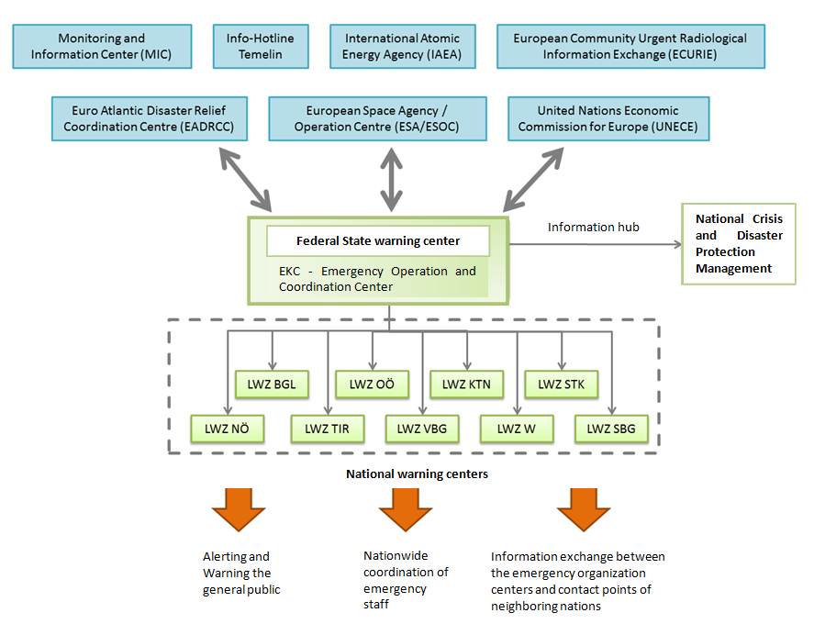
Figure 39: Information flow in disaster situations between the EU and emergency response authorities in Austria
As illustrated in Figure 39, if a large-area event occurs in Austria or its neighbour states, the information will be concentrated at the Federal warning centre, aiming at a rapid communication exchange between authorities inside Austria and foreign warning systems. As contact point for the Info-Hotline Temelin, the ECURIE, the IAEA, the ERCC, the EADRCC and the ESA/ESOC and the Federal warning centres stay in contact with the centres of the countries (Jachs 2011a).
The federal legislator directs the establishment of security centres or warning centres in each province and mandates the development, upgrading and administration of alerting and warning systems to ensure immediately situational awareness. In crisis and disaster case the alert and warning centres (LWZ) acts as a central hub for emergency services by providing appropriate facilities and modern technology. They are responsible to alert and warn the general public in crisis and disaster situations and take regional coordinating actions for their respective countries. Incoming emergency calls are taken by authorized call takers, who have an overview about the available resources and can alert the responsible organization or authority. In 2011, 6.9 billion incoming emergency calls were registered in Austria (Federal Ministry of the Interior 2010). Additionally, their tasks include to link communication between emergency organizations and the neighbouring nations. In the warning and alerting centres of the Federal Provinces, information from various (sensor) systems is merged and registers water levels, wind strength and even radiation levels. They are connected transnationally and enable information exchange beyond national and organizational boarders, e.g. information from the Central Institute for Meteorology and Geodynamics, which is Austria's national weather service agency.

Capabilities

Human resources
As explained by Potyka (2012):
However, since disasters have to be remedied in the first place by the persons affected, subsequently also by the local community and the population of the entire region where the disaster occurs, the provinces as well as the municipalities also hold extensive competences in his field. On the local and regional level, the voluntary fire brigades play an important role in combating disasters, both natural and man-made.
In Austria, authorities can draw on approximately 413,000 relief forces in the response to disasters. About 85 percent of the total human resources will be volunteers (BMASK 2009). About 14.2 percent of the volunteers have been actively engaged in disaster relief and rescue service (STATISTIK AUSTRIA 2008). As stated by the research institute in 2013, this means a voluntary resource of 360,000 persons (2013). In 2008, 413,000 Austrians were engaged voluntarily and 37.4 percent of them have been regularly participated in disaster missions, which represented about 1,576 hours per week.
The Fire Brigades (ÖBFV) were considered as an acknowledged, traditional organisation. They assume manifold tasks, including fire-fighting, averting dangers and disaster relief. Their organisation principle is based on the various provincial laws. They are organised locally and are operating on the behalf of the municipalities. Fire Brigades exhibit a high degree of technical know-how.
The ASBÖ is second largest ambulance in Austria. It is concerned with daily routine tasks, i.e. patient transportation as well as with emergency-related task, such as disaster relief, refugee settlement and providing the rescue dog group. The JUH is not represented in all provinces in Austria, but in the capital city Vienna, it is providing emergency aid.
As a special-skilled force, the ÖBRD is mainly concerned with accidents and emergencies in mountain regions. Therein it performs annually about 7,000 missions.
The Christopherus Helicopter Rescue Service, accompanied to the ÖAMTC is another specialized organisation, dedicated to provide quickly help in relief missions. Currently, 250 emergency doctors are joining the CHRS.
The Austrian Red Cross operates internationally and covers 5,600 employees and 51,000 volunteers. On behalf of its mandate, based on the Geneva Convention, it is concerned with the humanitarian aid, disaster relief and, among others, with search-services. As one of the biggest NGOs, it is experienced with cross-border missions. Primary a part of the ARC, in the meanwhile the MHDA has established itself in the field of ambulance service.
The Federal Police Forces will be mainly involved in search and rescue operations, because it is the competence of the police to search for missing persons. In that purpose, the executive body has access to data-bases, where missing persons may be registered.
In order to fulfil their duties in emergency cases, the Austrian Armed Forces are built upon Land Forces, Air Forces and Special Operations Forces (Ministry of Defence and Sports 2014). About 12,500 members of the Austrian Armed Forces can be mobilised in the case of an emergency. Disaster relief units of the Austrian Armed Forces are composed of volunteers on active service and militia. If needed, civil specialists, i.e. rescue dog brigade, will support them. Specialised forces, such as the CBRN-defence corps, decontamination units, drinking water purification unit or pioneers will be deployed in certain emergencies.

In Table 9, the personnel resources of the most important relief forces are listed(Multiple sources were used to develop this overview: BMASK 2009, FreiwilligenWeb 2014, Wikipedia 2014, Jachs 2011b)
Table 9: Overview on relief personnel for emergencies in Austria
Stakeholder Type | Name | Number of Personnel
Emergency Organisation | ARC | 48,500
 | ASBÖ | 3,879
 | CHRS | 250
 | ÖBRD | 11,420
 | JUH | 590
 | MHDA | 970
 | ÖRHB | 724
 | ÖHR | 298
 | ÖBFV | 249,000
 | Team Austria | 33,000
Federal Security Authority | Federal Police Forces | 27,000
Governmental unit | Austrian Armed Forces | 12,500

Materiel (non-financial) resources
Especially for radiological emergencies, the federal state established prevention measures by storing potassium iodide tablets, livestocks and some useful items. A total of 5 million packages of potassium iodide tablets are available at schools, hospitals, pharmacies and occupational doctors.
PHAGO pharmaceuticals wholesalers maintain a stockpile of over 50,000 pharmaceutical products to guarantee Austria's full supply of pharmaceutical products even during emergencies.
Furthermore, about 300,000 tablet packages are stored at the Federal Ministry of the Interior. By an order by the Ministry of Health the tablets will be distributed for free. For an emergency case, the “Lebensmittelbewirtschaftungsgesetz” regulates the structure and the distribution of food reserves in Austria (AMA 2014). The Federal Minister of Agriculture, Forestry, Environment and Water Management is authorised to set all necessary measures to avoid supply problems. This may include the seizure of goods, the expropriation of goods as well as prohibitions and requirements regarding the use of foodstuffs. Furthermore, the Federal Minister of Agriculture, Forestry, Environment and Water Management can instruct and authorise the governors of the provinces with extensive powers. He or she can also assign the public body of the Agrarmarkt Austria with the handling of food reserves. Appropriate prevention measures have been also defined in the “Lebensmittelbewirtschaftungsgesetz”. Municipalities will have the right to make use of registration data according to the Reporting Act. According to IAEA (2014), the Austrian Central Stockholding Entity (ELG) held an emergency oil stock of about 3.0 Mt (99 days of net imports).
In Austria, emergency stocks are not held separately from commercial stocks – all oil products held by ELG are commingled stocks. The legal framework for Austrian emergency management is the Energy Intervention Powers Act (Energielenkungsgesetz 2012) and the Stockholding Act (Erdölbevorratungsesetz 2012). Within the review it was stated, that in 2011, a total storage capacity in Austria stood at 6.6 mcm, or around 42 mb of crude oil and oil products. The storage capacity is almost evenly distributed between crude - 53 percent (3.5 mcm) and 47 percent oil products. As identified by IAEA (2014), Austria does not have government stocks on gas, nor does it place an obligation on its suppliers to hold natural gas reserves. In the case of disasters, the Military exhibits a rapid response capacity by mobilising a high amount of personnel. Apart from their availability, their special skills concerning technical know-how, i.e. water purification, CBRN defence capacities and the provision of specialised assets, i.e. the Landesbrückengerät (bridge building devices).

Training
Training is not organised centrally but authorities and response organisations at each level offer specialised education programs according to their specific focus (2014). Austria for instance has nine fire-fighting schools in the provinces. The qualification of fire fighters is regulated by specific curricula. The qualification of personnel in emergency medical services is regulated by a national law, i.e. the paramedic law, which also provides for certification. Governmental authorities also have their internal training system. The Ministry of the Interior furthermore offers specific leadership training in its security academy. In this frame the Ministry organizes different training courses for high-level decision makers. Voluntary participants will be acquainted with theoretical basics as well as with practical principles of leadership. Within the SKKM Strategy 2020, a four-part module-based training programme has been defined (Federal Ministry of the Interior 2009). Officials of an authority and the top-level managers of an emergency service will be provided with an introduction to the legal framework of the disaster management. These insights should build the basis for the second module – leadership in disaster missions. Targeting staff members, as a high-sensitive issue, crisis managers will be trained in a module about the risk and crisis communication. Finally, the module “Risk analysis and Disaster Protection Planning” is dedicated to provide an initiation into risk analysis, focusing on natural hazards. Furthermore, the Federal Ministry of the Interior coordinates the participation at European training programmes and delegates also national experts.
Until now, Austria has completed eight modules of the European Union Modules.

Procurement

Procurement regulation
Procurement of crisis and disaster management assets is not centralized but the relevant actors on different administrative levels do it. Austria does not acquire specialised equipment for international disaster management but uses available resources (Expert Interview 2014). After a formal request for assistance the Federal Ministry of the Interior usually coordinates the provision of relief goods. Given this fact there is currently no explicit national position on this issue which could be mentioned in this context. Procurement is generally done in accordance with existing national and supranational legislation depending on the deliverables needed.
At the moment, the provision of assistance after the request of a foreign country frequently includes the availability of personnel and material resources. In any case, a strict statutory regulation will be required to regulate such legal aspects.
In Austria, procurements of the MoD is in compliance with the Public Procurement Law is and the Federal Defence and Security Procurement Act. The first one implements Directives 2004/17/EC, 2004/18/EC and 2007/66/EC and “therefore covers the legal framework for the award of both public contracts from public entities and entities operating in the water, energy, transport and postal sectors (“sectoral entities”)” (EDA 2014). In addition, procurement of specific defence products and services is regulated by the Federal Defence and Security Procurement Act, which implemented Directive 2009/81/EC. Both federal laws are applicable for purchases above certain thresholds and for those below such thresholds.
Several types of procedures were identified by Stalzer (2014):
- Open procedures
- Restricted procedures (with and without prior notice)
- Negotiated procedures (with and without prior notice)
- Direct Award
- Direct Award with prior notice
- Competitive dialogue
- Dynamic purchasing systems
- Electronic Auction
- Design and Realisation contests
- Framework Agreement
In general, the procurement procedure undergoes three phases:
- Prior information notice (information about planned purchase)
- Announcement of request for tenders
- Announcement of awarding of contract (Announcement have to be published in the media)
As stated by Liebmann (2014), “restricted procedure and negotiated procedure, both with prior notice, are the standard in terms of the upper threshold. Contracting authorities can freely choose between the two procedures. In certain cases, for example negotiated procedure without prior notice, competitive dialogue and direct award are also available.” There was a critical note concerning the limiting measures for EU purchasing markets, which could cause retaliatory measures of third states. In 2011 it was emphasised, that new laws should not limit the contracting body’s freedom of decision-making or the national procurement law. Currently, only few applicants from third states have been taking part in Austrian procurement process is only. An implementation in the case of an imminent danger might be difficulty (Statement from the Federal Republic of Austria on the access of third states to public procurement 2011).

Procurement procedures
It was stated within the report of the OECD (2007) that Austria has a semi-centralised structure of Public Procurement, consisting of the national and the sub-national level. The Austrian Federal Procurement Act (Federal Act Governing the Award of Contracts, 2006) and the public procurement laws of the Federal Provinces regulate the public procurement .
Figure 40 illustrates the Structure of the Austrian public procurement system.
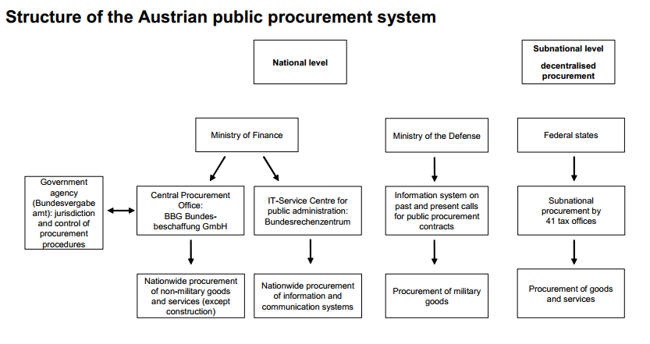
Figure 40: Structure of the Austrian Public Procurement System
Available at: ftp://ftp.cordis.europa.eu/pub/innovation-policy/studies/2_austria.pdf; accessed: 30th November, 2014.
At the national level, the Ministry of Finance, the Ministry of Defence and Sports and the Government Agency for Public Procurement are the responsible bodies for procurement. The Ministry of Finance is responsible for preparing public procurement rules, regulations and legislation. As sub-ordinated bodies of the Ministry of Finance, the Public Procurement Agency as the Central Procurement Office and the IT-Service Centre for public administration are fulfilling the tasks of nationwide procurement of non-military goods/services and information/communication systems. By establishing the Public Procurement Agency on the basis of the Law to establish the National Public Procurement Agency in 2001, the structure became more centralised. The Government agency for public procurement is dedicated to control and to rule upon public procurement procedures at the federal level. It is the competent authority “to rule upon publish procurement procedures con- ducted by public entities which fall within the competence of the provinces, cities and municipalities (Structure of the Austrian public procurement system n.d.). The Ministry of Defence is responsible for the procurement of military equipment (goods). An information system on past and present calls for public procurement contracts was established at the MoD. Finally, at the sub-national level, the provinces are the competent bodies for the procurement of goods and services. Additionally, the Austrian Register of Tenderers (AKNO) acts as an information interface between contractors and contracting bodies. The contract award portal of the Austrian Register of Tenderers contains all Austrian disclosures made by the Federal Government, the provinces and municipalities, all invitations for tenders from the supplement of the Official Journal of the European Union and selected invitations for tenders from Eastern Europe. From a strategic viewpoint interoperability is important to differentiate between relevant areas of interoperability. Interoperability can be related to technical standards but also to rules of procedure and management aspects (Expert Interview 2014). Of course there is a need for Austria to collaborate towards organisational and national borders on all levels like the strategic, operational and tactical level and therefore systems and procedures need to be compatible to a certain degree. Nevertheless it should not be disregarded that an efficient disaster management across borders has to rely on self-sufficient resources as foreseen on European and international level (Expert Interview 2014).

Niche capabilities
Austria possesses a considerable knowledge in the area of prevention and preparedness for natural, specifically alpine hazards, which might be exemplarily. The same applies to the capacity of volunteer work and the self-initiative of the civil society, which are very well established. About 431,000 volunteers, who are in some cases specially trained, contributes very well to the resilience of the Austrian society in cases of emergency. In particular, the involvement of convergent or spontaneous volunteers within the project “Team Austria” of the Austrian Red Cross and the Ö3 radio broadcasting might be considered to be a best practice model. Current figures estimate the personnel resources of Team Austria with about 30,000 individuals. The MoI emphasised, that from a technical perspective, knowhow in drinking water purification also outlines a special skill of Austria which has been proven in several international operations (2014). Furthermore, similar to Germany, highly regarded experiments in mountain rescue have been performed in Austria. Bossong and Hegemann (2013) have indicated, that the “strong but contested domestic role of the military,” as well as the well-established national security research, should be acknowledged as important capabilities. Apart from that, the already mentioned well-functioning early warning system and the well-developed warning infrastructure with over 8,000 sirens should not be disregarded. Due to the fact, that not the whole society is as technophile, by sirens the alerting in emergencies can be ensured.

Resources

Legislative acts
Federal Ministry of Finance. 2014. “Disaster Fund Act 1996. 10th Report of the Austrian Federal Ministry of Finance (german).” Vienna, Austria. https://www.bmf.gv.at/budget/finanzbeziehungen-zu-laendern-und-gemeinden/Katastrophenfondsbericht_2012-2013.pdf?4jwmz5.

Other normative acts
BMLFUW - V/7 Radiation Protection. 2013. “Notfallplanung in Österreich.” Vienna, Austria: BMLFUW. http://www.bmlfuw.gv.at/publikationen/umwelt/gefaehrliche_stoffe/notfallplanung.html.
BMLFUW, V/7, Strahlenschutz. 2009. “Das Österreichische Strahlenfrühwarnsystem.” Vienna, Austria: Federal Ministry of Agriculture, Forestry, Environment and Water Management.
COMMISSION OF THE EUROPEAN COMMUNITIES. 2004. Critical Infrastructure Protection in the Fight against Terrorism. European Commission. http://eur-lex.europa.eu/LexUriServ/LexUriServ.do?uri=CELEX:52004DC0702:EN:NOT.
European Parliament and the Council. 2007. Directive 2007/60/EC of the European Parliament and of the Council of 23 October 2007 on the Assessment and Management of Flood Risks (Text with EEA Relevance). Official Journal of the European Union. http://eur-lex.europa.eu/legal-content/EN/TXT/?uri=CELEX:32007L0060.
European Union. 2013. DECISION No 1313/2013/EU OF THE EUROPEAN PARLIAMENT AND OF THE COUNCIL of 17 December 2013 on a Union Civil Protection Mechanism. Brussels: Official Journal of the European Union.
Federal Chancellery of the Republic of Austria. 2013. “Austrian Security Strategy. Security in a New Decade - Shaping Security.” Vienna, Austria: Federal Chancellery of the Republic of Austria, Department IV - Coordination. http://www.bka.gv.at/DocView.axd?CobId=52251.
Federal Chancellor of Austria. 2013. “MASTERPLAN Österreichisches Programm Zum Schutz Kritischer Infrastruktur (APCIP).” Vol. 1. Vienna. http://www.kiras.at/uploads/media/MRV_APCIP_Beilage_Masterplan_FINAL.pdf.
Federal Ministry for European and International Affairs, and Austrian Development Agency. 2009. “International Humanitarian Aid. Policy Document.” Vienna, Austria.
Federal Ministry of the Interior. 2009. “SKKM Strategie 2020.” Vienna, Austria: Federal Ministry of the Interior. http://www.bmi.gv.at/cms/BMI_Service/SKKM/SKKM_Strategie_2020_Druckversion.pdf.
Federal Ministry of the Interior. 2010. “Aus Dem Inneren - 112 – ECHTE HELDEN HOLEN HILFE.” http://www.bmi.gv.at/cms/cs03documentsbmi/953.pdf.
International Atomic Energy Agency. 1986. “Convention on Early Notification of a Nuclear Accident.” Vienna, Austria. http://www.iaea.org/publications/documents/treaties/convention-early-notification-nuclear-accident.
Parliament of the Republic of Austria. 2014. “Limiting Each Other’s Power: Parliament and the Federal President.” Parliament and the Federal President. http://www.parlament.gv.at/ENGL/PERK/PARL/POL/ParluBP/Index.shtml.
Republic of Austria, Federal Ministry of Agriculture, Forestry, Environment and Water Management (BMLFUW). 2007. “THE AUSTRIAN FOREST PROGRAMME.” Vienna, Austria: The Austrian Federal Ministry of Agriculture, Forestry, Environment and Water Management (BMLFUW). http://www.bmlfuw.gv.at/en/fields/forestry/Naturalhazards/Protectionforests.html.

Official documents (white papers, strategies, etc.)
EDA, 2014. Vademecum on Member States Defence Procurement Practices for Defence Procurement Gateway, European Defence Agency. Available at: https://www.eda.europa.eu/docs/default-source/procurement-library/vademecum-of-pms-defence-procurement-practices-for-gatewayCF2123E529F9.pdf [Accessed November 28, 2014].
OECD, 2007. OECD Principles for Integrity in Public Procurement, Available at: http://www.oecd.org/gov/ethics/48994520.pdf [Accessed October 30, 2014].
United Nations, Department of Economic and Social Affairs, Population Division. 2014. “World Urbanization Prospects: The 2014 Revision, Highlights (ST/ESA/SER.A/352).” New York, U.S.: United Nations. http://esa.un.org/unpd/wup/Highlights/WUP2014-Highlights.pdf.
World Bank. 2013. “World Development Report 2014: Risk and Opportunity—Managing Risk for Development.” Washington, DC.: World Bank. https://openknowledge.worldbank.org/handle/10986/16092.
Structure of the Austrian public procurement system. n.d. Available at: ftp://ftp.cordis.europa.eu/pub/innovation-policy/studies/2_austria.pdf [Accessed November 30, 2014].
Statement from the Federal Republic of Austria on the access of third states to public procurement. 2011. Available at: http://www.bka.gv.at/DocView.axd?CobId=44628 [Accessed September 30, 2014].

Online resources (e.g. websites of key CM organizations)
AMA. 2014. “Handling of Food Reserves.” Security of Supply. http://www.ama.at/Portal.Node/ama/public?gentics.am=PCP&p.contentid=10007.46834.
Austrian Parliament. 2014. http://www.parlament.gv.at/ENGL/
Austrian Standards plus GmbH. 2002. “ÖNORM B 4015. Design Loads in Building - Accidental Actions - Seismic Actions - General Principles and Methods of Calculation.” Austria. http://www.bdb.at/Service/NormenDetail?id=98352.
Blöschl, Günter. 2013. “Kommt Die Nächste Sintflut?” ScienceBlog. http://scienceblog.at/kommt-die-nächste-sintflut.
BMASK.2009. “Freiwilliges Engagement in Österreich”, www.sozialministerium.at/.../Freiwilliges_Engagement_in_Oesterreich
BMLFUW IV/5. 2012. “Integrated Risk Management.” http://www.naturgefahren.at/massnahmen/ngmanagement/integrrisikomang.html.
BMLFUW. 2013. “Financing of the Measures.” http://www.naturgefahren.at/massnahmen/finanzierunghaupt/Finanzierung.html.
BMLFUW. 2012. “Damages Caused by Natural Disasters.” Exposition to Natural Hazards in Austria. http://www.naturgefahren.at/karten/chronik/oestr_exposition/schaeden.html.
BMLFUW. 2014a. “Torrent and Avalanche Control.” Protection against Natural Hazards. http://www.bmlfuw.gv.at/en/fields/forestry/Naturalhazards/Avalanchecontrol.html.
BMLFUW. 2014b. “Hazard Zone Plan.” Amendment to the Water Legislation - Regulation on the Hazard Zone Planning. http://www.bmlfuw.gv.at/wasser/wasser-oesterreich/wasserrecht_national/planung/wrg-gzpv.html.
BMLFUW 2014c. “Organisations.” Natural Hazards. http://www.naturgefahren.at/organisationen.html.
BMLFUW. 2014d. “Weather Warning, Avalanche Warning and Flood Forecasting.” Natural Hazards. http://www.naturgefahren.at/organisationen/Unwetter_HW.html.
Centre for Climate Adaption. 2014. “Air Temperature Changes until Now.” Climate Change Austria. http://www.climateadaptation.eu/austria/climate-change/.
Environment Agency Austria. 2014. “Land Use.” State of the Environment. http://www.umweltbundesamt.at/en/soer/soer2010_partc/soer2010_landuse/.
Federal Ministry of the Interior. 2014. “Information about the Federal Alarm Centre.” http://www.bmi.gv.at/cms/BMI_Zivilschutz/more_on_topic/Alarm_Centre.aspx.
Federal Ministry of the Interior. 2013. “State Protection.” Protection of Critical Infrastructure. http://www.bmi.gv.at/cms/bmi_verfassungsschutz/.
FreiwilligenWeb 2014: http://www.freiwilligenweb.at/index.php?id=CH3066&PHPSESSID=86g5cgv45a6qn64pfkickdpig4
Wikipedia 2014: https://de.wikipedia.org/wiki/Team_%C3%96sterreich
ZAMG. 2014a. “Stärkste Erdbeben.” Earthquakes in Austria. https://www.zamg.ac.at/cms/de/geophysik/erdbeben/erdbeben-in-oesterreich/copy3_of_die-staerksten-erdbeben-in-oesterreich.
ZAMG. 2014b. “Earthquake Exposure.” Earthquakes in Austria. https://www.zamg.ac.at/cms/de/geophysik/erdbeben/erdbeben-in-oesterreich/erdbebengefaehrdungzonen-in-oesterreich.
Liebmann, H., 2014. New regime for defence and security. Available at: http://at.schindhelm.com/content/lawyer/austria/news_jusful/news/new_regime_for_defence_and_security/index_eng.html [Accessed November 30, 2014].
Ministry of Defence and Sports. 2014. “Tasks of the Austrian Armed Forces.” Austrian Armed Forces. http://www.bundesheer.at/sk/.
PreventionWeb. 2014. “Austria - Disaster Statistics.” http://www.preventionweb.net/english/countries/statistics/?cid=10.
Profil.2013. “Hochwasser 2013”, http://www.profil.at/home/hochwasser-hochwasser-2013-ein-jahrhundert-hochwasser-oesterreich-359840
Reliefweb. 2014. “Disasters - Austria.” UNOCHA. http://reliefweb.int/disasters?country=26#content.
SKYWARN Austria. 2014. “Catastrophe Events in Austria.” http://www.skywarn.at/index.php/Unwetter_in_Oesterreich.html.
ZAMG. 2013. “Summer 2013.” Climate. https://www.zamg.ac.at/cms/de/klima/news/sommer-2013.

Publications
Benz, Arthur, and Christina Zimmer. 2010. “The EU’s Competences: The ‘vertical’ Perspective on the Multilevel System.” Living Reviews in European Governance 5 (1): 1–31.
Bossong, Raphael, and Hendrik Hegemann. 2013. “Country Study: Austria.” ANVIL - Analysis of Civil Security Systems in Europe (FP7 ANVIL project). http://anvil-project.net/wp-content/uploads/2013/12/Austria_v1.0.pdf.
Bußjäger, Peter. 2003. Katastrophenprävention Und Katastrophenbekämpfung Im Bundesstaat. Vol. 89. Vienna: Braumüller.
Embleton-Hamann, Christine. 2007. “Geomorphological Hazards in Austria.” In Geomorphology for the Future - Conference Proceedings. Joint Meeting of the Commission on Geomorphology of the Austrian Geographical Society and the IAG Working Group on Geomorphology and Global Environmental Change., edited by Kellerer-Pirklbauer A., Keiler M., Embleton-Hamann Ch., and Stötter J., 33–56. Obergurgl, Austria: Innsbruck University Press.
EUROPEAN COMMISSION FOR DEMOCRACY THROUGH LAW, 1995. EMERGENCY POWERS, Strasbourg, France. Available at: http://www.venice.coe.int/webforms/documents/default.aspx?pdffile=CDL-STD(1995)012-e [Accessed October 12, 2014].
FEU, 2014: Available at: http://www.f-e-u.org/national_legi.php; accessed: 21st September, 2014.
Gutknecht, D., Ch. Reszler, and G. Blöschl. 2002. “Jahrtausend-Hochwasser Am Kamp?” Vienna University of Technology. http://www.tuwien.ac.at/aktuelles/news_detail/article/3401/.
Hausmann, Helmut, Stefan Hoyer, Bernd Schurr, Ewald Brückl, Gregory Houseman, and G. Stuart. 2010. “New Seismic Data Improve Earthquake Location in the Vienna Basin Area, Austria.” Austrian Journal of Earth Sciences 103 (2): 2–14.
Hornich, Rudolf. 2013. “ACTUAL STATUS OF THE TRANSPOSITION OF THE FLOOD DIRECTIVE IN AUSTRIA.” In 6th Bulgarian - Austrian Seminar 2013: Practice and Research in Flood Risk Management. Bulgaria, Sofia.
Institut für empirische Sozialforschung. 2013. “Freiwilliges Engagement in Österreich (Volunteering in Austria).” Federal Ministry of Labour, Social Affairs and Consumer Protection. http://www.sozialministerium.at//cms/site/attachments/0/1/0/CH2174/CMS1218022135039/fweinoeerhebung2012kompl.pdf.
Jachs, Siegfried. 2005. “National Information Provided by Austria in Preparation for the World Conference on Disaster Reduction.” Kobe, Japan. http://www.preventionweb.net/files/854_Austria-report.pdf.
Jachs, Siegfried. 2011a. “Aus Dem Inneren - STAATLICHES KRISEN- UND KATASTROPHENSCHUTZMANAGEMENT (SKKM).” Vienna, Austria. http://www.bmi.gv.at/cms/BMI_Service/Aus_dem_Inneren/Staatliches_Krisen_und_Katastrophenschutzmanagement.pdf
Jachs, Siegfried. 2011b. Einführung in Das Katastrophenmanagement. Hamburg: tredition GmbH.
Khakee, Anna, 2009. Securing Democracy? A Comparative Analysis of Emergency Powers in Europe, Available at: www.dcaf.ch/publications.
Ladurner, J., Gerger, M., Holland, W., Mossialos, E., Merkur, S., Stewart, S., Irwin, R., Soffried. J, 2011. „Public Health in Austria – An analysis oft he status of public health“. Observatory Studies Series 24, WHO. http://www.euro.who.int/__data/assets/pdf_file/0004/153868/e95955.pdf?ua=1Leitgeb, M., and F. Rudolf-Miklau. 2004. “Risk and Disaster Management in Natural Hazards as Floods, Debris Flows, Land Slides, Rock Fall and Avalanches in Austria.” In Internationales Symposium INTERPRAEVENT 2004 – RIVA / TRIENT, 4:125–134. http://www.interpraevent.at/palm-cms/upload_files/Publikationen/Tagungsbeitraege/2004_4_IX-125.pdf.
Potyka, Georg. 2010. “Analysis of Law in the European Union Pertaining to Cross-Border Disaster Relief. Country Report: Austria.”
Potyka, Georg. 2012. “Background Report Law and Regulation for the Reduction of Risk from Natural Disasters in Austria A National Law Desk Survey October 2012.” Geneva, Switzerland: Disaster Law programme. http://www.drr-law.org/resources/Austria-Desk-Survey.pdf.
Schoenherr (Johannes Stalzer), 2014. Austria - Public Procurement 2015 A practical cross-border insight into public procurement. In Public Procurement 2015. GLG - Global Legal Group. Available at: http://www.iclg.co.uk/practice-areas/public-procurement/public-procurement-2015/austria.
Schwarzl, Ingeborg, Andreas Türk, Andrea Stocker, Martin König, Helga Nefzger, and Susanne Ostertag. 2005. “Heat and Drought and Their Impacts in Austria.” Edited by Helga Kromp-Kolb and Ingeborg Schwarzl. Vienna, Austria: StartClim2004. https://austroclimweb.boku.ac.at/startclim/bericht2004/StCl04fin.pdf.
STATISTIK AUSTRIA. 2008. “STRUKTUR UND VOLUMEN DER FREIWILLIGENARBEIT IN ÖSTERREICH.” Vienna, Austria: Federal Ministry of Social Affairs and Consumer Protection.
Stiefelmeyer, H., and J. Sattler. 2012. “Schutz Vor Naturgefahren in Österreich.” Vienna, Austria: BMLFUW, Department of Water and Forestry. http://www.bmlfuw.gv.at/publikationen/wasser/hochwasser_schutz/Schutz_Naturgefahren0.html.
Strosser, Pierre, Thomas Dworak, Pedro Andrés Garzon Delvaux, Maria Berglund, Guido Schmidt, Jaroslav Mysiak, Maggie Kossida, Iacovos Iacovides, and Victoria Ashton. 2012. “Gap Analysis of the Water Scarcity and Droughts Policy in the EU.” European Commission. http://ec.europa.eu/environment/water/quantity/pdf/WSDGapAnalysis.pdf.
UNU-EHS, and Alliance Development Works. 2014. “WorldRiskReport 2014.” http://www.worldriskreport.com/uploads/media/WorldRiskReport_2014_online-II_01.pdf.
Zwittkovits, Franz. 1983. Klimatypen - Klimabereiche - Klimafacetten. Erläuterungen Zur Klimatypenkarte von Österreich. Beiträge z. Vienna: Verlag der österreichischen Akademie der Wissenschaften.

Expert interviews
Expert Interview. National Crisis- and Disaster Protection Management and Civil defence (MoI, Austria). Vienna, Austria, November 2014.
The interview partner from the Federal Ministry of the Interior has stipulated to integrate the following note: “The statements, interpretations, and conclusions expressed in this interview do not necessarily reflect the views of the Federal Ministry of the Interior, the Federal Government, or the Republic of Austria.”

The term provinces of Austria corresponds to federated states – a synonym for counties, called “Bundesländer” in German.
The World Risk Report (UNU-EHS and Alliance Development Works 2014) expresses the risk “of becoming a victim of a disaster as a result of vulnerability and natural hazards such as earthquakes, storms, floods, droughts and sea level rise” on the basis of multiplying the exposure towards natural hazards, susceptibility depending on infrastructure, etc., coping capacities depending on the governmental structure, etc. and adaptive capacities related to future natural hazards and the impacts of climate change.
As “perceived” earthquakes, seismic activities with an epicentral intensity higher than 3° on the 12-class European Macroseismic Scale (EMS-98) have been defined.
http://www.refworld.org/cgi-bin/texis/vtx/rwmain?page=publisher&publisher=AUT_RC&type=&coi=NGA&docid=&skip=0
Information about the department is available at: http://bfw.ac.at/rz/bfwcms.web?dok=4905; accessed at: July 14th, 2014.
http://ec.europa.eu/councils/bx20041216/com_2004_702_en.pdf
http://www.fhs.se/Documents/Externwebben/forskning/centrumbildningar/Crismart/Forskning/Fallbanken/KAPRUN_T.PDF
Web-Page about Team Austria: http://oe3.orf.at/teamoesterreich; accessed: July 14th, 2014.
RE-ACTA project: http://blog.roteskreuz.at/reacta/beispiel-seite/; accessed: July 14th, 2014.
Directive 2008/114/EC issues the identification and designation of European critical infrastructures and the assessment of the need to improve their protection.
http://www.venice.coe.int/webforms/documents/default.aspx?pdffile=CDL-STD(1995)012-e
http://erccportal.jrc.ec.europa.eu/vademecum/at/2-at-4.html
The Document “Führen in Katastropheneinsätzen” (“Leading in disaster operations” is available at: http://www.bmi.gv.at/cms/BMI_Service/Richtlinie_fuer_das_Fuehren_im_Katastropheneinsatz.pdf, (only in german); accessed: 21st January, 2014.
Information is available at: http://www.phago.at/en/services/stockpiling/; accessed: 12th October, 2014.
Information is available at: https://www.kommunalnet.at/news/artikel/article/atomarer-super-gau-was-muessen-gemeinden-im-notfall-tun.html?cHash=f21f743b5bf6c5f422e0ad98b9c1e636; accessed: 11th March, 2014.
An overview on laws concerning public procurement is provided at: http://www.bundeskanzleramt.at/site/5100/Default.aspx (only in German); accessed: 29th November, 2014.

